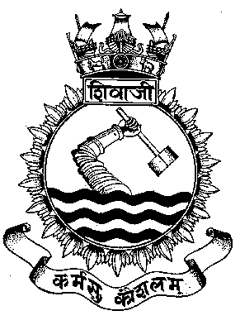
JME
“The Prime Mover”

The Alma Mater
of THE PROFESSIONAL JOURNAL OF
Marine Engineers MARINE ENGINEERING

Volume 73 Jan 17

‘INNOVATION IN MARINE ENGINEERING- NEED OF THE HOUR

Ser Contents Page

- Installation of Indigenously Developed Quick Reaction, 08
Early Warning Fire Detection and Monitoring System
onboard WJFAC
Lt Cdr V P Tolambia

- Water Mist Fire Fighting System a Green Alternative 20
Cdr Hari Vijay Pala, Lt Cdr Abhijeet B Kakade

- Aluminum Foam - Surface Modifications For Marine 29
Applications
Cdr Piyush Gaur

04. Efficacy of 3-D Metal Printing in Fleet Ships 39
Cdr AK Pandey

05. Innovative Measures to Enhance Reliability of Ship’s Boats 51
Lt Cdr MSN Murthy

06. Innovative Repairs of RO Plants at Sea 57
Lt Sahil Kanwar

GENERAL MARINE ENGINEERING / NOTES FROM SEA

07. It Happened One April Night in the Aft Engine Room 63
Capt Sunil Kumar

08. Recounting the Retubing Infusing the American Relic with 66
Indian Steel : INS Jalashwa
Capt Rakhi Ram, Lt Ashish Thapliyal

09. Assistance rendered to MCGS Barracuda 71
DI/ DR on RO plant and DG at Mauritius- INS Kolkata
Lt Cdr Ayush Pharasi

10. Free Rotation of Power Turbine of Inoperative Gas Turbine 75
Due to Wind-Milling Effect- Kolkata Class Ships
Lt Cdr Ayush Pharasi, Lt Rajan Sharma

Staff Student Projects On the Horizon 81

Kaleidoscope of Development & Training Activities 88
Undertaken at Shivaji

On the Horizon 102

Awards 108

LETTERS TO THE EDITOR

- Thank you for sending me the 72nd edition of the Journal of Marine Engineering “The Prime Mover” vide your DO letter 242/KPA dated 30 Aug 16.

- You have aptly chosen the theme and the topics to commemorate the Silver Jubilee of INS Eksila. I take this opportunity to congratulate you and the editorial team of the JME for bringing out a highly informative edition. I wish ‘Team Shivaji’ the very best in all your future endeavours.

Admiral Sunil Lanba, PVSM, AVSM, ADC
Chief of the Naval Staff
Integrated Headquarters
Ministry of Defence (Navy)
New Delhi 110011

****

- I thank you for your letter DO/242/KPA of 17 Aug 16 forwarding a copy of the 72nd edition of Journal of Marine Engineering. “The Prime Mover” based on the theme ‘ Marine Gas Turbine Propulsion’ – To commemorate the Silver Jubilee of INS Eksila on 22 Oct 16, published by INS Shivaji.

- I have found contents of the Journal very interesting and informative especially on important issues pertaining to Marine Engineering. The articles on Silver Jubilee of Erstwhile MGTOC, National Competence in Marine Gas Turbine Propulsion- Way ahead, Digital Control System onboard 1242 RE Ships, A road map based on M15 Test house at INS Eksila and Rectification of remote control panel of defective 500 KW DA- Delhi Class are very interesting and brought out the history and concepts of Marine Gas Turbine Propulsion- Modern Trends and problems encountered and innovative solutions.

- My heartiest congratulations to you and editorial team for bringing out an informative and exhaustive professional publication of Marine Engineering. On behalf of all of us here at Ship Building Centre, Visakhapatnam, I wish team Shivaji the very best in all future endeavors.

Vice Admiral KO Thakare, AVSM, NM
Project Director
Ship Building Centre
Krishna Gate, Naval Base Post
Visakhapatnam 530014

****

- Accept my sincere thanks for the copy of 72nd edition of the Journal of Marine Engineering “The Prime Mover”.

- The contents of the publication are indeed very informative, focusing on enhancement of technical efficiency and expertise for the people studying and working on Marine Gas Turbines. The publication will certainly find a place in the reference material held in my office.

Vice Admiral G Ashok Kumar, AVSM,VSM
Deputy Chief of Naval Staff
187,South Block
IHQ of MoD (Navy)
New Delhi 110011

****

- Refer to your DO letter DO:242/KPA dated 17 Aug 16.

- At the outset, let me thank you for sending a copy of the Journal of Marine Engineering, “Prime Mover”. The Journal and its articles are of real relevance to the Navy and make for a fascinating read. I am sure that the journal would be of immense value to the participants of the forthcoming TMC course and would help in their research on engineering related topics.

- Do convey our felicitations to all those involved in putting this fine publication. We would be placing the Journal in our library to enable greater circulation.

Rear Admiral Monty Khanna, NM
Commandant
Naval War College
INS Mandovi
Verem, Goa 403109
****

1. I am writing this letter to thank you for forwarding a copy of the 72nd edition of Marine engineering Journal “The Prime Mover”.

2. The Journal gives very informative reading on Marine Gas Turbine Propulsion, the theme for this issue. It was indeed a delight to go through the journal. Some of the very interesting topics covered in Journal are Modern Trends in Marine Gas Turbine Propulsion and IN effort towards Indigenisation of Marine Gas Turbine.

3. I take this opportunity to wish good luck to Engineering fraternity and specially INS Eksila for reaching the major milestone of “Silver Jubilee” and hope INS Eksila to continue this journey towards greater heights. I would also like to complement the editorial team who has produced such a high quality and very comprehensive journal, which will certainly find as appropriate place in our Data cell for sharing with Officers and staff of this Directorate.

Rear Admiral AK Saxena, NM
Director General Naval Design
Integrated Headquarters
Ministry of Defence (Navy)
Directorate of Naval Design
A-33, Kailash Colony, New Delhi

****

- I am writing this DO letter to convey my thanks to you for sending me a copy of JME journal ‘The Prime Mover’. It was nice going through the Journal and I am impressed with the content of articles.

- I am sure that the present JME Journal based on ‘Gas Turbine Propulsion’ will be of great help to Marine Engineers. Articles by the Naval Officers in the journal are thought provoking and speak volumes of the technical and management acumen and shall boost the capabilities of our service in the field of ‘Gas Turbine Propulsion’. My best wishes to all on the eve of Silver Jubilee of INS Eksila on 22 Oct 16.

- I compliment Shivaji and Editorial teams for evolution of the JME into a high quality professional journal over the years. Wish you success in all of your future endeavours.

Rear Admiral K Srinivas, NM, VSM
Director & Station Commander (Navy)
MoD- Dept of Defence (R & D)
DMD Establishment
Post Box No. 2043
Secunderabad 500003

****

- Many thanks for forwarding the 72nd edition of the Journal of Marine Engineering “The Prime Mover”. I found the Journal highly informative and well compiled. Please convey my compliments and best wishes to the editorial team.

2. I take this opportunity to wish INS Shivaji greater successes in the years ahead.

Rear Admiral Dinesh K Tripathi, NM
Assistant Chief of the Naval Staff
(Policy & Plans)
Room No 25A,South Block
IHQ of MoD (Navy)
New Delhi 110011

****
FROM THE CHIEF EDITOR’S DESK

1. India as a country is transforming. The recent surge in ‘Start ups’ mushrooming in every nook and corner, catalyzed by the ‘Make in India’ drive, has given the nation’s developmental pace a shot in the arm. The Indian Navy values innovation and has been one of the forerunners in innovating its way into self reliance. The indigenous ‘men of war’ being added to the Naval arsenal almost every year are a testimony to our transformation from a ‘Buyer’s Navy’ to ‘Builder’s Navy’. Given the rapid pace at which we adopt technologies and tame them to our benefit, there is a constant need for ‘out of the box’ solutions.

2. We in the Indian Navy are accorded ample opportunities and resources to innovate at various levels and in several domains. While some of these innovations are out right brilliant, others appear to be obvious in hindsight. Such innovations not only provide the necessary inspiration but need to be documented for implementation and posterity. Taking cognisance of the need of present time, Shivaji has undertaken various innovative projects in the field of Technology and Green Initiatives view which the unit has been awarded the “Best Green Practices’ award for the year 2016. It is with this sense of conscientiousness that the chosen theme for this issue is ‘Innovation in Marine Engineering–Need of the Hour’. The inputs received from far and wide towards compilation of this issue have been very encouraging and provide an insight into several innovations and potential leaps in the domain of Naval Marine Engineering that the reader will find intriguing.

3. The present edition of JME Vol 73 incorporates innovations envisaged while carrying out repairs/ maintenance, DI/DR activities at sea, thesis on specific challenges and trivia. Also, write ups on Staff Student projects including the innovative projects undertaken by the unit are included in the edition. A brief on training activities at the Engineer’s Alma Mater along with plans on the horizon for enhancing the quality of training are included to give the Engineer’s vision.

4. It has been the constant endeavour of the editorial team to continually augment the quality and reach of the Journal. I compliment and thank the Editorial team for their relentless efforts in publishing this Journal. Finally, I thank all the authors, reviewers and readers for their support. Also, I would request our readers for their continued support and contributions by way of technical papers, anecdotes, experiences and historical data, which are essential to further enrich the quality of Journal of Marine Engineering.

(Sumeet V Shidore)
Captain
Chief Editor
INSTALLATION OF INDIGENEOUSLY DEVELOPED QUICK REACTION, EARLY WARNING FIRE DETECTION AND MONITORING SYSTEM ONBOARD WJFAC
Lt Cdr V P Tolambia

Introduction
- Indian Naval ships are required to operate in environments that are inherently enclosed spaces that are prone to fires. These susceptibilities necessitate personnel onboard ships and submarines to train for fighting fires under all circumstances. Generally, when a fire lights up, it is unnoticed for a certain span of time and gets observed only upon its escalation or excessive smoke. Ability to successfully contain and fight a fire onboard is directly linked to its detection in early stages. The time to detect a fire also determines the extent of damage. It is obvious that detection at an early stage and real time monitoring will enable Ship’s staff in fighting the fire effectively by concentrating the effort in a guided manner. With this aim, a MESC student project was taken up at INS Shivaji where the seat of fire can be detected in the initial moments using automation techniques. The automatic detection system also has unique civil application where it can be used in any environment with high stakes or greater risks of fire.

Background

- History is replete with examples where ships, especially ‘Men of War’ have been incapacitated or even completely lost due to fires. The thrust imparted to effective fire fighting aids and organisation onboard ships is a testimony to the magnitude of threat posed by fires. Generally, only smoke sensors are provided in the compartment which only detects the fire when there is a huge smoke which obstructs the transmission of optical pulse to photodiode. The lag associated with this kind of fire detection leads to fire propagation beyond control. Driven by this requirement, the developed system explored means to detect fire initiation, faster than conventional methods of smoke detection.

- Principle of Operation. The system detects Ultraviolet and Infrared waves in the range of 190-380 nm and greater than 790 nm respectively in combination for any kind of spectral response emanating from seat of fire. The location thus captured by the sensor will direct the camera to move in the respective quadrant thereby providing real time scene on the monitor.

- Development of Prototype. The prototype was designed by integrating IR sensors & ionization sensors and camera unit with microcontroller. The system was designed for machinery compartments, wherein, IR signatures are sensed in real-time and automatically the seat of fire is located by moving the camera in the concerned direction. The design can interface with the existing automated fire fighting system for activating water sprinklers/ CO₂ drenching system. The Supervisory Control & Data Acquisition (SCADA) software communicates simultaneously with other sensing units in real time to provide the supervisory control. On successful trials of staff-student project at INS Shivaji, approval was accorded from HQSNC to install the ‘Quick Reaction, Early Warning Fire Detection & Monitoring System’ onboard WJFAC for field trials.

- Few photographs of the prototype developed are displayed below: -

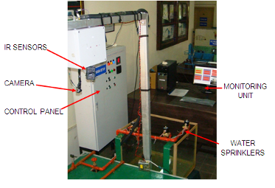
Fig.1 Experimental setup of PLC & SCADA based Fire Sensing, Detection and Fighting System (MESC Project)

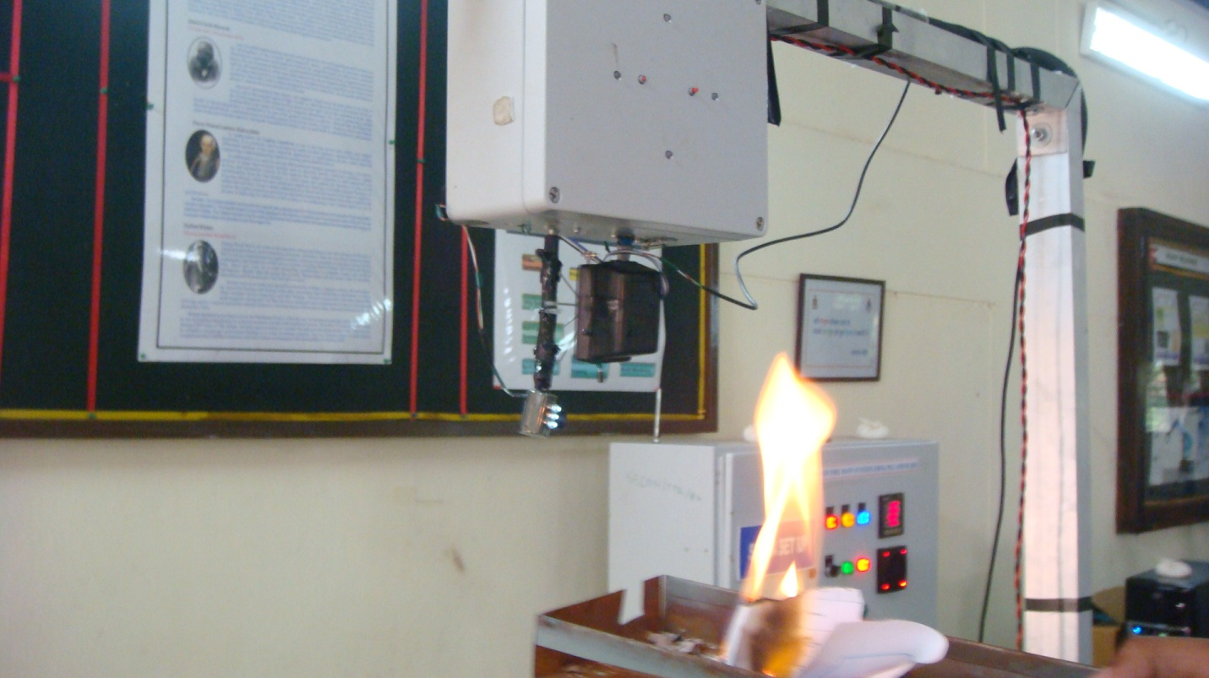 | 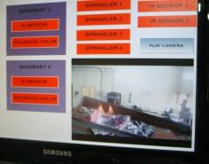
Fig.2 Camera Monitoring Fire | Fig.3 Live Monitoring of Fire at Remote Control Station
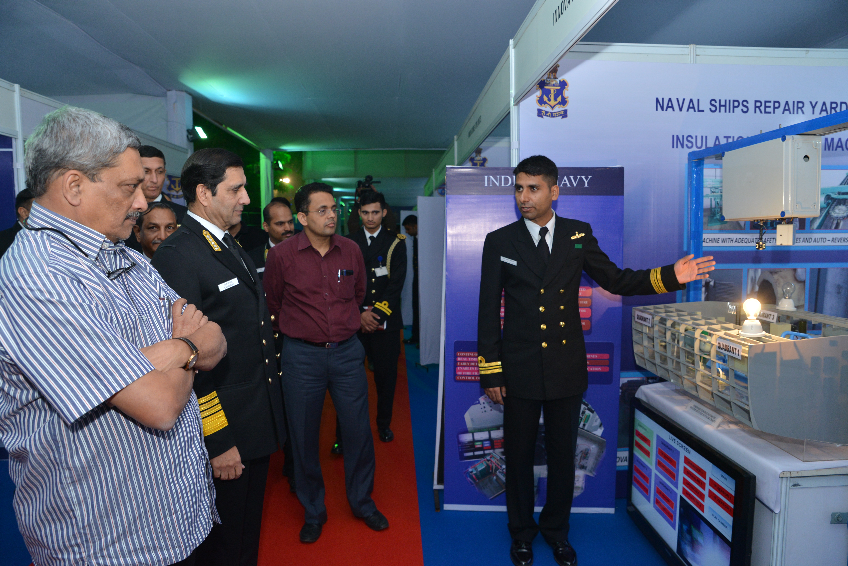
- The prototype was demonstrated to Honourable PM Shri Narendra Modi at the Navy House on the occasion of Navy Day and subsequently at IFR 16 and was appreciated at all forums.
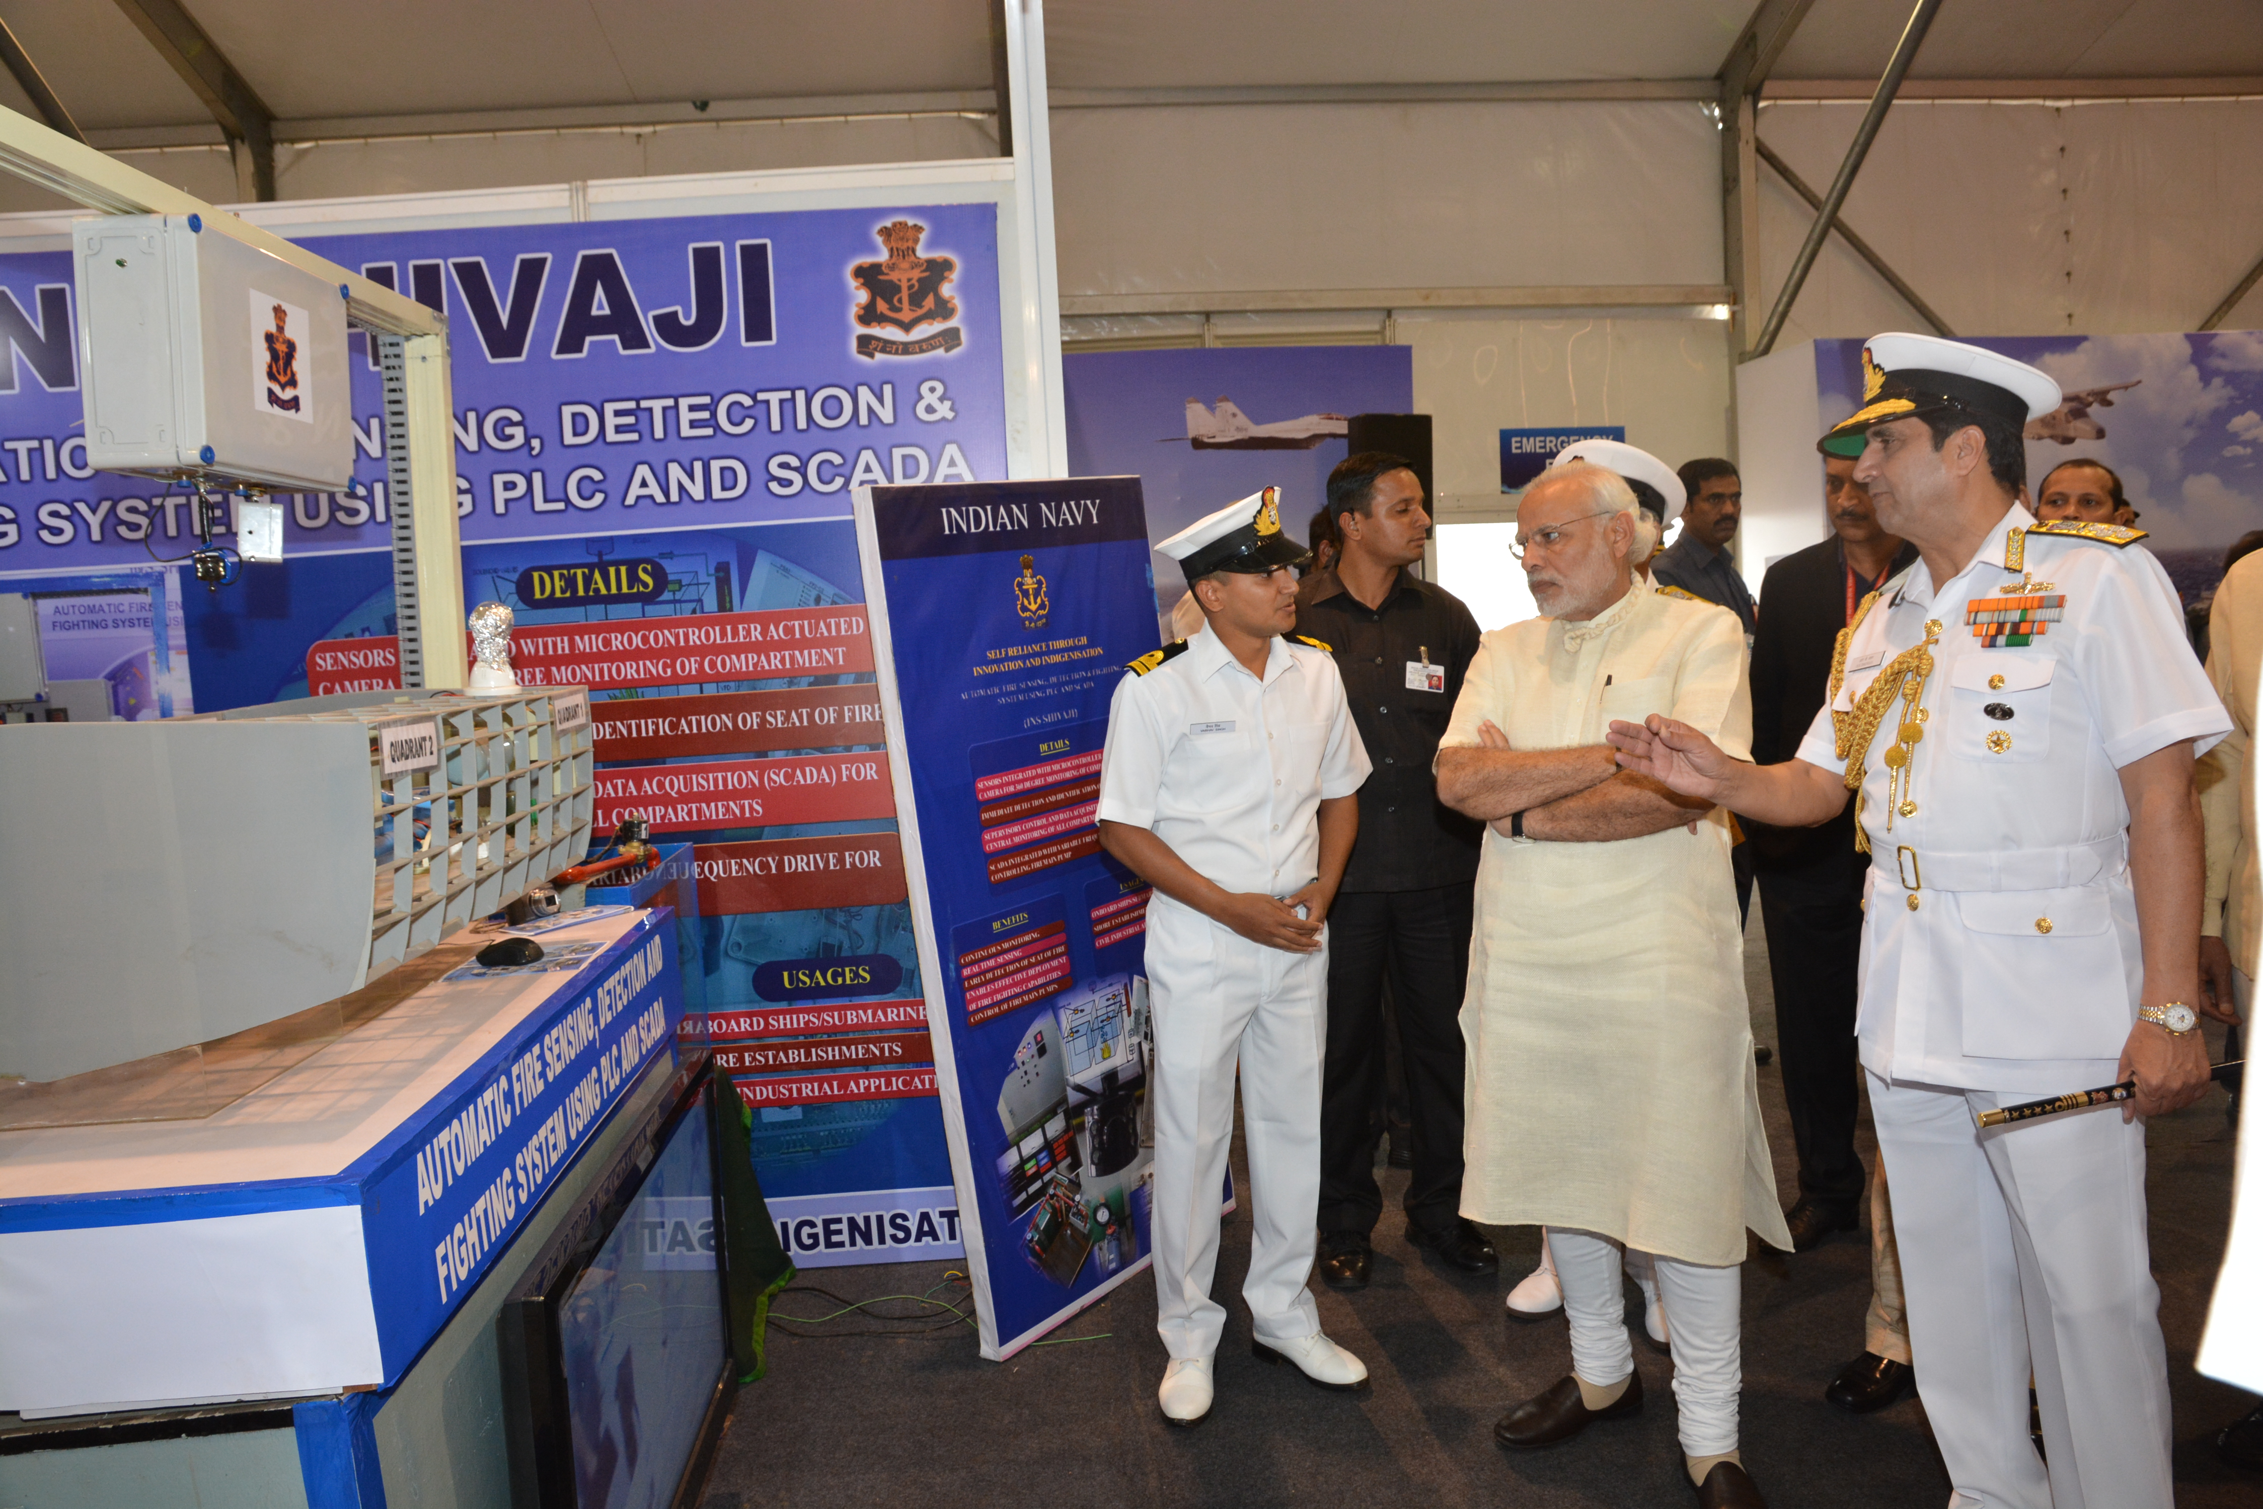
Fig.4 Demonstrating the system to Hon’ble PM & RM

- Pre requisites for the system. The following requirements were considered for the system onboard: -

- The system should be able to operate on ship’s supply.

- Size & weight of the panel shall be kept to a minimum consistent with IP66 protection.

- Cables should be sheathed, fire retardant, zero halogen toxicity and should be able to withstand temperatures from -30˚C to 120˚C.

- The cables used for internal wiring shall be provided with identification ferrules on both ends.

- The sensors should be configured with a Centralised control where one PLC will communicate with all sensors.

- The panel should have audio visual alarm.

- The system shall also distinctly indicate fault conditions of open loop conditions, short circuit and earth fault in the loop.

- Panel and detectors should be EMI/EMC protected.

- System should withstand all sea way conditions with out and deviation in parameters.

- The system should withstand operating temperature upto 55˚C and 95% relative humidity.

- Technical drawings, installation manuals, part identification list, test reports and fault location procedure should be provided with the system.

- System should be able to detect the minimum intensity of fire as possible and be able to scan the entire area for any fire signature.

System Design

- The system was designed keeping in mind the QRs considered above and following are the salient points of the design: -

- Selection of Detectors. While infrared and proximity temperature sensors can detect fire, the problems are compounded in case of a space such as a machinery compartment, which inherently has several hot components, such sensors can falsely alarm as fire. Diligent research in this domain revealed that a combined ‘AND Gate’ arrangement of Ultraviolet & Infra-red sensors can accurately detect flames and effectively eliminate it from a hot surface.

- For complete scanning of the compartment, an arrangement was arrived at wherein the enclosed space is divided into zones installed with these special UV/IR sensors and a control system algorithm was built around the concept.

- The project was designed using four UV/IR sensors, four smoke sensors, four PTZ night vision cameras, network video recording unit, main control panel, remote stick control and junction box able to withstand the operating environment and sea way conditions.

- Real Time Monitoring. The system is designed using Programmable Logic Controller (PLC) with ladder logic and is supervised by Supervisory Control and Data Acquisition (SCADA) technology. The sensors take real time UV/IR signatures from the machinery compartment and provide feed to the watchkeeper at MCR & DCHQ. As and when the fire signature is detected by the sensor, the signal go to PLC which will provide actuation signal to the camera motor to move to the respectable quadrant of the compartment.

- The programming of PLC is done in ladder logic and of HMI is done on Visual Basics. Post formulating a flow chart, ladder logic for the system is developed and checked in the PLC with help of Simulation. The entire operation of PLC, sensors and camera are supervised by the SCADA program.

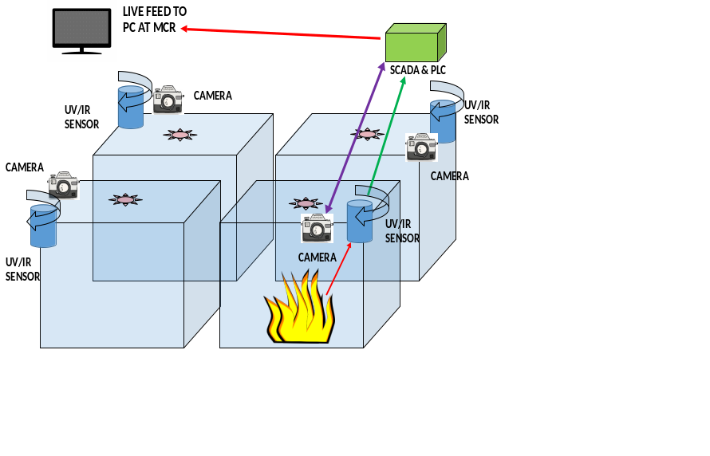
Fig. 5 Design of Quick Reaction, Early Warning Fire Detection and Monitoring System
Integration and Installation of System at Fire Fighting Training Facility, NBCD School
- Being the first of a kind system, multiple measures, and development stages were planned and executed. The initial design and control algorithm was successfully tested in a smaller scale laboratory setup with live fire. Once proven, the real scale hardware, suiting the rigours and harsh environment of naval machinery compartment, was assembled and installed at Fire Fighting Training Facility (FFTF), NBCD School. This setup is as close as it can get to the final objective of encountering live fire. The trials were conducted at FFTF to obviate possibility of error / deviations from SOTR.

- Test Setup. The machinery compartment of FFTF (8x4x4 m³) was divided into four quadrants and one camera, UV/IR sensor and smoke sensor each was installed at every quadrant. SCADA software is communicating simultaneously with all components at real time and is providing Supervisory control to all concurrently. During simulation trials with live fires (that can be induced in FFTF), the system has fulfilled all designed requirements; sensitivity of the system was ascertained using a candle flame. Additionally, multiple fire seats were also induced and escalated for pushing the hardware. All induced fires and their seats were detected without exceptions.

- Integration and Installation of System at Engine Room of WJFAC. On successful conduct of trials at FFTF, the system was installed onboard one of the Engine Room of WJFAC. The set up was maintained similar to that of the FFTF where the engine room compartment was modeled in four quadrants and one more unit was provided at center. Extensive trials were conducted in the engine room simulating fire where all induced fires were detected quickly and an early warning was issued to the watchkeepers at MCR and DCHQ both.
UV/IR Sensors installed in each quadrant
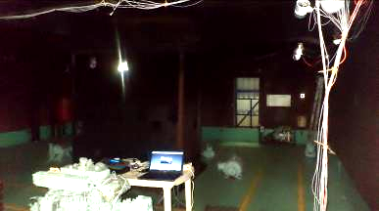
UV/IR Sensors installed in each quadrant
Manual control panel with monitor
ENGINE UNIT
Fig.6 System Layout at Machinery Compartment
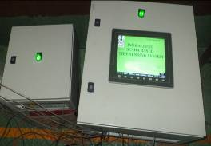 | 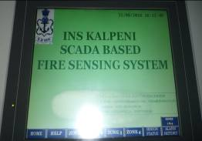
Fig. 7 Main Control Panel | Fig.8 Main Screen
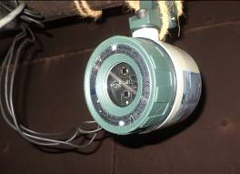 | 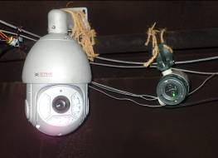
Fig.9 UV/IR Sensors | Fig.10 PTZ Night Vision Cameras
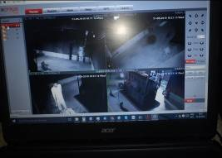 | 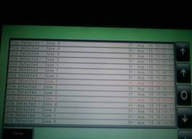
Fig. 11 Live feed of Cameras to Monitor | Fig.12 Data Logging of every fire input
- Data Logging. The provision of Data logging has been provided in the PLC for monitoring and data analysis.

- Working of the System. The system on initiation will direct the cameras to position zero. All UV/IR sensors installed at the respective quadrants will start scanning the compartment for ant possible fire signature. The cameras will subsequently sweep the entire compartment at an interval of 60 minutes with live feed of compartment at MCR & DCHQ. On case of fire / smoke at any position in compartment, the respective quadrant sensor will detect it first and provide signal to the PLC / SCADA. The controller then provides signal to all the cameras installed in the machinery compartment to rotate towards the respective quadrant thereby providing 360 degree view of the section for easy identification of seat and type of fire.

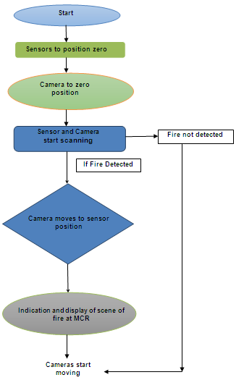

Fig. 13 Flow Chart for Operation of System
- Trials. Post installation of the system, trials were carried out extensively and following observations made:-

Ser | Fuel Used | Flame Characteristic | Zone | No. of iterations | Remarks
(a) | Candle | Colour- yellow,  Temp- 900˚K | All four zones detected | 10 | Trials Satisfactory, flame detected in less than 5 sec
(b) | Butane from cigarette lighter | Colour - blue & yellow,  Temp- 1000˚K | All four zones detected | 45 | Trials Satisfactory, flame detected in less than 4 sec
(c) | Propane flame at m/c fire simulator | Colour –orange & yellow,  Temp-1200˚K | All four zones detected | 40 | Trials Satisfactory, flame detected in less than 4 sec

- Results and System Performance Assessment. The detection system has following salient features:-

(a) Detection of flame within 2-4 seconds of generation of flame.

(b) Capability to detect a flame as small as a conventional candle which amounts to 1 candela luminous intensity only or cigarette lighter.

(c) Ability to detect multiple flames within the scanned area.

- Robust hardware integration using IP 66 and CAT 6 armoured cabling to withstand the rigours of a naval platform’s machinery compartment.

(e) Low weight of merely 150 kgs aggregate will have virtually zero implications on stability and tonnage of ship.

- Ability to differentiate between flame heat and hot machinery surfaces to avoid false alarms.

- Benefits Accrued. Following benefits are amplified in following heads: -

(a) Increase in Operational Efficiency. Sensing and detection of fire at the initial stage will improve the overall safety of the ship.

(b) Increase in Training Efficiency. The prototype of the system was developed as a Marine Engineering Specialisation Course staff- student project under the guidance of staff. The system is developed by integrating various state-of-the-art technologies which the trainees have learnt during the design and development phase.

(c) Reduction in Human Effort. At present on detection of fire in any compartment, Attack party has to rush to the scene of fire to ascertain the seat & type of fire followed by entire FEP. The developed system can pin point the seat of fire and can help in detecting the type of fire by the live feed of that particular quadrant, thereby enabling the watchkeeper to take immediate steps to alert the fire-fighting organisation & prevent the fire from spreading.

- Compliance with IT/Infosec policies. The system developed is an application of embedded system, which is implemented as a stand-alone system and will not be integrated with the IPMS software. The system has an administrative right to access and cannot communicate with any of the existing database onboard ship. All policies as per naval guidelines have been adhered to while developing the system.

- Efficiency over Existing Practices / Methods. Presently, smoke sensors are installed in the machinery compartments which sense the smoke for any possible fire hazard. Large amount of time is generally lapsed in identification of fire using smoke sensors. Application of this system will obviate the employment of attack party and additional watchkeepers in the machinery compartment as one watchkeeper either in DCHQ or MCR can do fire identification and can deploy effective fire fighting measures. Early detection will tremendously reduce the effort in fighting a fire by following: -

(i) Earlier than the human eye.
(ii) Eliminate oversight, negligence and other errors associated with humans.
(iii) Identification of seat of fire, despite smoke and heat in vicinity.
(iv) Multiple seats can be detected, as the system continues to scan the compartment and log every new incident.

- Innovation Through In-House efforts. The system developed is one of its kind in the country and is a indigenously developed technology under ‘Make in India’ theme. The system is a suitable example which can fulfil Indian Navy motto ‘Self Reliance through Innovation’. Development of such system using highly advanced technologies proves mettle of Naval personnel in the country in the field of R&D. The innovation is designed in-house and is going to be installed onboard ship as a debutant system for any class of ship. This system can be effectively utilized in other cases that are prone to fires or are ‘high value’. Adoption by industry or even foreign navies is likely and will prove to be a shot in the arms for Indian Navy’s image.

    - Cost of resources utilised in development vis-a-vis direct financial benefits. Investments pertaining to safety of human lives and ‘men of war’ cannot be quantified financially. This prototype along with the investments in development and iterations has being integrated at a cumulative cost of Rs 24,14,700.00. However, this will significantly reduce with greater numbers being inducted. Against this investment, the accrued financial benefit can be estimated to be infinite.

Author is presently serving as a Senior Instructor, System Engineering and Control (SECON) Wing at INS Shivaji
WATER MIST FIRE FIGHTING SYSTEM
A GREEN ALTERNATIVE

Cdr Hari Vijay Pala, Lt Cdr Abhijeet B Kakade

Background

- ‘Incidents of Fire’ onboard sea going vessels is a major concern for all sea farers since ages, because of possibility of quick spread and inherent space constraints for fighting the fire. Onboard warships, this concern is of bigger proportions due to ramifications on the float, move and fight capabilities as well as loss of life. With modern technology and automation of major functions onboard, the incidents of fire has greater ramifications on operational availability and deployability of a warship due to the effect of fire on control units, cabling and sensitive instrumentation. Hence, the need to introduce latest technologies in fire fighting systems onboard warships is the need of the hour.

- Engine room compartments and machinery spaces are high risk areas having high probability of occurrences of fire and presence of fuel, oils and other inflammable materials makes such occurrences disastrous. The source of fire could be as small as fuel leak/ spray/ spill onto a hot manifold or engine surface or a spark from electric panel. The disposition of machinery, contained atmosphere and possibility of fuel/ oil vapours in the compartment makes these fires difficult to attack and reach the source of the fire. In addition, burning fuels result in rapid temperature increase damaging ancillary equipment and surrounding electrical & electronic components. Further, heat convection through a compartment can result in flashover and conduction through decks and bulkheads increasing the chances of spread of fire to adjoining compartments. Protection against fires in high-risk areas such as machinery spaces requires a fire extinguishant that is

- Maintainable - minimal hardware and extinguishant, low cost, easily replenished.

- Effective - capable of extinguishing fires in lesser time comparable with current gaseous systems.

- Safe - minimal toxicity of both the extinguishant and byproducts generated due to thermal breakdown.

- At present for the high risk areas, Halon and Inert gas based fire fighting systems are being used onboard warships across all Navies. The halogenated hydrocarbon and inert gas systems necessitate evacuation prior to the discharge as they break down into hydrogen fluoride under the influence of heat. Hence, evacuation if not done is fatal to human beings and, if delayed may lead to losing of precious time in controlling and arresting the fire before it causes catastrophic damage.

- Halon 1301 has been the fire extinguishant of choice in ship’s machinery spaces since the mid-to-late 1960s because of its efficacy. However, halons have been proved to be ozone depleting chemicals. Their manufacture and use has been banned under the Montreal Protocol. Subsequently, non-ozone depleting halocarbon suppressants such as HFC-227ea^{i} and NAF-S-III^{ii} have been introduced to replace Halon 1301. The introduction of these suppressants has by and large addressed the environmental concerns, but like halons these halogenated hydrocarbons also breakdown into hydrogen fluoride necessetitating evacuation. Also, the inert gas and halocarbon suppressants require a minimum concentration to extinguish a fire, if a compartment is breached, the effectiveness of the gaseous suppressants are diminished.

- ‘Water Mist Fire Fighting System’ overcomes the above mentioned inherent disadvantages of existing fire fighting systems and if its extinguishing capacity can match the chemical or gaseous suppressants’ extinguishing attributes, it could replace Halon 1301, the halogenated hydrocarbons and inert gas systems.

- The major advantages of Water mist system over halon/ inert gas based fire fighting systems are as follows:-

(a) Does not require evacuation prior to activation,
(b) Minimises time for preparation prior to activation,
(c) No toxic effects of the suppressant/extinguishant

Introduction

- Water mist is toxicologically and physiologically inert. Water mist systems are different from the conventional Water Sprinkling systems, where, in the former the system is designed to produce a drop size distribution with a range of drop sizes under 1000μm. While the more conventional sprinkler systems produce much coarser particles. The smaller particle sizes have greater cooling efficiencies because evaporation and cooling are controlled by surface area. And the surface area of a large number of small droplets is greater than that of a small number of large droplets of the same total volume.

(Same volume, lesser surface area) (Same volume, greater surface area)
(a) (b)

Fig 1. Surface to volume ratio of coarse droplets and small droplets

- Coarse droplets from sprinkler systems are efficient at providing boundary cooling to large surfaces such as deck walls and floors and penetrating flames to get to the seat of a fire, but the large drop sizes that make up these sprays are not as effective on spilled fuel fires or in providing cooling to the regions around a flame. In addition, Water mist systems also have lower water demands than sprinkler systems, which is beneficial in shipboard applications where prolonged sprinkler discharges may affect stability (as experienced onboard warships during recent times).

Water Mist Characterisation

- Nozzle pressure, flow rate and the presence of obstructions influence the mist characteristics but do not characterise the mist. The mist characteristics will also be affected by the presence of a fire but are initially measured in a non-fire environment. Three basic parameters that are important in characterising water mist behaviour are as follows:-

(a) Flux density
(b) Spray momentum
(c) Drop size distribution

- Flux density. Reducing flame zone temperatures requires a sufficient volume of water droplets to interact with the fire. The greater the volume of water that interacts with the flames, the greater the heat absorption and larger the reduction in flame zone temperature. Flux density is a measure of the volume of water available for flame cooling and is defined as the volume of water that passes through the base of the spray cone per unit time. The total flow rate Q’ is a measure of the volume of water available for fire suppression, however some of the flow through the nozzle will be present as suspended mist droplets and some will evaporate, contributing to the other extinguishing mechanisms.

- Spray momentum. Imparting sufficient momentum to the water particles is necessary for them to penetrate the flame before they evaporate or are transported away from the fire by the hot buoyant combustion gases. The velocities of the spray droplets exiting a nozzle are reduced by friction and drag.

- Drop size distribution . Forcing liquid through a small diameter restriction such as a nozzle will result in a spray of droplets as it exits the restriction into air. The spray will not be made up of the same size droplets but a range of drop sizes referred to as the drop size distribution. The droplet size will be dependant on the nozzle type but will be controlled by viscosity, surface tension, the flow rate and pressure. A number of representative drop size diameters may be used to characterise sprays and the mean particle diameter is a convenient comparison. A mist of small diameter droplets (<50 μm) will exhibit gas like properties viz. following airflow patterns around obstructions and behaving like gaseous fire extinguishants.

Extinguishing Mechanisms

- Fire extinguishing through water mist application is controlled by three mechanisms, each of which are essentially independent. However, flame extinguishment generally occurs as a result of a combination of these effects. Each of the following mechanisms are described in succeeding paragraphs :-

(a) Flame cooling
(b) Reduced oxygen concentration by displacement of air by water vapour
(c) Radiant heat attenuation

- Flame Cooling. Water is an efficient substance for removing heat from a system because of its high specific heat and latent heat of vaporization. The increased surface area of small droplets for a given volume of water increases the evaporation rate via heat conduction from the flame, fire gases and hot surfaces. Flame cooling occurs when droplets of sufficient momentum penetrate the hot, buoyant gases and absorb heat directly from the flame environment. If the drops do not have sufficient momentum, they may evaporate or be removed by airflow currents before providing any significant flame cooling.

- Oxygen Displacement. Some of the water introduced into a fire evaporates. When it does so, it expands to approximately 1500 times its initial volume, diluting the oxygen concentration around the flame by displacing the air. If the oxygen content is reduced from a typical 20.9% to around 13% for most Class B^{iii} fuels, the fire will extinguish. A reduced oxygen concentration may become the dominant extinguishment mechanism when a compartment is sealed or poorly ventilated.

- Radiant Heat Attenuation. Suspended water vapour may reduce radiant heat transfer between the flame and unburnt fuel. Radiant heat can cause unburnt fuel to volatise resulting in flashover where all surrounding combustibles will begin to burn. Reducing radiant heat transfer may restrict fire growth and spread.

- The main fire extinguishing mechanisms of the water mist systems are radiant heat attenuation and oxygen displacement. Droplets over 50 μm diameter are projected into the fire zone because of their greater momentum. The drop size distribution also varies throughout the protected volume. As the distance from the nozzle increases, interaction between falling particles will result in particles coalescing and the average particle size increasing.

- Interaction of sprays from adjoining nozzles will also result in a change in drop size distribution as will interaction with obstacles. These all are the effects that occur without a fire, however, when flames are present, evaporation rates and thermally induced air flows taking particles away or into a flame will have a significant effect on the drop size distribution. If the spray characteristics such as droplet velocity, drop size and flux are known at or near the nozzle, the spray behaviour at any point, particularly around the flame zone, can be modelled using computational fluid dynamics.

Contrary Effects Of Extinguishing Mechanism

- Pressure Fluctuations. When an enclosed fire is extinguished using fine water mist system, the rapid cooling of the gas leads to severe contraction of the gas volume causing pressure inside the compartment dropping to less than atmospheric pressure and thus leading to implosion of window panes. However, if for the same fire situation, a coarse water system is used, the reduction in pressure caused by contraction of gas volume inside compartment due to cooling, is not that significant. This is because finer mist provides larger surface area for faster evaporative cooling than that of coarser water mist, for a given volume.

- Flare up A liquid pool fire is sometimes intensified by the application of water spray, which is referred to as Flare Up. This momentary intensification is attributed to effect of droplets striking the fuel surface and causing splashing and thus increased vaporization rate.

Factors Affecting Water Mist Performance

- Air entrainment. The release of heat from a fire results in a column of hot gases and combustion products forming a plume above the fire. The high temperatures within the plume reduce the density of the hot gas resulting in buoyant motion of the plume. The buoyant flows within the plume causes the colder surrounding air to entrain into the flame zone and the plume, thereby either aiding the fire or smothering it, depending on geometrical location of fire. If an item is burning against a wall or in a corner, the area through which air may be entrained is reduced. Similarly, if the fire plume impinges on a ceiling, it will be deflected horizontally to form a ceiling jet, again restricting entrainment.
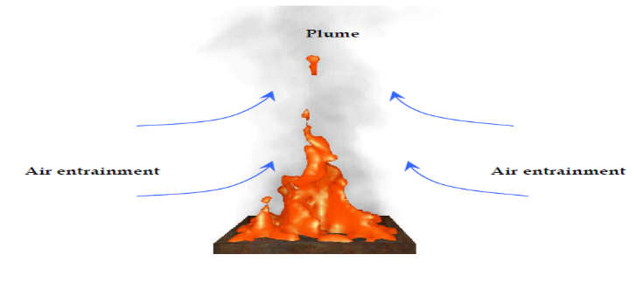

Fig.2 Air entrainment due to plume in a diffused flame

- Mist Entrainment. The mist particles are drawn into the flame by the exchange of momentum between the entrained air and the mist particles. The mist particles provide cooling that will bring down temperature necessary for reaction kinetics. Entrainment of mist into the flame zone may also produce local dilution of the oxygen concentration to a level that will inhibit combustion.
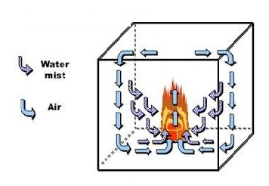
Fig. 3 Entrainment of water mist alongwith air

- Enclosure Effects. When a fire occurs in an enclosed compartment, the room is heated and the oxygen concentration in the compartment is gradually reduced. In addition, the hot gases from the fire tend to concentrate near the ceiling. With the discharge of water mist downward from ceiling level, a maximum amount of water is converted to vapor and displaces oxygen and fuel vapour around the fire, as fine water droplets quickly absorb heat from their hot surrounding. The capability of the compartment to capture heat and confine combustion products and water vapour, has an important impact on existinguishing performance of water mist which is described as enclosure effects in fire suppression. With enclosure effects, it is possible to extinguish fires with low momentum sprays in heavily obstructed compartment like machinery spaces. The flux density required for extinguishment can be as much as 10 times lower than that required for unconfined and well-ventillated fires.

- Ventillation Considerations. If extinguishing cannot be achieved through the removal of heat from the flame and combustion products, diluting the oxygen content to a level that will not support combustion is required. This occurs because the water particles do not reach the flame zone. The two factors contributing to this phenomenon are (a) the particles do not have sufficient momentum to penetrate the flame zone to directly reduce the flame temperature and (b) they are too small to move through to the flames before evaporating prematurely. If the major contributing factor in extinguishment is oxygen dilution, ventilation due to breached decks, bulkheads or open doorways will result in airflow into compartment, disrupting the oxygen dilution and possibly delaying the conditions that could result in extinguishment.
Merits of Water Mist Fire Suppression Systems

- The Water Mist System offer following advantages:-
(a) Inexpensive.
(b) Non-toxic and pose no environmental problems.
(c) Utilize lesser quantities of water as compared to sprinkling systems and hence have little or no collateral damage (Para 8 above refers).
(d) Have application as inerting or explosion suppression systems view expansion on evaporation and high latent heat of vapourization (Para 15 above refers).

Mandatory Requirement of Test Prior Installation

- The International Maritime Organisation (IMO) allows water-based systems in machinery spaces and pump rooms. However, the systems must be proven by test to be capable of extinguishing a range of fire scenarios that can occur in these spaces. The method of acceptance of a water-based system differs from that of gaseous systems; the latter require a specific extinguishing concentration, dependant on the extinguishant employed, to be maintained for a specified period of time. Unlike water based systems, gaseous systems can be designed through calculation and are not required by the IMO to extinguish test fires to prove their capability.

Conclusion

- Although all the extinguishing mechanisms of water mist are involved to some degree in fire extinguishment, only one or two mechanisms play a predominant role. Which of the suppression mechanisms is dominant depends on the characteristics of the water mist, fire scenarios, compartment geometry and ventillation conditions. Many other factors such as enclosure effects and dynamic mixing created by water mist, have important impact on the effectiveness of water mist in fire suppression.

- Halon 1301 has been the fire extinguishant of choice in our machinery spaces since the mid-to-late 1960s because of its efficacy; however halons have been shown to be ozone depleting chemicals and their manufacture and use has been banned under the Montreal Protocol. This has even led to difficulties in sourcing the halon by Materiel Organisations. Ship’s undergoing refits and are undertaking major routines on halon systems are not able to demand required quantities of halon. Issues that may mandate relook into use of Halon Systems onboard ships. In addition, the ships presently undergoing MR-MLU may be considered for phasing out of Halon Systems and replacement with water mist systems.

- Presently, the ship’s under construction at various shipyards viz. P 15A, P 15B, P 28, NOPVs, FACs are being fitted with CO₂ based fire fighting systems. Efficacy of these systems is ascertained through Gas Discharge Tests (GDT) that is undertaken prior commissioning. The test entails operation of the system within the machinery space to verify adequacy of the concentration levels of fire suppressant in the compartment.

- At present, water mist based fire fighting systems are not fitted onboard Indian Naval Warships. However, the same is being considered for fitment onboard major warship under construction.

i Heptafluoropropane
ii Chlorodifluoromethane
iii Combustible fuels like petrol, diesel etc.

Authors are serving as Engineer Officer and Senior Engineer Officer onboard INS Delhi.

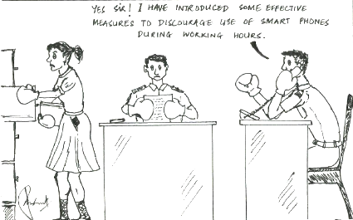
ALUMINUM FOAM - SURFACE MODIFICATIONS FOR MARINE APPLICATIONS

Cdr Piyush Gaur

1. Introduction. Preparation of highly porous closed cell metal foams has been a subject of research for production of novel lightweight materials for structural use. To use materials in marine applications considerations of strength, weight and corrosion resistance properties of foams are very promising and aluminum foams have been established and are being used worldwide. 5083 aluminum is used for marine applications and it was hypothized that foaming of this material would offer corrosion resistance properties similar to the parent material and also offer shock absorption properties. The paper presents the manufacturing processes of marine grade Aluminum foam at lab scale and surface modification process on Al foam to improve the shock absorption capacity.

Experimental

2. Preparation of Sample. The furnace used was a modified Muffle furnace of rating 12 kW designed and developed specifically for the process used. The furnace was of internal dimensions 300*300*300 (in mm). Two crucibles made of Mild Steel and capacity 500 grams each were used. The composition of material used for the process is as follows:-

TiH₂ powder 4.8 gm (1.6%)
Calcium metal 4.5 gm (1.5%)
Aluminum 5083 300 gm (base metal)

3. The method employed for production of the pilot sample was ALPORAS method [1]. The process was carried out as follows:-

(a) The first crucible filled with small pieces of Aluminum metal was placed in the furnace. The temperature of furnace was raised from 50°C to 400°C in steps of 50°C with period of 10 minutes in between the steps. Further the temperature was increased to 720°C in steps of 20°C.

(b) On visually confirming the formation of the Aluminum melt, the temperature was brought down to 695°C and stabilized for 15 minutes.
(c) The second crucible was placed in the furnace below the dosing pot for preheating to the furnace temperature. Then Calcium metal was added into the second crucible through the dosing pipe. Immediately after adding the Calcium metal in the second crucible, the alloy melt from the first crucible was poured on top of the calcium metal to achieve effective mixing and decomposition of the calcium metal granules in the Aluminum melt. The stirrer was lowered into the Aluminum melt and stirring was commenced. The stirring was continued for 15 minutes to get uniform mixing of melt and calcium metal. All the actions were carried out remotely in the temperature range of 670°C - 695°C (inside the furnace). This process of addition of calcium metal and stirring is aimed at increasing the viscosity of the melt [1].

(d) Next step involved the mixing of the blowing agent- Titanium Hydride (TiH₂) granules at 670°C. The process was carried out similar to the above step in the temperature range of 670°C - 695°C. The blowing agent- Titanium Hydride (TiH₂) powder were added through the dosing pot in the first crucible followed by immediate transfer of the melt from second crucible onto the blowing agent in the first crucible. This was done to achieve effective mixing and decomposition of the blowing agent in the melt mixture. Rigorous stirring was carried out for 05 minutes to get uniform mixing of melt and the blowing agent- Titanium Hydride (TiH₂) powder.

(e) The foaming/bubbling action was visible through the viewing port and the melt was allowed to foam at the fixed temperature (isothermal foaming) of 690°C.

(f) The foamed sample was taken out of the furnace and cooling was carried out by blowing air over the sample.

4. Tensile test. The tensile test was conducted on the test rig developed to ascertain the change in tensile properties of the foam samples with respect to the aluminum base metal. This equipment uses modified Monsanto extensometer for conducting tests on standard ASTM/Monsanto specimens. The standard sample as per ASTM-E8 is installed between the grips up to gripping length of the specimen and then strained according to required strain rate of material till it fractures. As the foam samples produced were of smaller size, the making of the test specimen from the foam samples close to the specifications as per ASTM E-8 standard was difficult. Hence the existing dimensions of standard specimen were scaled down and the test specimens were made (figure 1).

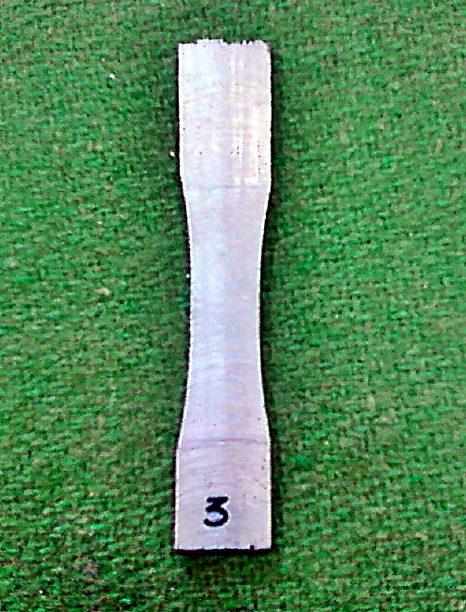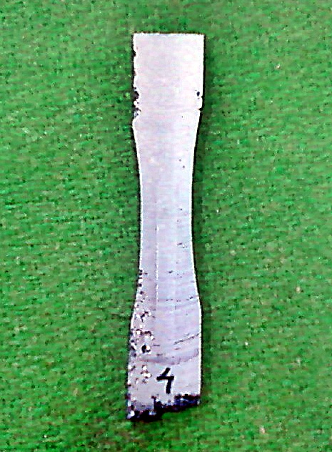

Fig. 1 Test Specimen

5. Tensile test results. The results obtained from the tensile test were found to be close to the recorded UTS for Al 5083 of 280MPa to 400MPa as against 480 MPa for pure Aluminium. The difference in the tensile properties can be attributed to the uneven porosity and the non standard size of the samples. The decrease in the UTS (figures 2 & 30 for foamed material is in line with previously recorded results [1] [2].
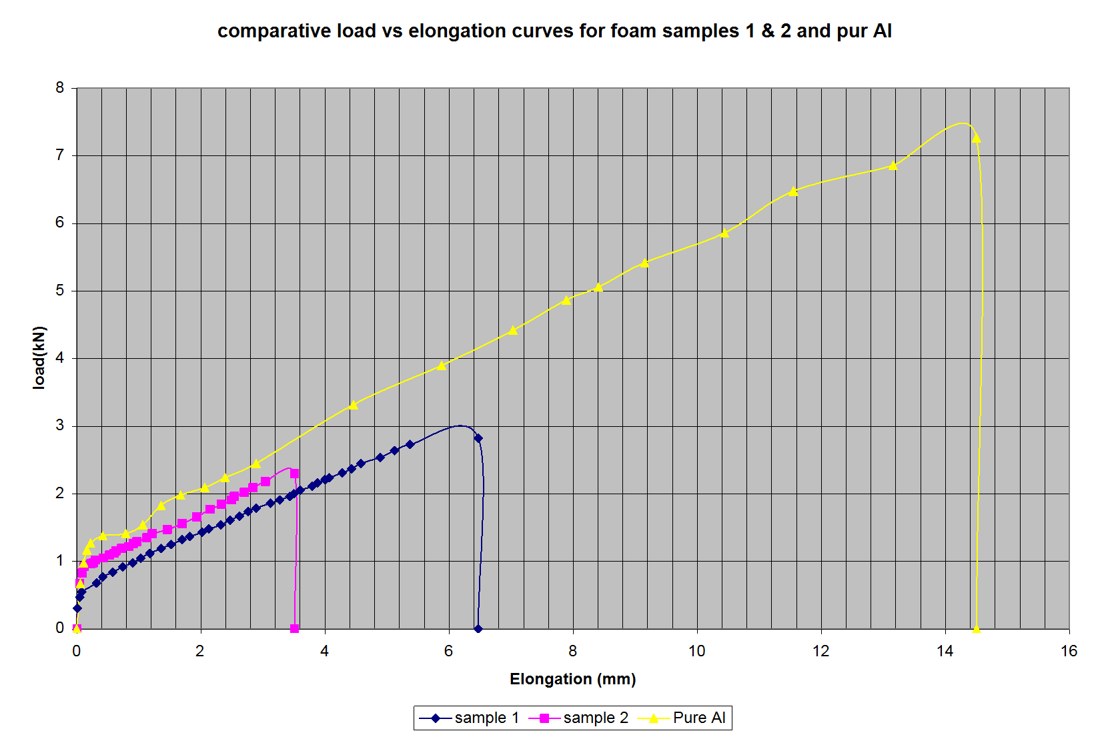

Fig. 2 Load vs Elongation Curves

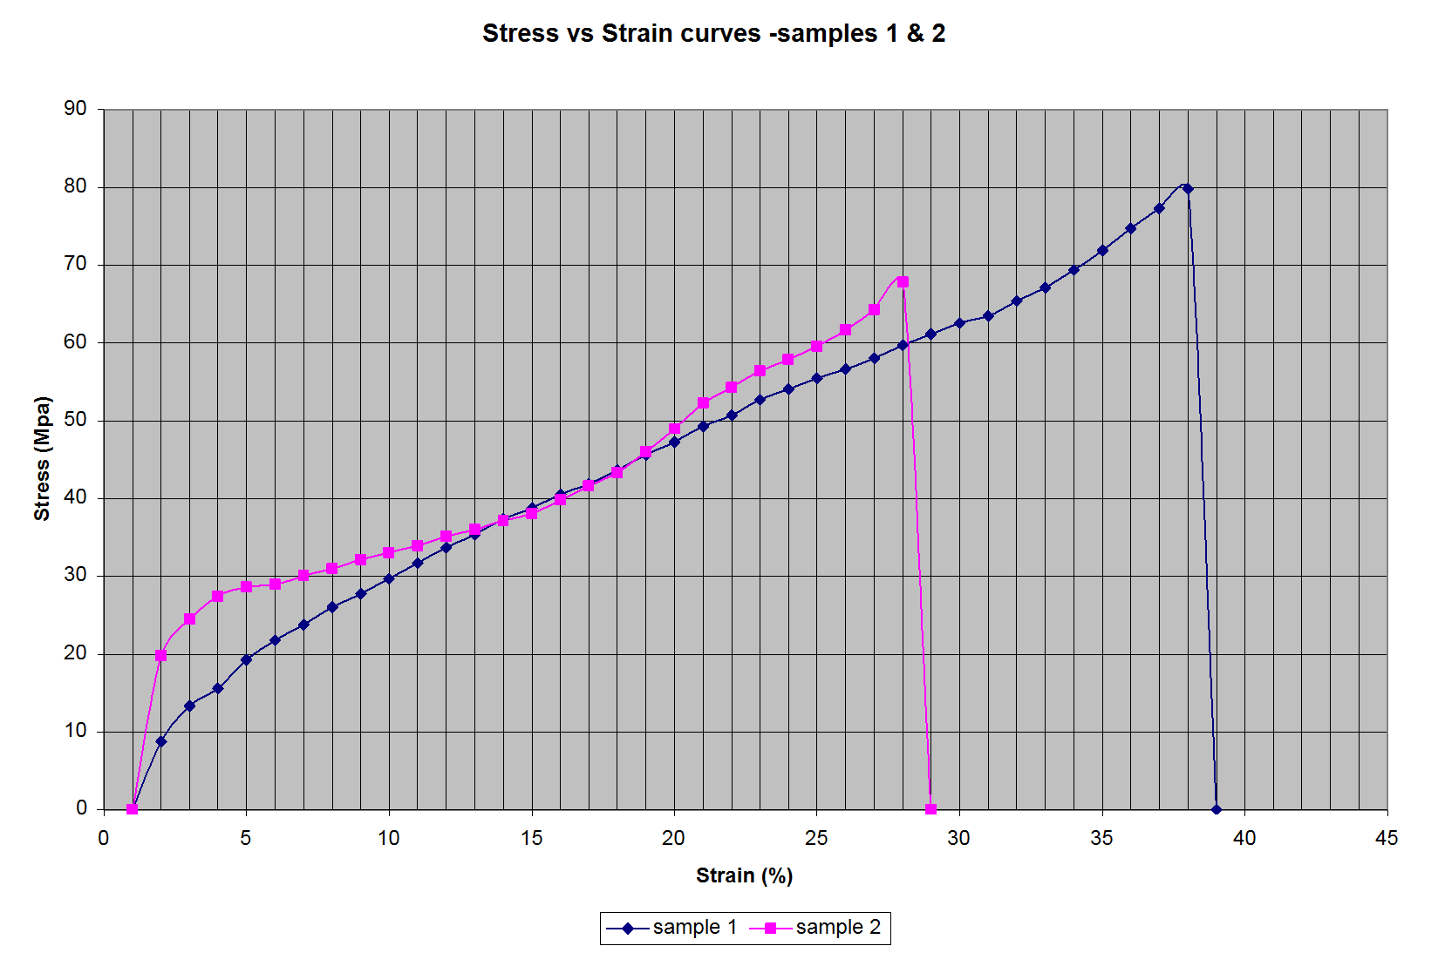

Fig. 3 Stress vs Strain curves

6. Corrosion Potential Test. The test specimens were prepared out of the available pilot foam samples. The samples were prepared as per ASTM G69 standard. The solution was prepared as per the following composition (ASTM G69-X1):

NaCl 53gms
30%Hydrogen Peroxide reagent 9 mL
DistilledWater 01 L

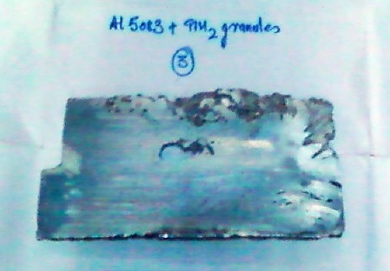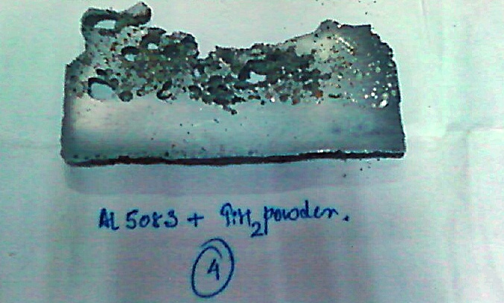

Fig. 4 Sample1 Fig. 5 Sample2 for OCP measurement

500mL of the prepared solution was used in one experiment. The data was recorded using Gamry Software. The sample and the Calomel electrode were directly immersed in the solutions and the data recorded for 10 minutes each. The potential appeared to stabilize in the given period of time.

7. Corrosion Potential Test Results. The test results for the two samples are as follows:-
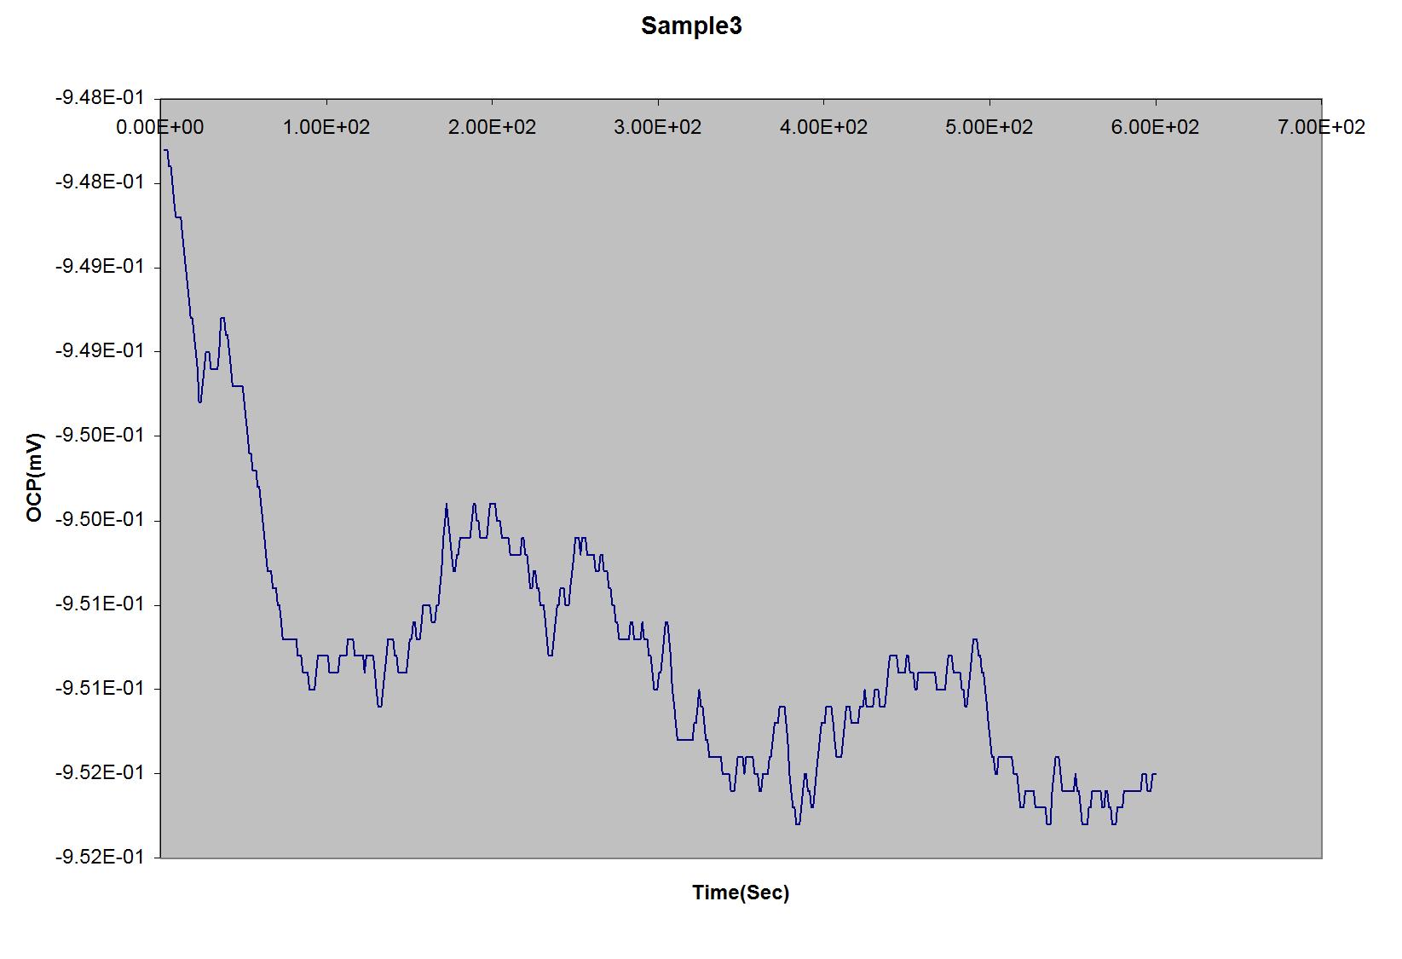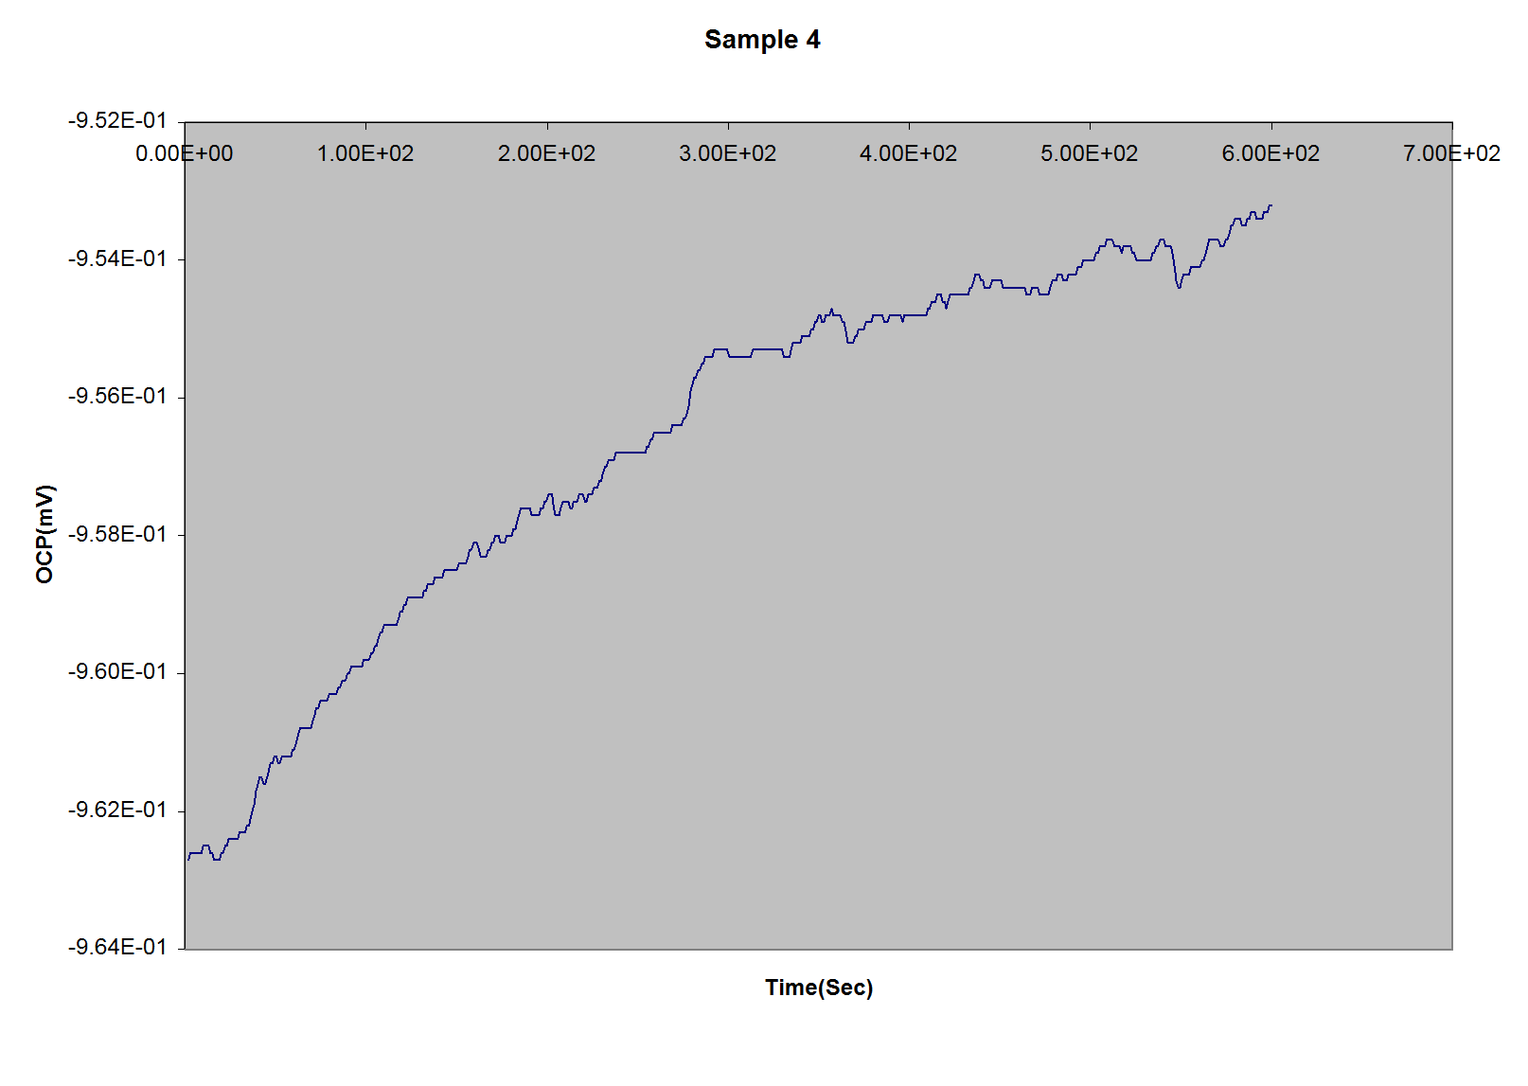

Fig. 6 OCP vs time for sample1 Fig. 7 OCP vs time for sample 2

RESULTS OF OCP TEST | Sample1 | Sample2
Experimental results | -952 mV | -953 mV
OCP as per ASTM G 69-X1.1 | -860 mV | -861 mV

8. The Open Circuit Potential (OCP) of the tested samples was found to be increasing towards the OCP of Al 5083. The results (figures 6 & 7) indicate the formation of protective oxide layer on the samples in the first 10 minutes of the experiment and hence the resistance to corrosion appeared to be increasing. The relatively lower potentials in the beginning of the experiment are attributable to the porosity of the sample material. With this we can infer that the corrosion resistance of Al 5083 foam would have more corrosion resistance vis-à-vis the base metal indicating its likely use in marine applications [4]. The potential for sample 1 (figure 6) was found to non stable and this was attributable to the large pore/cavity at the centre of the sample.

Processing of Hybrid Al Foam by Surface Modification to meet Impact and Shock Resistance

9. Source for procurement of Aluminum foam sheets of workable dimensions (1200mmX600mmX24mm) was identified. A number of samples were prepared using several different methods to assess the compressive strength of the hybrid Aluminum foam laminate.

10. Sample 5. Aluminum foam of density 0.35 coated with alumina based ceramic coating of 0.5 mm thickness using the commercial spray coating method available in the industry. The process employed coating an epoxy layer on the foam surface and there after spraying Alumina through Oxyacetylene flame. The working temperature of the method was approximately 300-400 deg C. The sample was thereafter cured at room temperature for 24 hours.

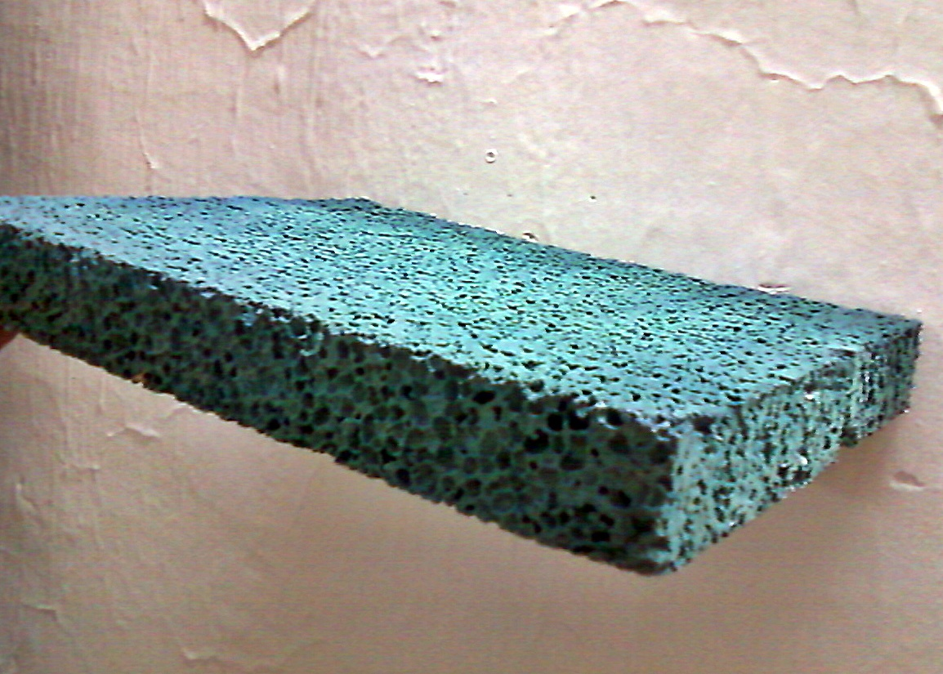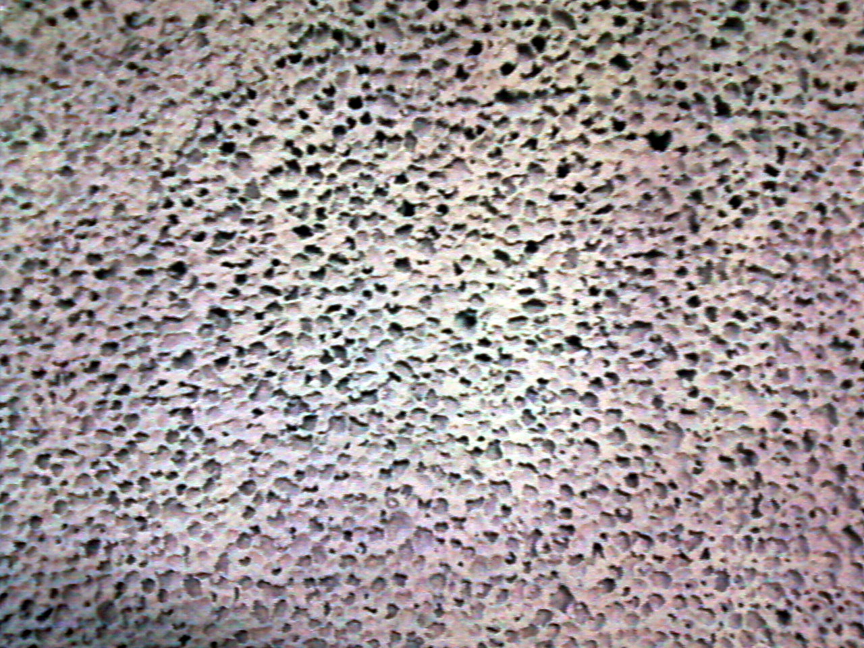

Fig. 8 Sample No 5

11. Sample 8. was prepared using plain aluminum foam sheet of density 0.35 gm/cc with alumina coating on one side. The process used was identical to the one used for preparing sample 7 above with the only difference being the curing time and the temperature range. The mixture of epoxy and the Alumina powder was allowed to cure at room temperature for 02 hours after application of a coat, 02 mm thick on the foam sheet and was thereafter baked in the furnace at a temperature of 200 deg C for 01 hour. The temperature was thereafter increased to 260 deg C and the furnace temperature was maintained for 01 hour. The sample was then removed and allowed to cool at room temperature until cold.
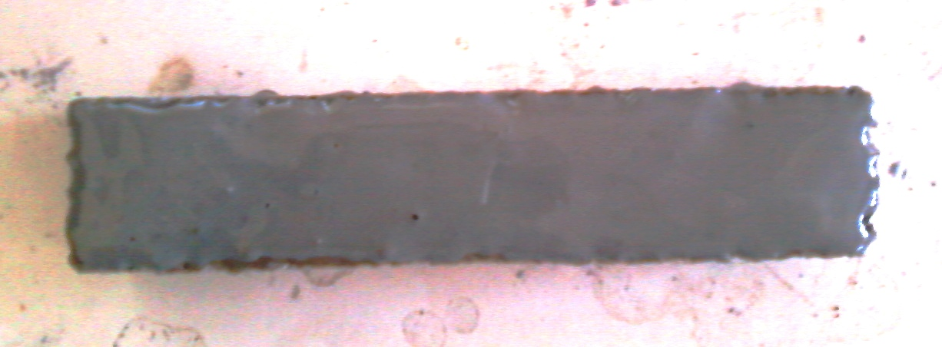

Fig. 9 Sample No 8

12. Sample 9 and 10. Sample 9 and 10 were prepared using a commercial source and the method employed was to spray alumina ceramic powder onto previously applied surface via a plasma spray gun. The plasma plume temperature while application was @ 7000 Deg C while the temperature of the foam sheet did not exceed 150 deg C during the time of application. The foam sample was thereafter cooled at room temperature for 24 hours.

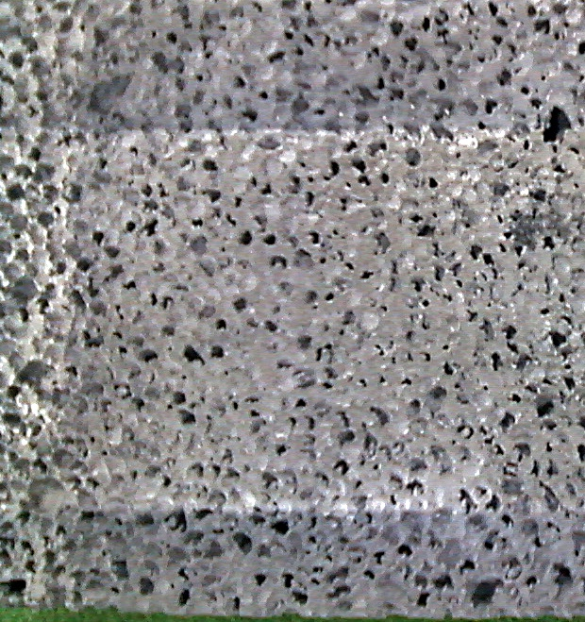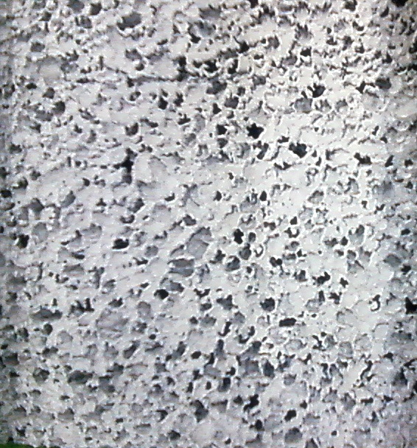
9
10

Fig. 10 Sample No 9 and 10

13. The apparatus used was a simple load cell bearing machine available at DIAT (DU). The readings of compression and load applied were recorded via the SSRT software available. The sample size was kept constant (24mmX25mmX25mm) throughout the experiment. Total of 04 samples of Hybrid Aluminum foam samples were subjected to the compression experiment to judge the shock absorbing capacity of the hybrid with different forms of lamination and coatings

Analysis of Hybrid Aluminum Foam Prepared from Foam of Density 0.35 Gm/CC using various methods of surface modification

14. A typical Stress Strain Curve for Al foam under compressive loading is shown in the figure 11.
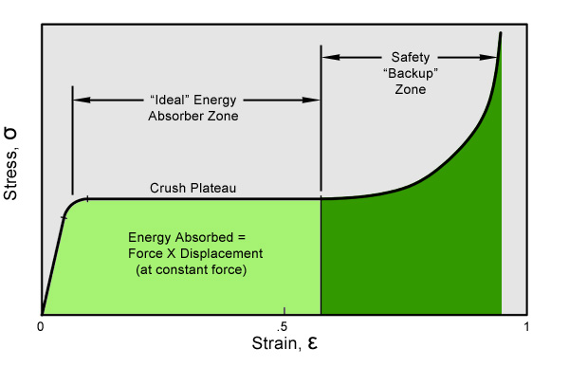
Fig. 11 Typical Stress Strain Curve for Al foam under compressive loading
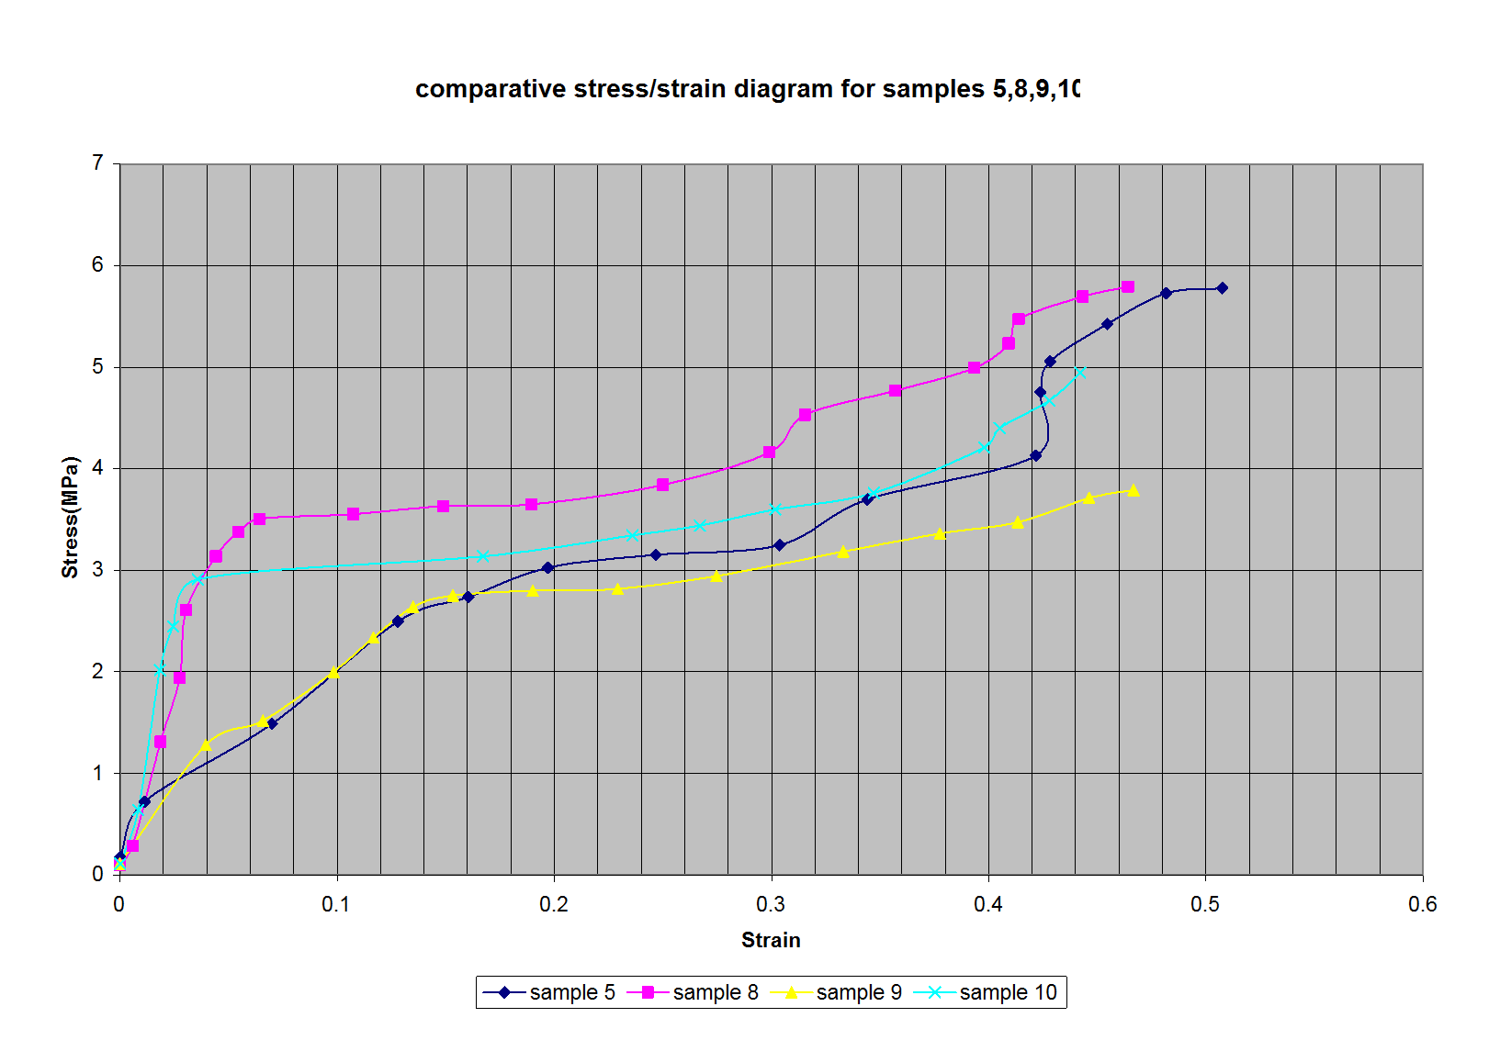
Ideal Energy Absorber Zone
Safety Backup Zone
Fig. 12 Comparative Stress vs Strain Curves for samples 5, 8, 9 &10

15. When a load is applied to a foam structure, it will initially yield elastically in accord with the Young‘s modulus equation discussed above. However, at approximately 4-6% of strain, depending on the sample size, the foam structure will begin to buckle and collapse continuously at a relatively constant stress. Depending upon the initial relative density of the foam, this constant collapse will proceed to approximately 50-70% of strain. At that point, the stress / strain curve will begin to rise as the compressed foam enters the "densification" phase [5] [6] [7]. Same mechanism was observed in the curves obtained below for sample nos 5, 8, 9 & 10. The hybrid foams studied were laminated with alumina based ceramics using oxyacetylene flame, Baking in furnace and also using plasma spray.. The curve obtained after the compressive deformation of sample 8 (Foam density 0.35 gm/cc, coated with Alumina ceramic coating in lab, baked in furnace) gave the best results for hybrid foams involving surface modification using lamination with Alumina based ceramic. It can be observed here that the curve under the energy absorber zone and the safety backup zone accounts for the total energy absorbed by the hybrid foam. It can be seen by the curve of sample 8 ( ) that the energy absorption capacity of the hybrid foam laminate produced in lab was of a higher degree than those of the samples prepared by other processes.

16. Conclusion. Al 5083 is the alloy currently being used in marine applications. While pure Al foam is established worldwide and is being used in structural applications, Al 5083 foam and its ship borne use have not been widely researched. The initial in house results on production of corrosion resistant Al 5083 foam have been encouraging. The successful characterization of Al with foam samples prepared in lab will be a way ahead in utilization of Al foam for ship borne applications. The surface modification carried out in house on Al foam sheet has been found to be encouraging with regards to the increased shock absorption properties of Al foam. The foam production method coupled with the surface modification process, carried out with corrosion resistant marine grade Al 5083 provides an excellent material for future use onboard warships and other military applications.

References

1. Michael F. Ashby, AG Evans, NA Fleck, LJ Gibson, JW Hutchinson and HNG Wadley & LU Tianjian, Metal foams: A design guide

2. Hai-jun YU, Guang-chun YAO and Yi-han LIU, School of Materials and Metallurgy, Northeastern University, Shenyang 110004, China, Tensile property of Al-Si closed-cell aluminum foam

3. ASTM G 69- Standard Test Method for Measurement of Corrosion Potentials of Aluminum Alloys.

4. Investigation on optimum corrosion protection potential of Al alloy in marine environment. By Seong-Jong-Kim, Seok-Ki-Jang, Jeong-Il Kim, Mokpo Maritime University, Mokpo city, Jeonnam, Republic of Korea.

5. Crushing of Closed cell al Foams-Density and strain rate effects by I W Hall, M Guden*, C J Yu**, Dept of Mech Engg, Univ of Delaware, Newark, *Izmir Yuksek Tekonoloji Enstitusu, Izmir, Turkey, **Fraunhofer Centre Delaware, 501 Wyoming Road, Newark

6. Compressive strength of aluminium foams by E. Kozaa,*, M. Leonowicza, S. Wojciechowskia, F. Simancikb Faculty of Materials Science and Engineering, Warsaw University of Technology, Woloska 141, 02-507 Warsaw, Poland b Institute of Materials and Machine Mechanics, Slovak Academy of Sciences, Poland

7. Effects Of Missing Cells On The Compressive Deformation Of The Closed-Cell Al Foam I. Jeon, Y. Yamada, T. Yamada, K. Katou, T. Sonoda and T. Asahina Materials Research Institute for Sustainable Development, National Institute of Advanced Industrial Science and Technology(AIST), Japan

Author is presently serving as Manager, Boiler Erection and Fabrication at Naval Dockyard (Mbi)
EFFICACY OF 3-D METAL PRINTING IN FLEET SHIPS

Cdr A K Pandey

Introduction

1. 3D printing, or Additive manufacturing (AM), is a process of making a three dimensional solid object of virtually any shape from a digital model. 3D printing is a manufacturing technology where a three dimensional object is created by laying down successive layers of material. It is also known as rapid prototyping. This technology was developed by Scott Crump in the late 1980s and was commercialized in 1990. However the first successful attempted 3D printing is credited to Charles Hull in mid 80s who developed a printer that fired a beam of UV light in to a bath of UV curable resin thereby printing a 3D tea cup. 3D printing is vastly different from traditional machining techniques, which mostly rely on the removal of material by methods such as cutting or drilling (subtractive processes).

2. The 3D printing technology is used for both prototyping and distributed manufacturing with applications in architecture, engineering, construction, industrial design, automotive, aerospace, military, engineering, civil engineering, dental and medical industries, biotechnology, human tissue replacement and many other fields. 3D printing can easily offset their capital costs by enabling consumers to avoid costs associated with purchasing common household objects.

3. The advent of 3D printing technology has had relevance to the Armed Forces across the world. This technology makes it possible to manufacture anything in just a few hours, a capability which can majorly enhance the fighting capabilities. A piece of equipment breaks but, instead of scrapping it or awaiting replacements from the base, soldiers can simply 3D-print the replacement part they need to get back in a matter of minutes, or hours. This would be especially handy in remote areas or in the open ocean where it's not so easy to keep an extensive inventory of spare parts.
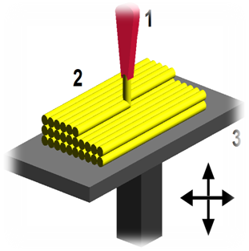 Fig. 1 3-D Printer
1 - Printer Head
2 - Material being laid down in layers
(Additive Manufacturing)
3 - Printer Bed Frame
Types of 3D Printing

4. Stereolithography (SLA). It is chemical based and relies on the combination of light sensitive chemicals and lasers. These chemicals are oriented in such a manner that when they're exposed to UV laser light they turn from liquid to solid. The 3D printers that use this method are designed to maneuver the UV laser across a thin surface of the chemical liquid in the design of the required object. As each layer solidifies, it is lowered and thinly submerged in the chemical liquid. The UV laser then creates another solid layer by moving across the liquid and so on until the final product is solidified and complete. The stereolithography method has proven to provide a very high level of detailing and finishing on the surface of the objects created.

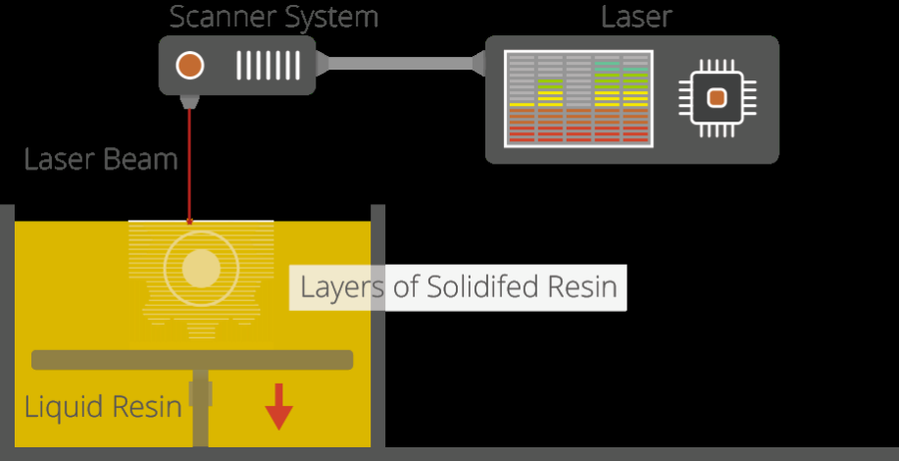

Fig. 2 SLA technique

5. Fused Deposition Modeling (FDM) This technique is based on the use of molten material that becomes solid as it's layered on to the print surface. As the molten material is injected from the printer head, it creates the successive layers of the 3D design. This process continues until the product is fully created. This technique also uses food-based molten material such as cheese and chocolate to create complex shaped food items. This is one of the most affordable types of 3D printers available in the market. These types of printers use ABS and PLA plastics as well as biodegradable polymers which are organic in nature.

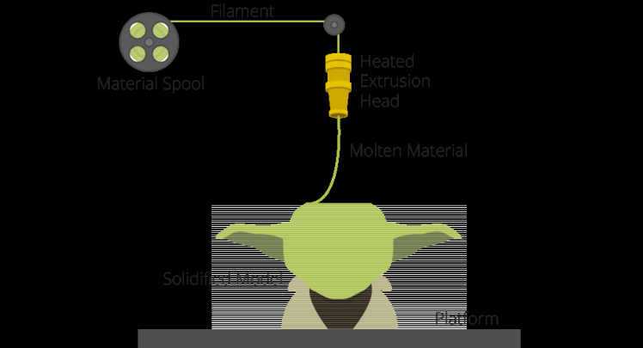

Fig. 3 FDM Technique

6. Selective Laser Sintering/Melting (SLS/SLM). This method uses powdered materials that are fused together using heat to achieve the desired 3D shape. This method is called 'Selective Laser Sintering/Melting' (SLS) or SLM and is actually a combination of traditional 3D printing and powered lasers, (instead of UV light). By augmenting the stereolithographic method, SLS replaces the chemical pool with powdered base material and the UV light with a powered laser. Combining both the methods makes it possible for SLS printers to use not only all plastics but also ceramics and metals to fabricate objects. The powdered material from these sources is easy to fuse using a laser and once the 3D printing project is completed, the surplus material is left available for reuse.

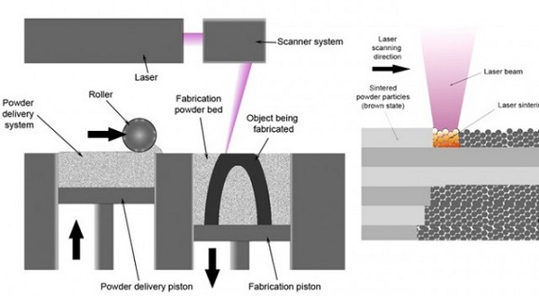
Fig. 4 Process of SLM

Implementing 3D Printing In Fleet Ships

7. A pilot project to explore the developments in 3D printing technology and to workout an implementable solution is being pursued under the aegis of Fleet HQ. As a first step in the direction, a visit to premises of M/s Bharat forge and M/s Renishaw in Pune was undertaken on 12 Jul 16 by Cdr A K Pandey, Engineer officer of the Ship. The details of the visit and its roadmap for practical implementation onboard for Fleet ships of Indian Navy would be enumerated in the succeeding Paragraphs

Visit to M/s Bharat Forge

8. Bharat forge has taken a big step in the future for of 3D printing technology at its research and development centre at Pune. The Additive manufacturing section of Bharat forge is located in the R&D section of Kalyani centre of Innovation and technology (KIAT) at Keshav nagar at Pune. The premise has all the metallurgical labs for metallographic analysis dealing in various Defence and PSU projects. The Additive Manufacturing (AM) section of KIAT has different types of 3D printing machines including equipment for post processing like sand blasting and polishing machines. The AM lab has a EOS M 290 machine based on SLM technique, which uses 400 W laser beam to melt the metallic powder for 3D printing. In addition a 3D scanner for generation of CAD model followed by slicing layout is available. The team of AM has qualified metallurgical post graduates.
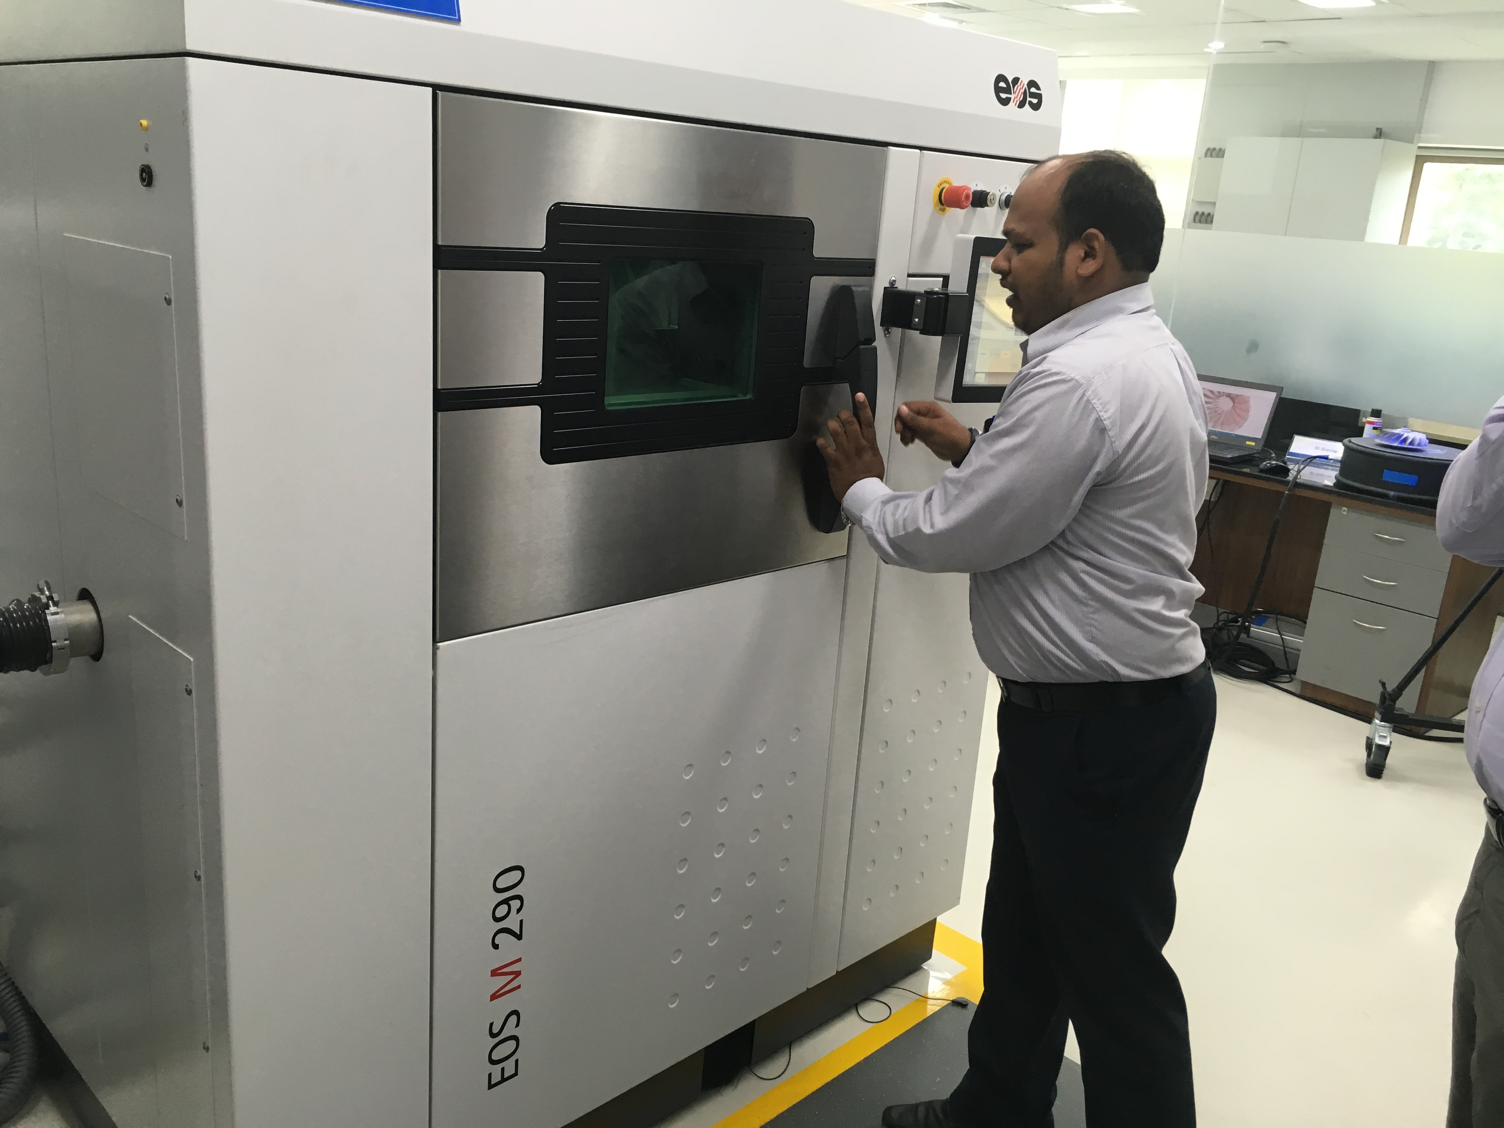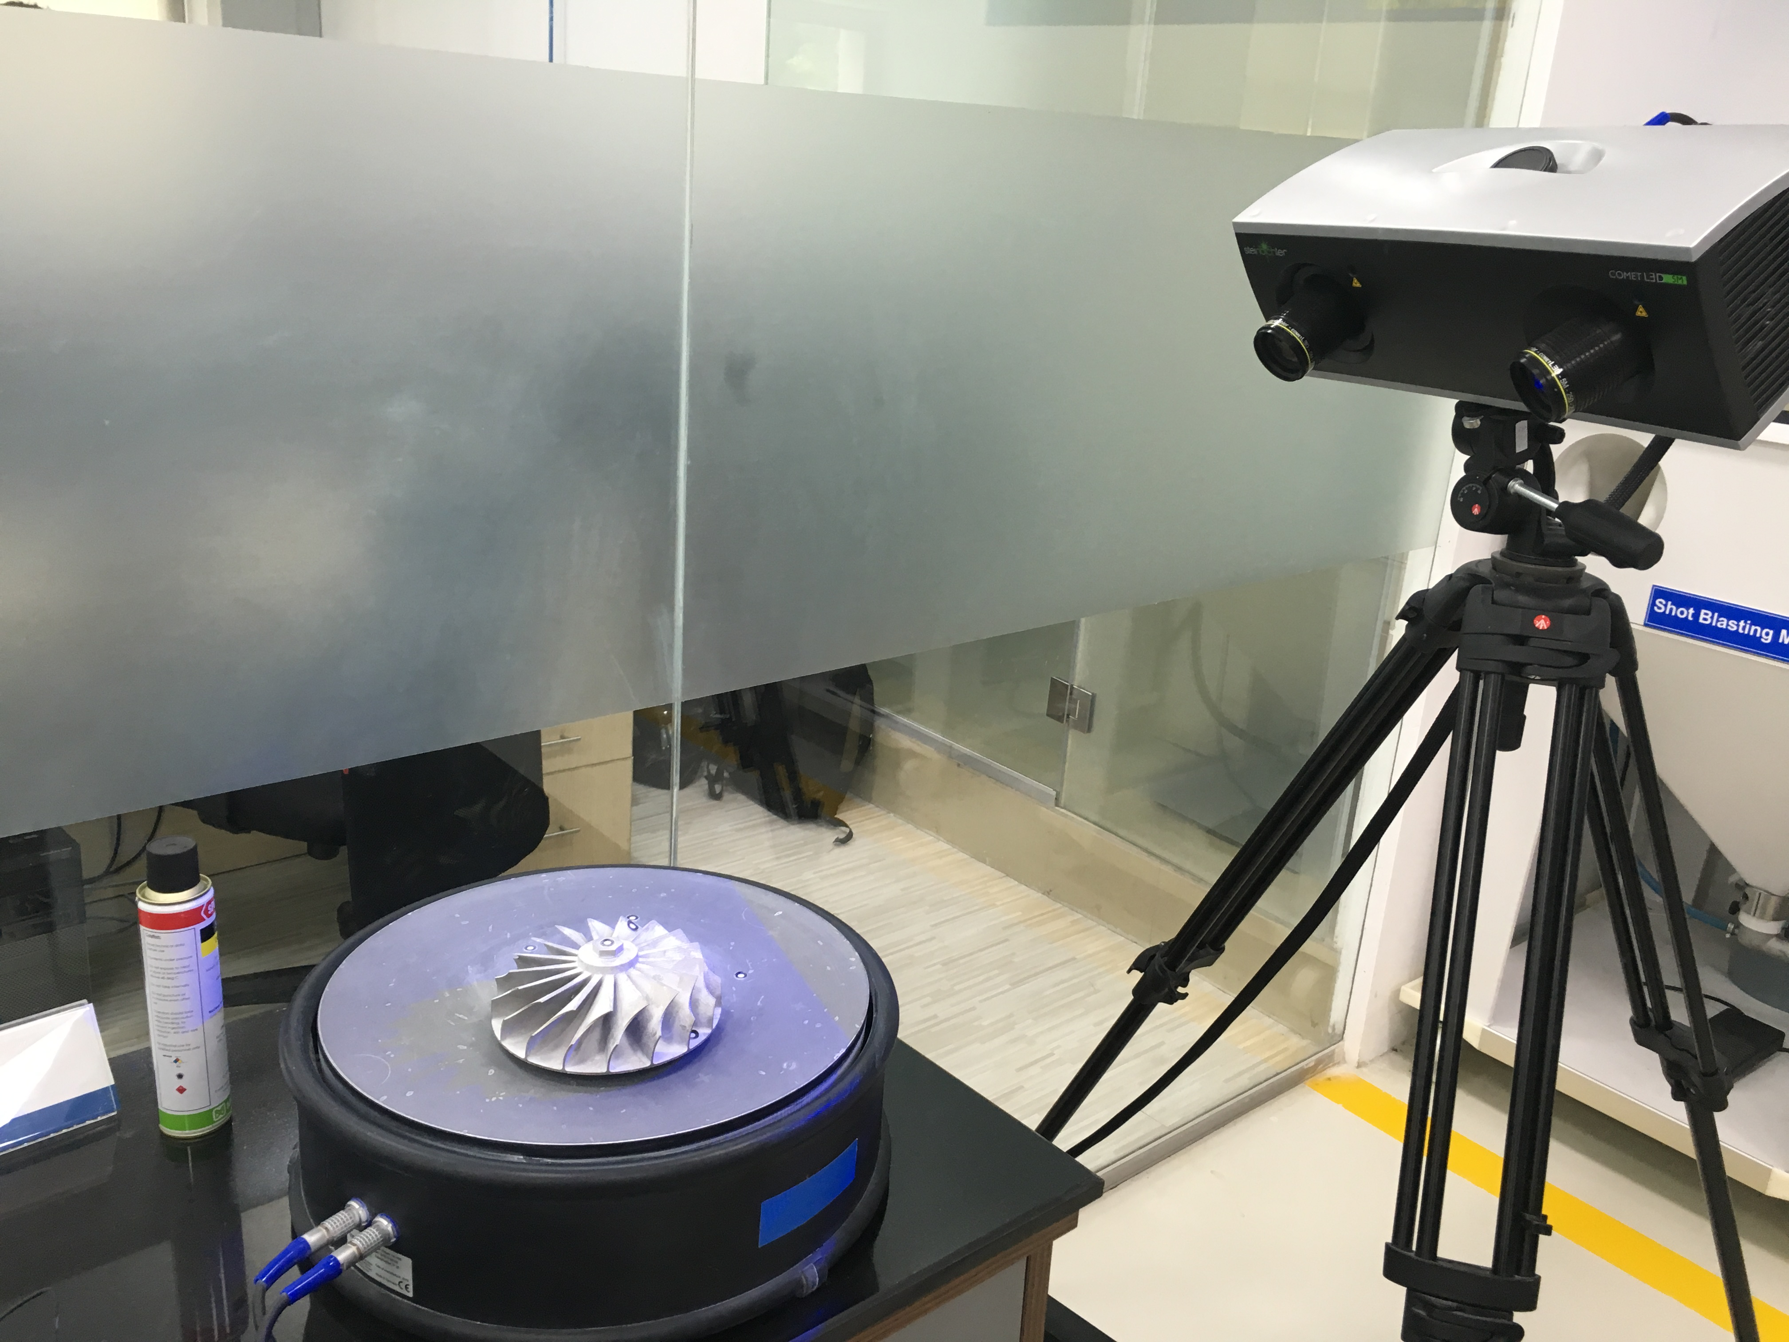

Fig. 5 3D Metal Printer Fig. 6 3D Scanning Machine

9. The process of 3D printing starts by making the CAD model of the object to be developed. The CAD drawings can be developed through 3 D scanning machine which has high resolution cameras that accurately maps the surface of the object and develops the CAD model. This process is followed by converting the CAD file to process file (STL format) using a slicing software. The slicing software basically defines the entire 3D manufacturing process by slicing the process step by step from 20 microns onwards. This file is then fed to the 3D printing machine along with the requisite metallic powder. The process is followed by post production polishing/finishing if required.
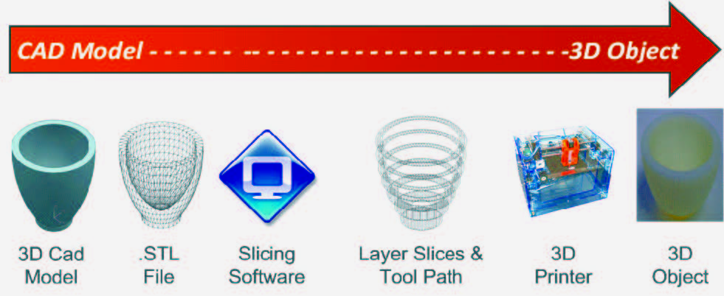

Fig. 7 Process of 3D printing

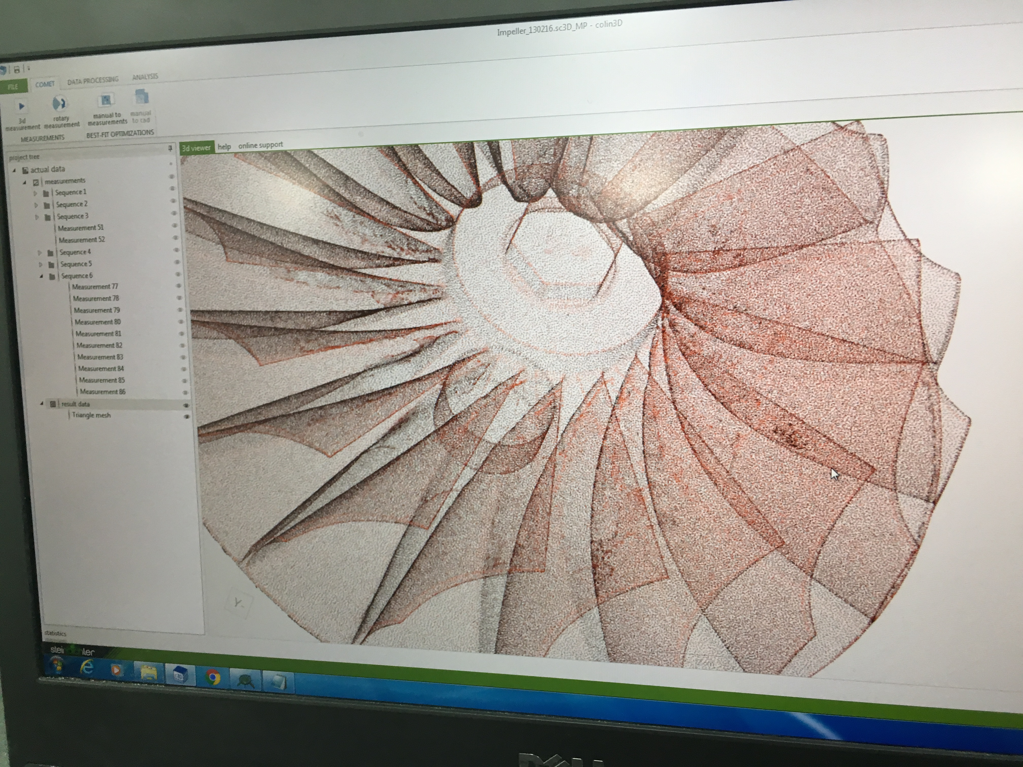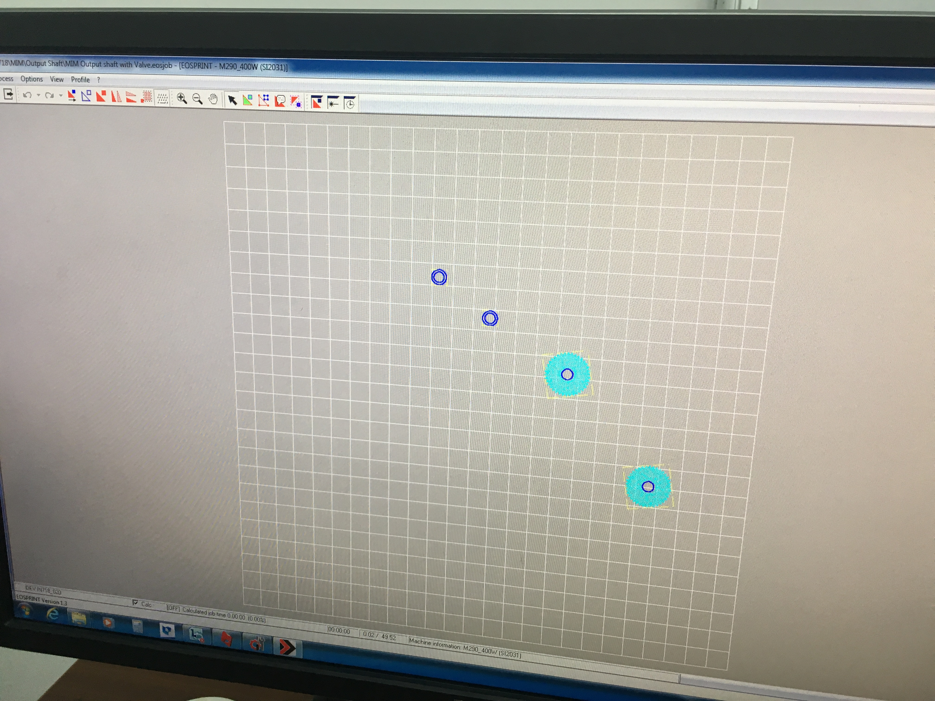

Fig. 8 CAD model from 3D scanner Fig. 9 Production format through slicing software

10. The entire process from scratch to development can be finished within 24 - 60 hours depending upon the availability of CAD drawings, time taken for CAD scanning and development material based on dimensions. The various development items made by Bharat forge are as shown:-

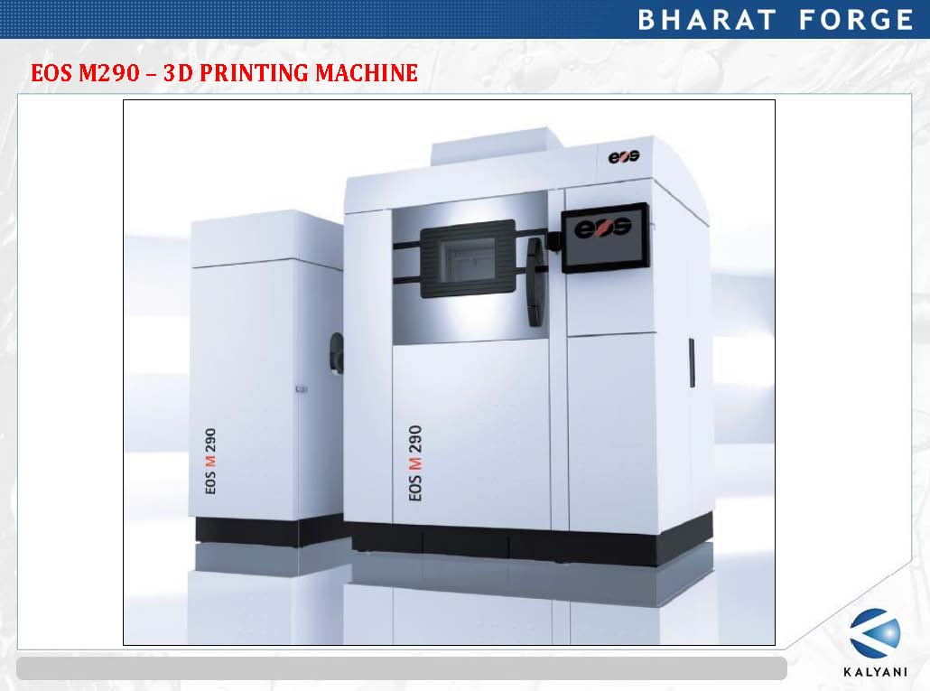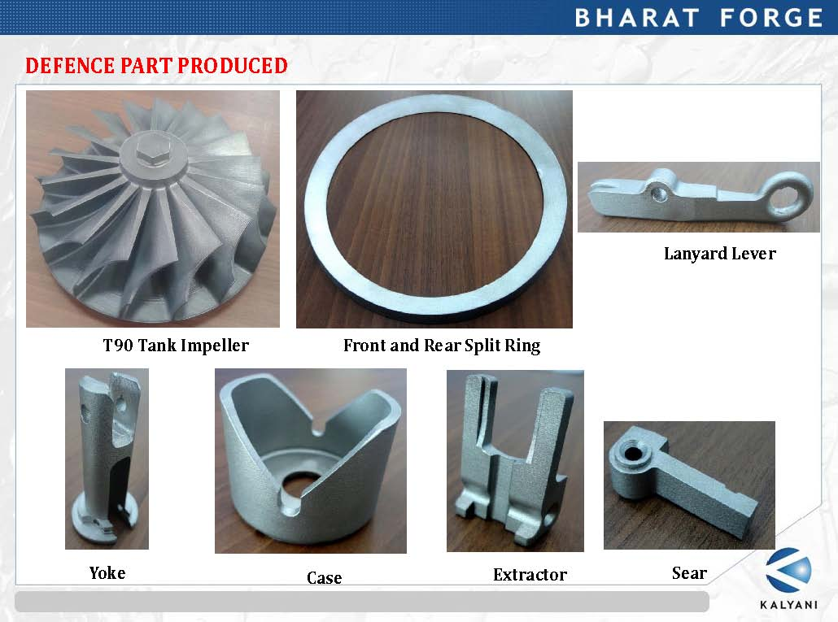

Fig. 10 3D printing machine at Bharat forge and Items developed
for Defence

Visit to M/s RENISHAW,Pune

11. M/s Renishaw is UK based MNC involved in manufacturing of precision based meteorology and engineering equipment’s. They are worldwide no 1 manufacturers of precision based CMM machines. They are manufacturers of additive manufacturing machines for metallic 3D printing based on SLM techniques. Being the OEM, they have developed the processing software for their development process. The premises is located at Hinjewadi Pune. The two variant of machines developed by the firm are AM 250 and AM 500 and both are working on the principle of SLM based 3D printing.
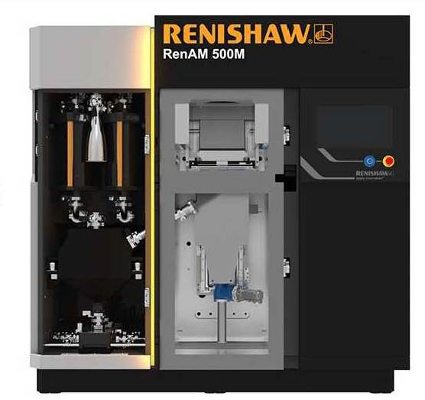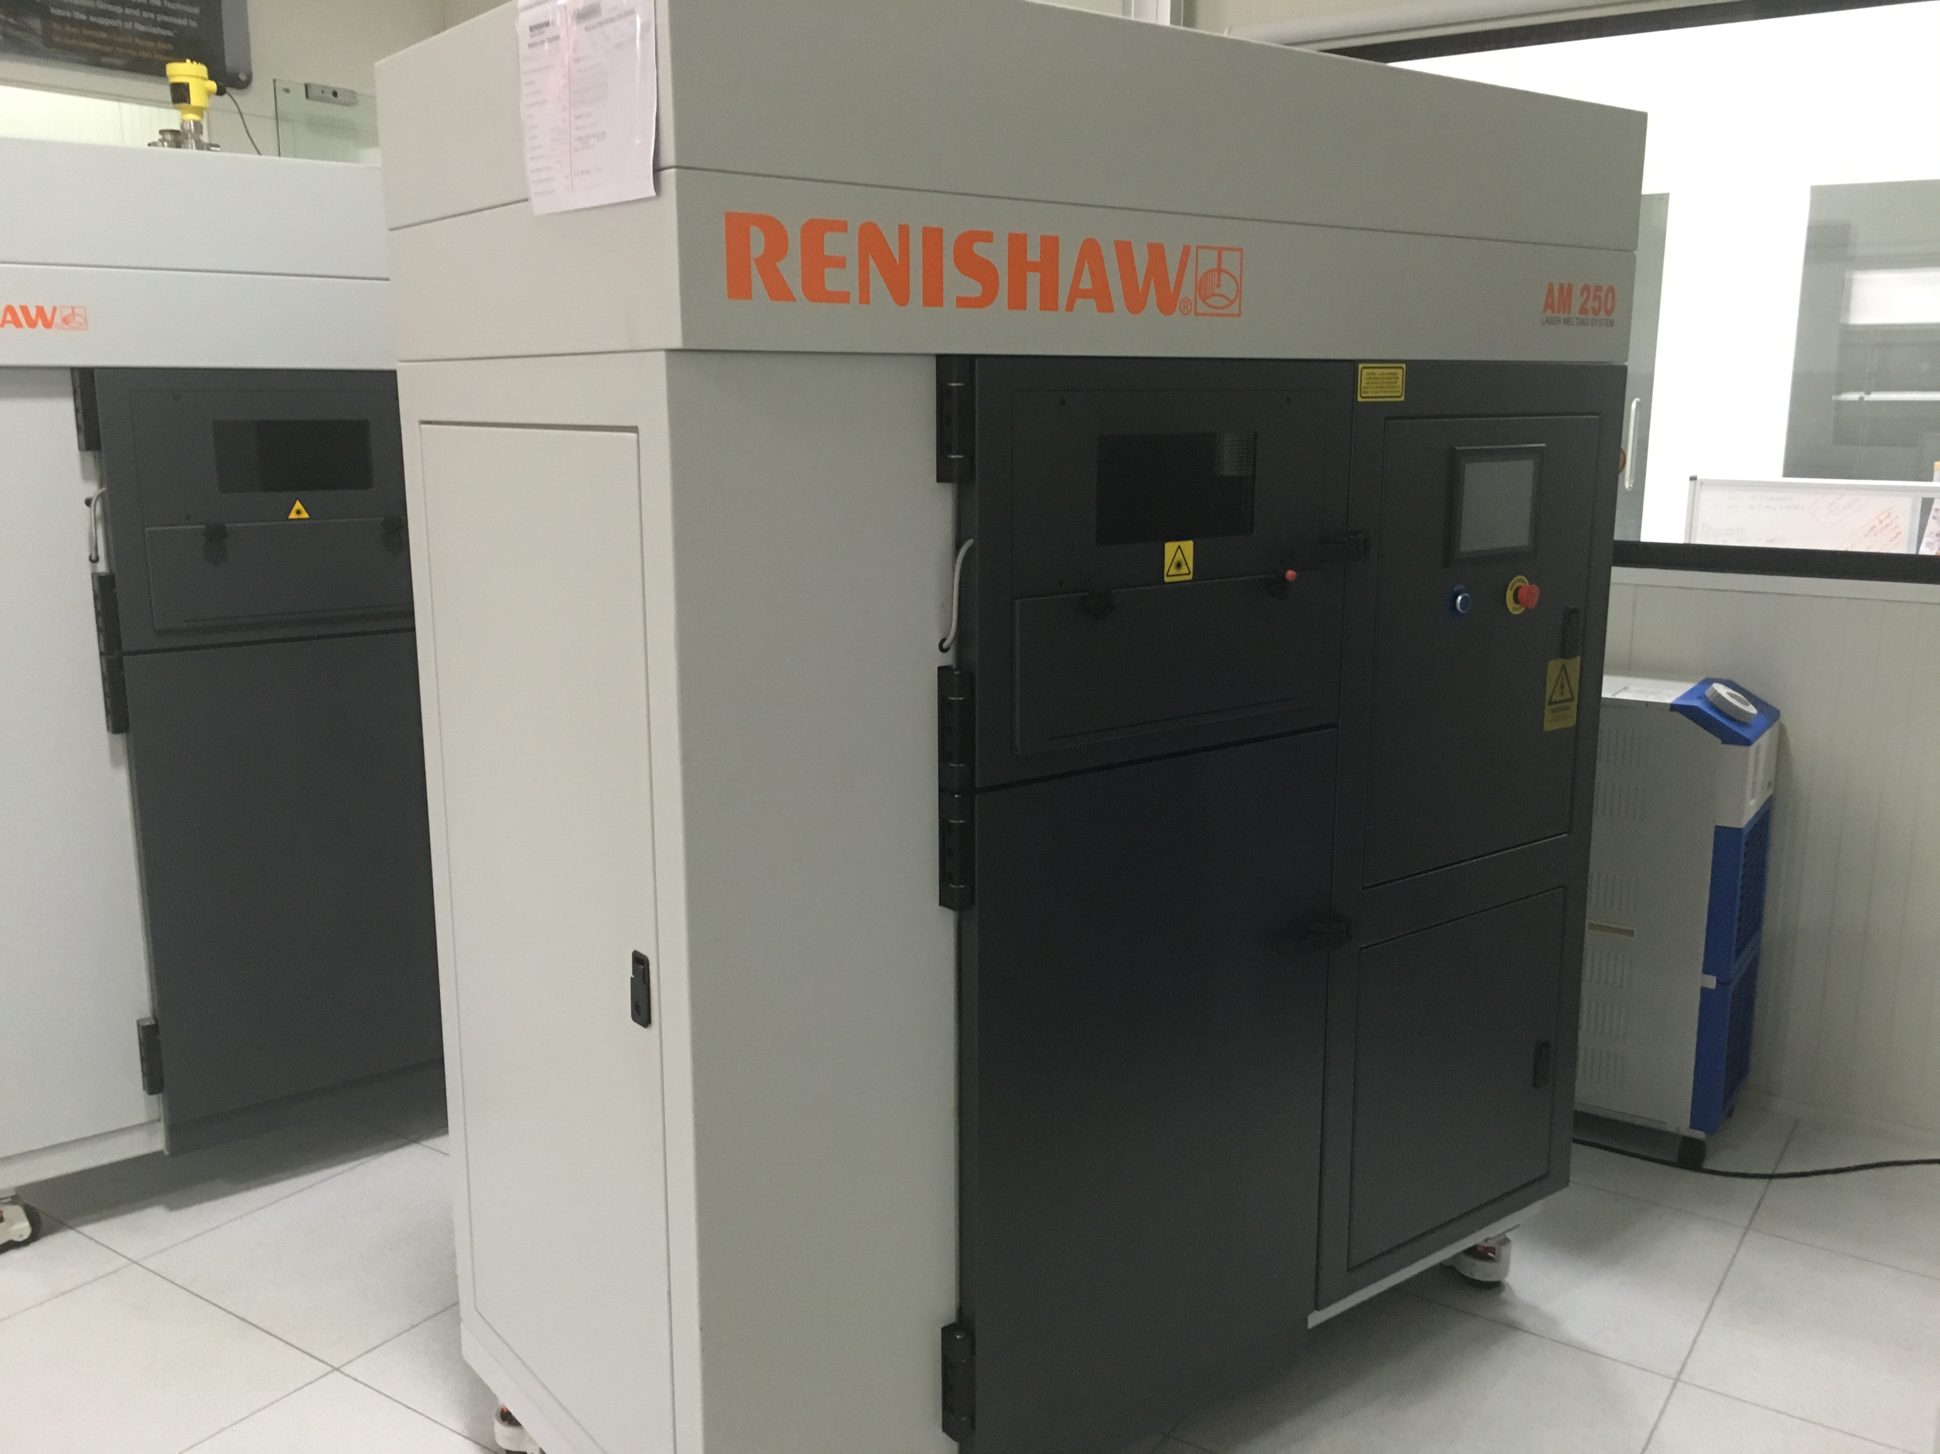

Fig. 11 AM Machine 500 and AM 250 Machine developed by M/s Renishaw

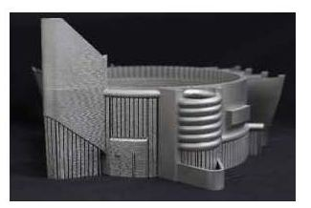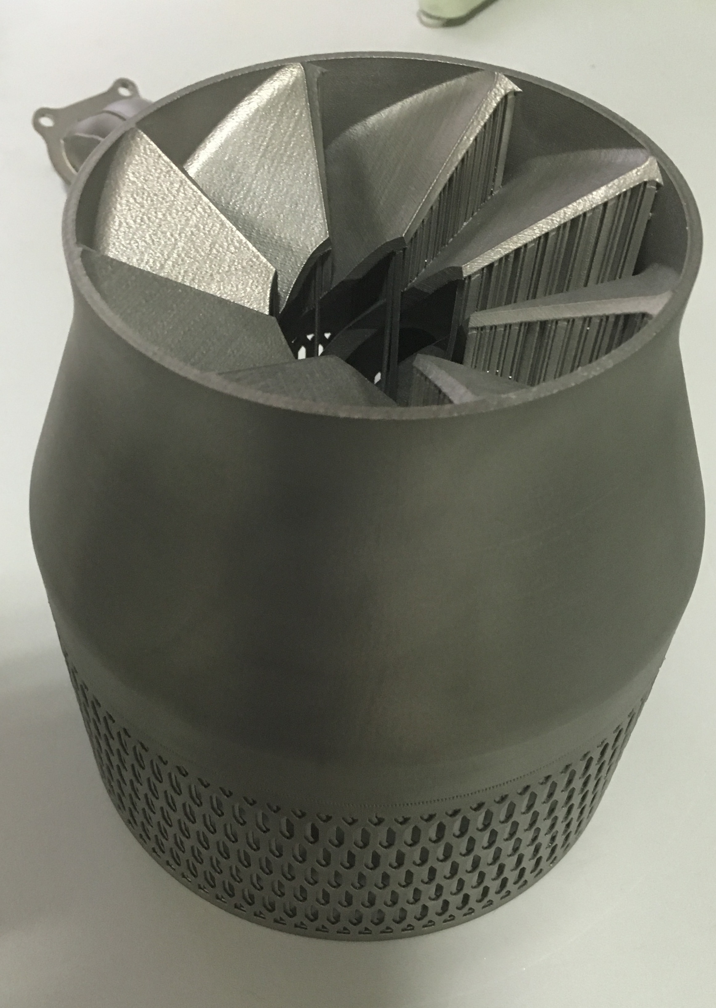

Fig. 12 Complex items developed by Renishaw for Aerospace industry

12. Capability assessment. Both the firms have been found to be capable to undertake development of 3 D metal printing for IN requirements. The size of the development depends upon the build volume of the machine which is currently available upto 250mm(X) * 250mm(Y) * 300mm (Z). However, bigger size machines are being sourced for future developments. The additives used in the machines are metal powders. The type of powders currently available for usage on SLM machines are Stainless steel, titanium , Inconel, Aluminium and cobalt chrome. The modalities for development of sample models in the initial stages for capability assessment of the firm was discussed with the firms and both the firm have confirmed to develop the initial sample items on NC-NC basis. In addition the firms have requested for visit to Naval Dockyard for interaction and presentation to the IN team.

Adaptation Of 3D Printing by Armed Forces Across The Globe

13. Adaptation of 3D printing across the Globe. 3D printing has taken over the entire production sector by a storm. Armed forces across the world including US, China and UK have adapted 3D printing with US having used 3D printing onboard USS Truman recently. The details regarding usage of 3 D printing by armed forces is elaborated in subsequent paragraphs:-.

- United States. The US military is undoubtedly at the forefront of adapting 3D printing in its numerous military programs. US army and airforce are already utilizing the usage of 3 D printing in Afghanistan. Recently US Navy installed and effectively utilized metal 3 D printers onboard aircraft carrier USS Harry S Truman and amphibious vessel USS Kearsrage and USS Essex. US Navy has already started manufacturing certain critical components onboard. To raise the awareness, events like “Print the fleet” are being organized by US Navy.

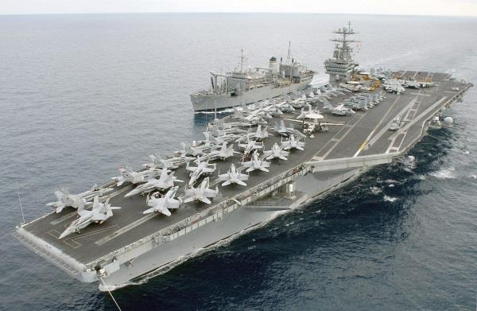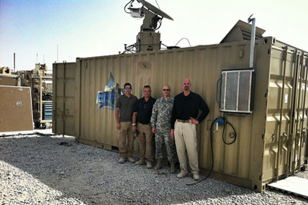

Fig.13 3D Printing on USS Fig.14 3D Printers in use in Army
Harry S Truman

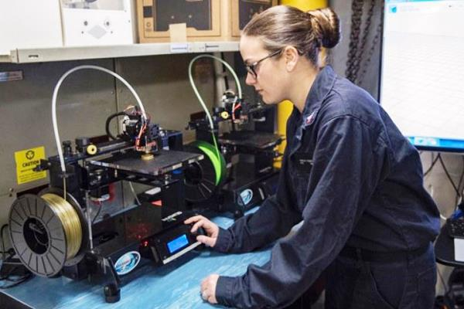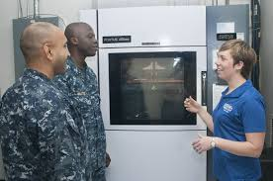

Fig. 15 Metal 3D printers onboard in US Navy

(b) Royal Air Force and Navy, UK. The British Royal Navy has recently in Apr 16 launched a 3D printed UAV from HMS Protector to help the ice patrol ship to navigate through antarctica The British Royal Air Force’s Tornado fighter jets have performed their first flights with some onboard metal parts manufactured using revolutionary 3D printing technology used by defense firm BAE Systems. A lot of ground support equipment have been 3D printed at RAF Marham which are saving the RAF time and money when it comes to repairs, maintenance and support of the Tornado aircraft. Just one part alone, a protective cover for the Tornado cockpit radio is made in a day for less than £100, meaning savings to date of £300,000 and a projected 4-year reduction in manufacturing costs of £1.2 million. Furthermore, they have printed one of the largest components pertaining to airframe, a large titanium spar section measuring 1.2m in length, demonstrating how this cutting edge manufacturing technique can be used to produce large structural components for aircraft in the future
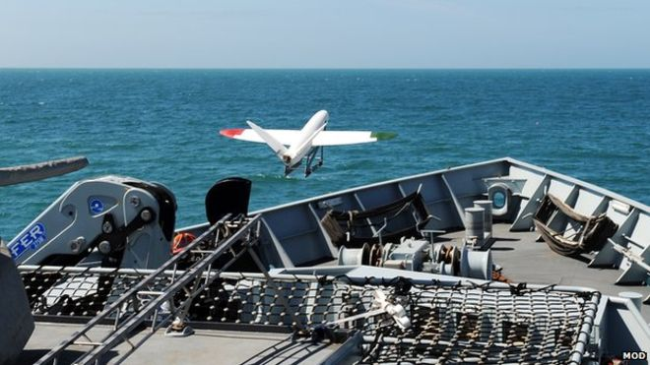

Fig. 16 3D printed UAV launched from HMS Protector

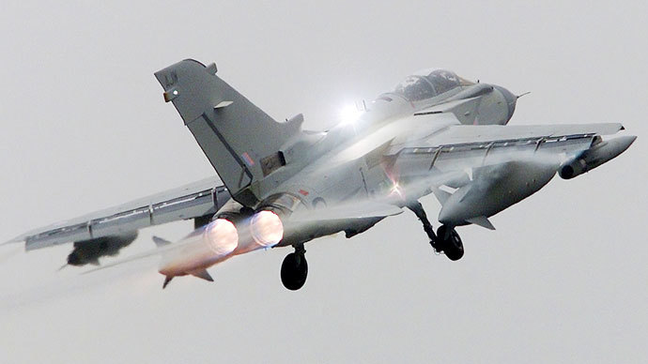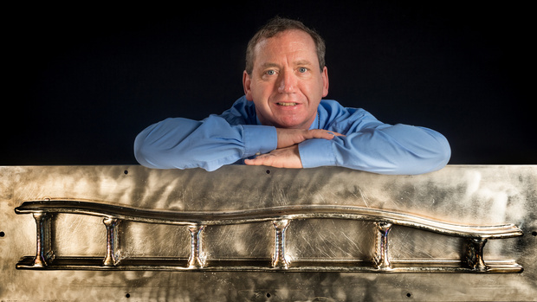

Fig. 17 RAF Jet using 3D printed Fig 18. Long titanium spar parts section

(c) China. The J-25 produced by the Chengdu Aviation Corporation, reportedly uses 3D printing for several key parts, leading to a lighter weight, while remaining extremely durable and strong and is tipped to be superior to the F-22 Raptor of the USAF. The J-25 is reportedly faster, and has greater undetectability than that of the United States fighter. It has the ability to hide from enemy radar, while remaining extremely agile to maneuver, can also reportedly be credited, at least in part, to 3D printing. The aircraft weighs approximately 20 tons, and it is said that additive manufacturing was used to make at least part of the fuselage

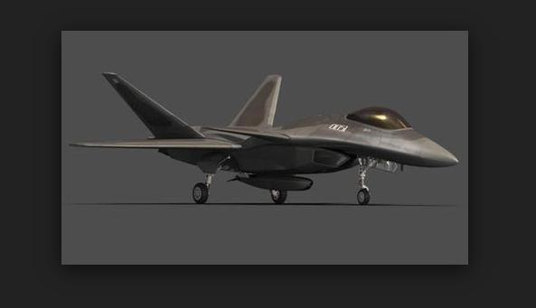

Fig. 19 J 25 Raptor

Proposed Way ahead for Adaptation in Indian Navy

14. Indian Navy’s core rationale for undertaking any exploratory research in a ‘niche’ area is essentially driven by the needs of user to meet rather than a desire to assimilate friendly technologies, which is routed through DRDO to obviate duplication of effort. 3-D printing technology for Navies the world over, have their applicability to print spares on demand, which seeks to overcome typical constraints imposed by non standard OEM / spare base of differently abled sea going units. Given the context, the adaptation of this technology has relevance to immediate support agencies of the Fleet viz the FMU, Naval dockyard, logistics supply ships to consolidate and augment a comprehensive supportability, paradigm for Blue water Navy and sustained maritime operations.

15. The initiation towards 3D printing is not a new subject as keen interest has been seen amongst professional directorates. There have been certain developments in the field of 3D printing in the Indian Navy, mostly in the form model/trinket generation machines used for plastic prototyping. Time is ripe to concretize it as a roadmap of reference. The proposed road map for the Western Fleet is as follows:-

- Development of certain components of auxiliary machineries like fasteners, pump impellers, valve plates, hydraulic control blocks and valve discs through firms like M/s Bharat forge or M/s Renishaw on experimental basis. During the visit both the firms have agreed to develop the items on NC-NC basis. M/s Renishaw reps have collected few samples of pump impeller, valve discs and fasteners for feasibility assessment and prototyping. M/s Bharat forge is likely to visit shortly for sample collection and prototyping.

- Trials of these items manufactured through 3 D technology on the equipment to establish the reliability of component.

- Initiate the case for procurement of one or two metal 3 D printing machine for Fleet maintenance Units (FMU) with OEM assistance and training for designing of components and operation of these machines.

- Once the usage, operation and maintenance of these machines have been established, subsequently these machines can be installed onboard Aircraft carrier and Fleet tankers for providing fleet support at sea.

- Include the availability of 3D printing facility for fleet support during the procurement of Amphibious vessels.

Author is presently serving as Engineer Officer, INS Deepak

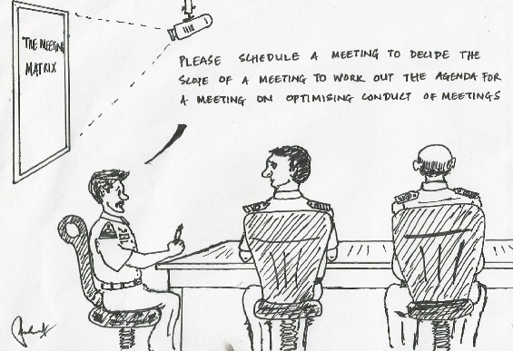
INNOVATIVE MEASURES TO ENHANCE RELIABILITY OF SHIP’S BOATS

Lt Cdr MSN Murthy

1. Introduction. A ship is known by her boats says an old adage. The proficiency of engineering department gets gauged when it comes to ship’s boats. Ship’s boats are extensively used for VBSS, SAR and other emergency operations, requiring high state of preparedness at all times. High reliability and continuous availability of the ship’s boats is a critical operational requirement of IN ships. However, reliable exploitation of ship’s boats is still a grey area. This article discusses few common challenges faced in ensuring high state of preparedness of boats, innovative measures to circumvent the same and recommended way ahead for exploitation of boats.

2. Challenges in Exploitation of Ship’s Boats. Delhi class of ships are provided with two 6.5m Rigid Inflatable Boats (RIBs) with either Volvo Penta engine of Model D3 160 along with DuoProp stern drive, or with MerCruiser engine of Model D4.2L D-Tronic along with Bravo stern drive. The same is apparently the case with boats of other ships barring few exceptions like Teg class which are provided with boats with water jet propulsion. Exploitation pattern of these boats onboard ships demand starting of the boat on chocks to keep them alive and running of the boat just before touching the water level during lowering of the boat at sea. Following are the main challenges involved:-

(a) When the boat is hoisted from sea onto chocks, the sea water of the engine is drained out. Cranking of boat engine on chocks without cooling water leads to dry running of rubber impeller of sea water pump resulting in overheating and cracking of rubber fins followed by failure of sea water pump, which further leads to failure of engine.

(b) Lack of opportunity to lower the boat due to ship/ jetty alongside resulting in inability to undertake periodic performance checks and keep alive.

3. Common Defects/ Problem Areas. The present day ship’s boats are marred by following recurring defects of which most of them have their origin from the challenges faced in exploiting them as mentioned above:-

(a) Sea Water Pump Failure. The sea water pump is made up of rubber impeller as shown in figure 1 below. It is prohibited to run the pump dry as per OEM manuals. Dry cranking of the engine may lead to premature failure of sea water pump as discussed in para 2(a) above. During the gradual wear down of the pump, due to dry running, the sea water flow rate gets reduced initially and subsequent failure of the pump becomes imminent. The sea water strainer caters for maintaining some water level in it even after hoisting of the boat from sea. However, once dry cranked the sea water pump is again starved of water, rendering it prone to dry running.
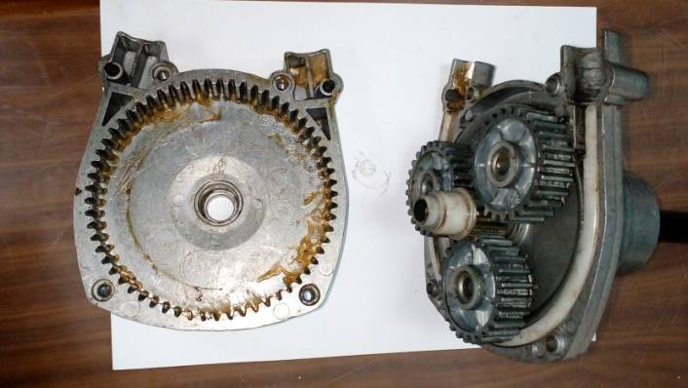
Internal threading for push/ pull cable
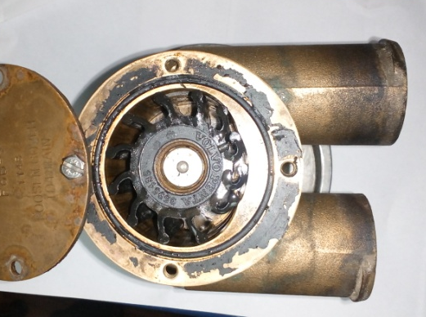
Rubber impeller

Fig. 1 Sea Water Pump Fig. 2 Steering Hub of Boat

(b) Steering Hub Failure. The steering system of the boats is hydraulically powered with engine driven steering pump providing hydraulic pressure. In absence of hydraulic power from steering pump, the steering of the boat is available manually albeit hard to turn. The steering hub as shown in figure 2 is typically made of aluminium body provided with female screw passage through which male screw at the end of pull/ push cable is attached .In the absence/ reduction of hydraulic power, due to improper maintenance of steering system or failure of steering pump, the steering hub is subjected to over loading. The steering hub under excessive load due to manual power, slips on the pull/ push cable screw and fails to transmit torque from the steering wheel and eventually results in failure of steering system.

(c) Maintenance Envelope. The boats are often prone to poor maintenance due to very narrow maintenance envelope in the engine enclosure. The requirement of better maintenance envelope is further apparent when it comes to undertaking repairs which otherwise are unwarranted. Undertaking leaks rectification, replacement of starter motor, renewal of engine lub oil are some of the activities that require better maintenance envelope.

(d) Engine Controls. Engine controls comprise three main components; harness of wires, Electronic Control Unit (ECU) and Helm Interface Unit (HIU) apart from the sensors, actuators and display. The harness is a bunch of wires and connectors that connect all the sensors and fuel injectors to ECU and HIU. The ECU controls the Common Rail Direct Injection (CRDI) type fuel system with inbuilt codes for firing order and safeties of the engine. HIU integrates the engine, ECU and helm display and control units. The entire control system is designed to be close ended with no provision for accessing the logic cards. This entails replacement of any defective control component entirely. Identification of a defective control component requires special OEM diagnostic tools, which increases dependency on OEM reps. Documentation available with SS on engine controls is also insufficient to handle such defects.

(e) Dependency on OEM/ RRC. The functioning of the core engine is per se reliable. However, defects on engine’s auxiliaries and control system even if minor become difficult to rectify due to non availability of either spares or expertise. Dependency on OEM/ RRC is therefore high when it comes to boats. The competency of the reps of RRC may also be challenged leaving the boats susceptible for further damage and impending defects during the process of DI/DR on boats due to inherent sensitive design.

(f) Scarcity and Cost of Spares. Spares of the boats are generally available with very long lead time. Since all the parts are specific to OEM design and no replacement items exist as off the shelf items in local market. Thus procurement of imported items through local agencies takes a long lead time. The cost of spares of these boats is also found to be exorbitant when compared to the items of similar specifications.

4. Innovations. Two most recurring defects/ problem areas have been addressed successfully through in-house innovations. Detailed description of these innovations is as follows:-

(a) On Chock Starting. To facilitate routine starting and performance checks of the boat on its chocks, an adaptor has been designed, manufactured and integrated to the boat’s sea water system through in house efforts. The adaptor as shown in figure 3 has been provided with a male coupling similar to standard fire hydrant at one end followed by a shut off valve. The other end has been fitted to a T-pipe using a flexible hose. The T-pipe has been inserted into the existing sea water system durite pipe before suction strainer. The adaptor has been rigidly mounted on to the wooden wall of the boat. Whenever the boat would be required to be started on chocks, a fire main hose would be connected from nearest fire hydrant to the adaptor to provide sea water flow to the boat engine sea water pump. To avoid high pressure from the firemain into the boat sea water system, the flow would be regulated through the shut off valve and further the sea water would be let to leak through the out board stern drive. This innovative boat adaptor has been successfully used for on chock starting of the boat thereby facilitating routine starting of the boat as a keep alive policy. This feature has reduced the dependency on lowering the boat for routine maintenance works and has enhanced reliability of the boat.
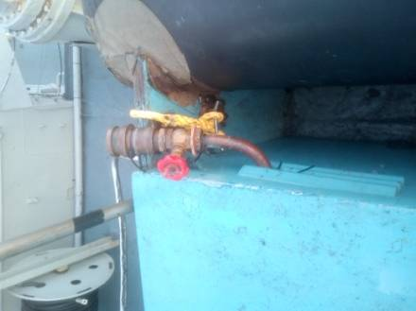
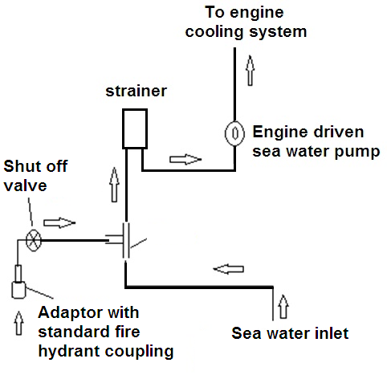
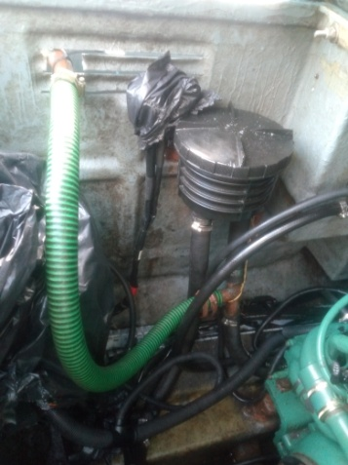

Fig. 3 On-Chock Starting System

(b) Modified Steering System. As discussed in para 3(b) above, the steering system is prone to frequent break down/ unreliable operation due to the steering hub failure. The existing steering system with steering wheel, hub, pull/ push cables and actuator is replaced with a new steering wheel with attached pump, hydraulic pipe lines and hydraulic actuator along with a fixture to adapt with earlier frame. Steering is achieved through the closed loop steering system without dependency on the engine for additional hydraulic power. This innovation as shown in figure 4 was undertaken without affecting the existing system on a trial basis, such that the previous steering system could be restored to by merely replacing components. The mechanical advantage achieved in the steering system between steering wheel and its attached hydraulic pump in this modification, mitigates the need for additional hydraulic power unit. Trials on this boat steering system has been found to be satisfactory both on chocks and at sea.

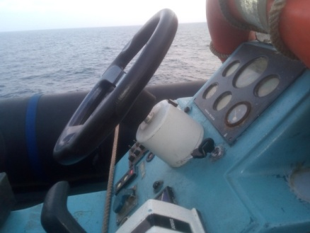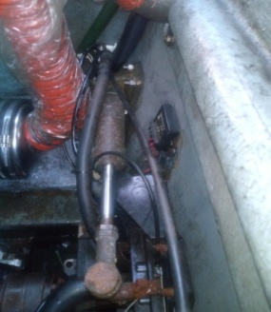
Steering Wheel with inbuilt hydraulic pump
Hydraulic actuator mounted on adaptable fixture

Fig. 4 Modified Steering System with Hydraulic Actuator

5. Recommendations. Recommendations to ensure reliable exploitation of the existing boats as well as new induction boats are as follows:-

- Dry running of the boat on chocks is to be strictly avoided, as this is identified as the root cause for many defects on the boat.

- Alternate arrangements for running the boat on chock are to be made such that reliability of exploitation of the boats can be ascertained before lowering the boats in high seas.

(c) Hydraulic power steering system is to be maintained functional. A non- functional hydraulic power system deteriorates the engine driven steering pump further, and results in overloading of steering hub followed by sluggish response /failure of steering system.

(d) Custom made water proof covers need to be provided with boats to avoid rain water ingress. Drain hoses in the stern are to left open, to drain any water accumulation on the boat, else the water level would rise and may fill up the engine enclosure. Non adherence to the above has resulted in partial/ full submerging of boat engines in the past.

- Water jet propelled boats may be considered as a future option for ships, as its design gives more flexibility for maintenance and repairs.

- Indigenous design of boat hull incorporating on-chock running feature, with better maintenance envelope would result in higher reliability of boats and reduce dependency on foreign OEM and spares.

6. Conclusion. Sustainable innovations in the existing boats to mitigate deficiencies will go a long way in ensuring reliable exploitation of ships boats. After all, a Navy is known by its Ships and a Ship is known by her boats.

Author is presently serving as Senior Engineer Officer onboard
INS Mumbai
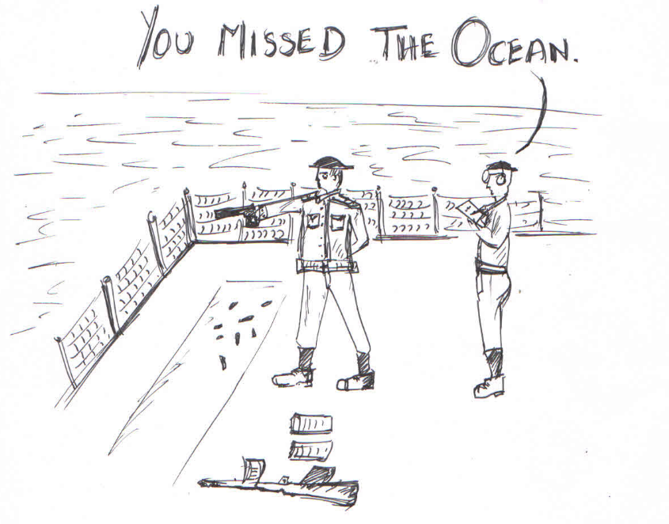
FIRING PRACTICE AT SEA

INNOVATIVE REPAIRS OF RO PLANTS AT SEA

Lt Sahil Kanwar

1. Introduction. Teg Class ships are fitted with two nos RO plants of make M/s Rochem GMBH, Germany, type RO 1530 DT-06 30 S. Both the RO plants are located in Auxiliary Machinery Room (AMR).

2. Defect Description. During an important operational deployment, while putting RO plant in operation, lamp buttons 2, 4 and 5 illuminated and the plant was tripping. The possible causes for the defect were as follows:-

Lamp Signal  1 2 3 4 5 | Device | Meaning | Possible Causes
○ ○  | PT160 | Over pressure in DT module | - PT160 does not stop pressure rise  - VS160 does not open  - Relay output to VS160 defective  - Set value at PT160 wrong  - PT 160 damaged  - Connection to processor defective

3. Detailed checks were carried out by SS and all six possible causes indicated by the OEM manual were ruled out. The OEM when contacted indicated that under these circumstances, the PLC is considered defective. During further investigations, the PLC fault lamp also illuminated which confirmed the fault in PLC.
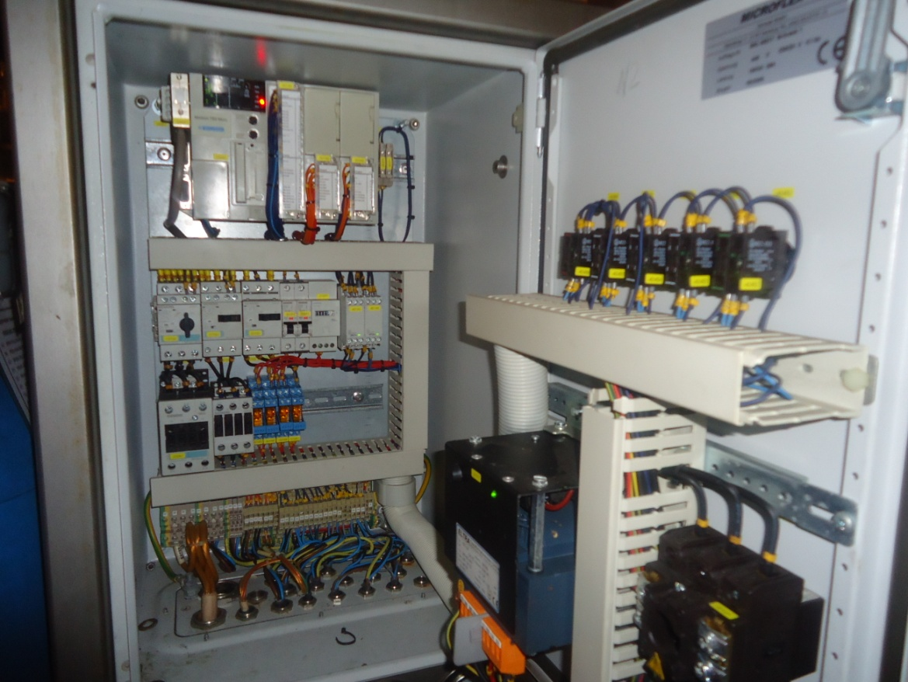 | 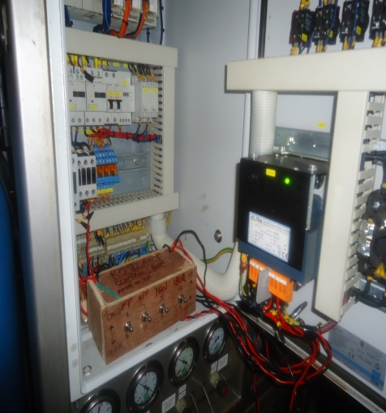
Fig. 1 Local Control Post indicating a fault in the PLC | Fig. 2 Control Panel for operation in Manual Mode
4. Discussions With OEM. OEM M/s Rochem, India was contacted for availability of PLC cards/ repair of the same however the OEM indicated that the RO plants fitted onboard Teg class ships have been manufactured and supplied by Rochem, Germany and Rochem, India does not have all the details required for repairs of PLC. Although the plants of both Teg and Talwar class are similar, control system / spares are not compatible. Further PLC cards have been manufactured and supplied by sub contractor of Rochem, Germany and logic uploaded by OEM and hence most of the cards are out of production and are not available in open market.

5. Criticality of Defect. In the absence of spare PLC, DR on the plant was considered necessary as other RO plant was operating with reduced output due to reduction in sea water temperature (15/17 ⁰C) and ship was to sustain for remaining part of the deployment (almost 40 days). Discussions were also undertaken with OEM rep for feasibility of manual operation of the RO plant and it was confirmed that these plants can be operated in manual mode in extreme emergencies.

6. Manual Starting of RO plant. Electrical connection diagram for manual operation of RO plant was obtained from M/s Rochem, India and connection were made accordingly. A small wooden box was fabricated to house the electrical connections and switches to avoid shorting and to ensure personnel safety. Logic was developed for manual operation of the plant based on sequence of auto operation.

7. Sequence for Electrical Connections. Step wise sequence for electrical wiring is as enumerated below.

(a) Ensure that Main power supply to plant is switched off.

(b) Connect a wire in 230 VAC line 211 F3 (MCB) output. Connect four toggle switches to this wire in parallel.

(c) Check the wire which goes to PK 130 contactor.

(d) Connect 301K7 Auxiliary contact by wire to over load 111Q1 auxiliary contact supplying 230 V AC.

(e) Connect NO (Normally Open) Aux contact 13/14 t to PK 130 Contactor Coil.

- Connect first switch output to PK 130 (pre filter pump) over load NO contact and remove originally fitted wire.

(g) Connect second switch output to HP pump over load auxiliary contact after cross checking circuit.

(h) Remove VE 1801 wire connection from terminal connector and connect it to output of 3rd switch

(j) Remove VE 1802 Wire from terminal connector and connect it to output of 4rth switch.

(k) To protect the plant from back pressure, the solenoid valves are to be interchanged.

8. Comparison of Starting Sequence in Auto and Manual Mode. The comparison between starting sequence during Auto and Manual mode are enumerated as in below:-
Ser | Activity during Auto Mode | Activity during Manual Mode
(a) | Open all valves to and from the RO unit. | Open all valves to and from the RO unit.
(b) | Open VK111 | Drain all water from cleaning tank.
(c) | Set valves to Normal operation | Set valves to Normal operation
(d) | Turn master-switch to “I” (On). | Turn master-switch to “I” (On).
(e) | Motor control valve VS160 is open. | Open VS 160 manually
(f) | When WS161 sends signal "valve completely open“ to the PLC, filter pump PK130 starts. | - Switch on solenoid valve VE 1801 (permeate line to cleaning tank BK 111)  - Start filter Pump  - Check filter pump pressure being developed to 6 bar
(g) | High pressure pump PP160 starts 150 seconds after pressure switch PS150 has given start signal. | - Start PP 160  - Check pressure gauge (pr will rise till 20 bar)
(h) | Motor control valve VS160 runs towards close to bring up pressure. | - Start closing VS 160 manually  - Observe gradual increase in HP pump pressure  - Increase till 40 bar and then in steps of 5 bar.  - Maintain / stabilise HP pump pressure at 58/60 bar
(j) | Pressure transmitter DT160 stops pressure rise when maximum pressure or maximum permeate flow rate is reached. VE1801 sends permeate into tank B111, since conductivity limit is exceeded. | - Observe increase in permeate flow starting from approx. at 45 bar till 60 bar  - Check pressure of permeate line gauge  - Observed flow of permeate to cleaning tank B111  - Ensure drain valve of VK111 is open to avoid overflow of the tank.
(k) | Conductivity of permeate drops below allowed maximum. VE1801 switches to permeate discharge,i.e. fresh water storage. | - Check salinity of the permeate water at interval of five minutes  - When requisite conductivity is achieved, undertake following operation in sequence as mentioned (change in sequence will lead to back pressure on DT module thereby damaging the same)  - Switch on solenoid VE1802. This will open permeate line to fresh water tank  - Switch off solenoid VE 1801. This will close permeate line to cleaning tank. Observe stopping of permeate water to cleaning tank.  - Observe any change / increase in pressure of permeate water. Any abnormal increase above 3 bar, stop the plant

9. Difficulties Encountered During Manual Starting of the Plant. Two major difficulties / defects were encountered during efforts of manual starting of the plant. Details are as appended below:-

(a) Conductivity Meter. It was assumed that line conductivity meter would be available iaw the electrical wiring suggested by the OEM. During manual starting, it was observed that power supply to conductivity meter was not available. However conductivity of the permeate water was measured using portable conductivity meter during starting as well as every 30 minutes during operation.

(b) DT Modules. During manual starting of the plant, three modules were rendered defective due to high back pressure (above 3 bar) in the permeate line.

10. Inclusion of Safety during Manual Operation. All the safeties were by-passed for manual operation of the plant thereby the plant was susceptible to damage due to any increase in parameter above permissible limit. Analysis of all the safety / critical parameter revealed that it was necessary to control abnormal / rapid rise in permeate line pressure (above 3 bar). The same was also indicative of abnormal rise in HP pump pressure and possibility of damage to DT module due to back pressure. It was therefore decided to include safety to control abnormal rise in permeate line pressure. Following points merits attention towards the same:-

(a) Controlled operation of solenoid valves VE 1801 and VE 1802 are mainly responsible for normal / rapid rise in permeate line pressure. VE 1801 is a ‘Normally Open’ and VE 1802 is a ‘Normally Close’ valve. Both the valves change position on energising.

(b) During manual operation, change / rise in conductivity was being checked by portable conductivity meter, however, there was no safety against abnormal / rapid rise of permeate line pressure.

(c) VE 1801 solenoid valve was then replaced with ‘Normally Close’ valve and VE 1802 valve was replaced with ‘Normally Open’ valve, thus ensuring continuous availability of permeate line to fresh water tanks without any back pressure.

(d) Stopping of the plant in ‘Stop and Rinse mode’ requires availability of RO plant water in cleaning tank B-111. The same was also ensured by manual feeding of the RO water while stopping of the plant.

11. Benefits Accrued. The following benefits have been accrued by the Ship’s Staff by successfully undertaking the repairs at sea:-

(a) High Learning Value. The above activity has given vast “Hands on Skill” experience and is of immense learning value for the SS especially the young artificers. They have learnt that the seemingly impossible task of running the plant in manual mode by minor changes in the system.

(b) Confidence. Successful completion of the repairs and subsequent trials have not only enhanced the knowledge and awareness level of the SS but have also instilled high confidence in the crew to undertake difficult and challenging tasks and ensure reliable operational availability of equipment at sea.

Author is presently serving as Assistant Engineer Officer, INS Teg

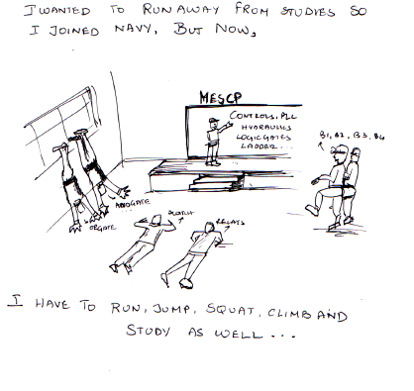
IT HAPENDED ONE APRIL NIGHT IN THE AFT ENGINE ROOM

Captain Sunil Kumar

Apr 25, 1800 h - The ship was due to sail at 1700h for the Eastern Fleet ORI-16. Whilst, the work on Ship’s BMA Pump no 4 had been going on since 0630h, with both BMA pumps now unavailable, she was nowhere close to heading out to sea. When the old man went down to the Aft Engine Room (AER) to obtain a firsthand assessment, the Ship’s team with the assistance of ND(V) were trying their best to get alignment of the pump and motor within limits. However, success was eluding them, time and again. Each time the motor’s peripherals were manipulated by the Chargeman from ND (V), a dozen anxious eyes expectantly sought succor in his expressions. He had already tried his luck three times and each time he had emerged sweat soaked, shaking his head, signaling lack of achievement. With each despondent nod, the mood in the AER turned tenser and the vibe of dejection, stronger.

The old man stood there, his overalls completely drenched in sweat, absorbing the proceedings with keenness and silently reciting his prayers.

After three more failed attempts, the old man’s faith began to show signs of a break down. He asked the Dockyard Centre Manager and his Engineering Officer if the attempts at aligning the assembly would work out within the next few hours. They indicated that they were hopeful but were not sure. Whilst holding firm to his faith and prayers, myriads images and questions streamed through his mind. What if these attempts do not fructify? What if a new assembly required? The new assembly would not be ready by next day evening… the ship might miss the sailing… the TFX and PMF. He, however, remained firm to his faith and continued to pray.

By 2200h, ND (V) finally completed the motor’s alignment. Unfortunately, it was not all good news as some alignment readings were off the mark. Upon obtaining this conditional success, Yard decided to retain the motor’s position and achieve alignment by manipulating the pump. The old man left for Bridge to assess the overall situation and to check availability of Tugs and channel clearance for the next few hours.

By 2300h, the alignment of BMA 4 was completed. Our troubles should have been over by now. But alas! Sometimes adversity hugs you tighter than love. The new motor BMA 4 varied in dimensions from the one fitted earlier. Owing to this variance, the pipelines of BMA 3 opened up earlier to accommodate BMA 4 motor were now not fitting into the available space and were in fact being obstructed by the new BMA 4 motor. Three attempts were made to fit the pipelines by manipulating the compensator but success continued to elude the team.

Apr 26 - In the dead of the night at 0030h, when the old man checked from the Bridge regarding readings of the propulsion systems, he was informed that BMA 3 pipes were still not fitting into the space available. Whilst, attempts were still ongoing, it could take at least one hour or even more to be ready. Therein, the Captain decided to visit the AER for the third time.

En route, the Doubts that dominated the Captain’s mind were not comforting… Is ND (V) going to support SS in this work? What if they leave? Will SS be able to handle it? What he saw in the AER brought tears to his eyes. The complete ND(V) team, Manager downwards, were not only helping and advising the Ship’s Staff but had taken over the complete ownership of proving BMA 3 also. After many attempts they were able to start BMA 3 but unfortunately it had to be stopped due to heavy leaks. The situation was getting quite desperate as any more delay would have resulted in the ship missing the first serial of the ORI. At this point, the ND(V) Chargeman opened the offending compensator himself and very painstakingly removed the remains of the washer that was causing the leak.

By then the team had been at work for 18 hours with no meals, their overalls full of sweat, grease and oil, some of them even torn by the maze of the pipes. But their faces wore warm smiles and beamed with total commitment. The ND(V) team not only crafted the washer but also fitted the pipes themselves, taking complete ownership, till the system was fully ready.

WHILST WE TAKE PRIDE IN CALLING OURSELVES A SILENT SERVICE, I AM CONVINCED THAT THE REAL SILENT ARM OF THE SERVICE ARE THESE TEAMS FROM ND(V) WHO WORK TIRELESSLY IN THE DEEPEST AND REMOTEST CORNERS OF THE SHIP , THROWN MILES AWAY FROM ANY LIMELIGHT, SACRIFICING EVERY INCH OF THEIR PERSONAL COMFORT AND FAMILY TIME , IN TURN ENABLING US TO ACHIEVE GLORY AT SEA . IT IS IMPORTANT THAT WE THE DECISION-MAKING PART OF THE NAVY, RECOGNISE, ACKNOWLEDGE AND NURTURE THEM. THEY ARE A VERY VITAL AND ROBUST COG IN THE POTENT NAVAL MECHANISM.

As I was walking back to the bridge from the AER, I realized that my own faith, hope and belief went through many sinusoidal crests and troughs in the last 20 hours, but the teams at AER remained calm, focused and steadfast, as if blessed with some magical powers. They-these silent warriors-deserve many salutes.

Was this exemplary demonstration of professionalism a one off incident! Certainly not! In the last few months I can count at least six occasions wherein ND(V) completed repairs against near impossible timelines. The last occasion being just two days earlier when the WECORS team had worked from early morning to noon on a Sunday to operationalise the magnetron of Volna thus ensuring that we were ready for the PMF.

ND(V) we are proud of you !

Author is presently serving as Commanding Officer, INS Ranvir
RECOUNTING THE RETUBING
INFUSING THE AMERICAN RELIC WITH INDIAN STEEL : INS JALASHWA

Capt Rakhi Ram & Lt Ashish Thapliyal

Introduction

1. A success story was made in indigenisation endeavours when the re-tubed main propulsion boilers of INS Jalashwa completed Full Power Trials (FPT) at sea. The re-tubed Boilers pounding more steam than was done at the time of acquisition of ship. This saga of indigenisation success story was very aptly captured in the signal by Eastern Fleet. The signal read as follows

DTG PRIORITY

FROM : FOCEF RESTRICTED

TO : FOCINC EAST

INFO : ASD(VZG) MS (VZG) CBIU(MBI) JALASHWA

NSN/NMM (.) DURING SEA TRIALS ON 15 APR JALASHWA ACHIEVED REV 213 SP 19.8 KN AT FULL AHEAD EOT (.) OUTCOME OF SEA TRIALS MARKS A RED LETTER DAY IN ORGANIC INDIGENOUS CAPABILITIES (.) ACHIEVEMENTS TESTIMONY TO THE COMMITTED AND SYNERGISTIC EFFORTS SPANNING OVER TEN MONTHS BY SS, ALL ND(VZG) TEAMS, MO(VZG), CBIU(MBI), TRIAL AGENCIES, HQENC/NHQ STAFF AND THE INDIAN INDUSTRY
=162010/APR

2. The USS Trenton was rechristened as INS Jalashwa on acquision by Indian Navy in May 2007 as part of Foreign Military Sales (FMS) programme. This multi-role amphibious Hippopotamus (Jalashwa) as an LPD has served the Indian Navy during various HADR operations in providing relief to affected populace, Non-Combatant Evacuation (NCE) missions and as a ‘Hotel Ship’ during the IFR-16 at Visakhapatnam.

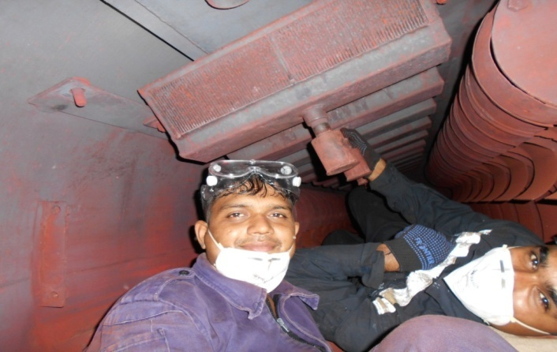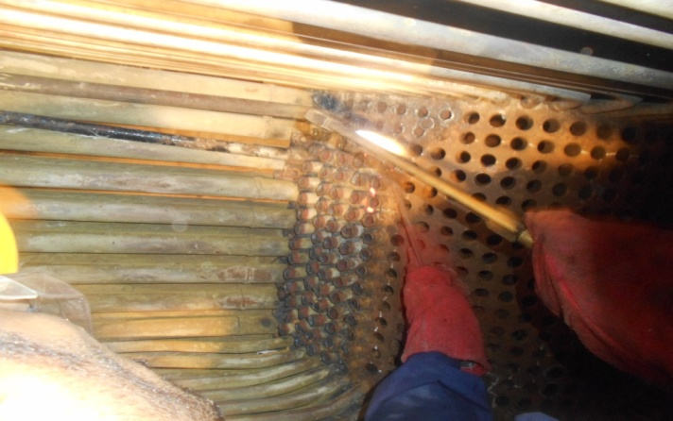

Fig.1 Removal of Boiler Internals and Cutting of Boiler tubes

3. The 17000 T ship has two D-Type Boilers of Make M/s Foster Wheeler, USA. These two boilers, in addition to providing the steam for main propulsion turbines also supply steam to four Ship Service Turbo Generators (SSTGs) of 750 KW each and other Turbo Driven auxiliaries of the boilers. The reduced pressure steam, also called ‘Hotel Steam’ is used for meeting domestic requirements such as for galley, laundry and bathrooms etc.

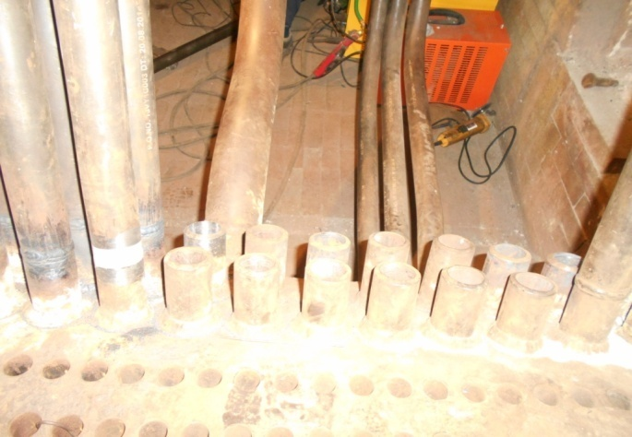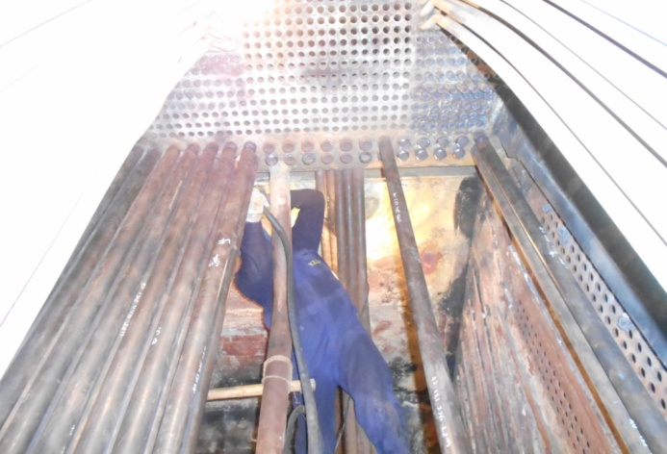

Fig. 2 Welding of Intermediate tubes

4. The work of re-tubing of both boilers was offloaded to M/S Yeoman Marine Services (YMS), Mumbai by ND (VZG) with QC supervision/ stage inspection by M/S Foster Wheeler, IRS and QC Dept. of ND (VZG). The re-tubing and furnace refractory material was partly sourced from US through Navy Inventory Control Point (NAVICP) and remaining (approx 80 %) through indigenous sources.

5. As part of re-tubing; 1176 generating bank tubes, 56 intermediate tubes, 40 side water wall tubes, 71 screen row tubes, 129 superheater tubes of various sizes and profiles were renewed for each boiler. In addition, both (inlet/ outlet) superheater headers, desuperheater coils of both boilers were also renewed. The pressure testing and bending of tubes as per the profile of each tube row was undertaken at the premises of M/S Bajaj Power, Ahmednagar.

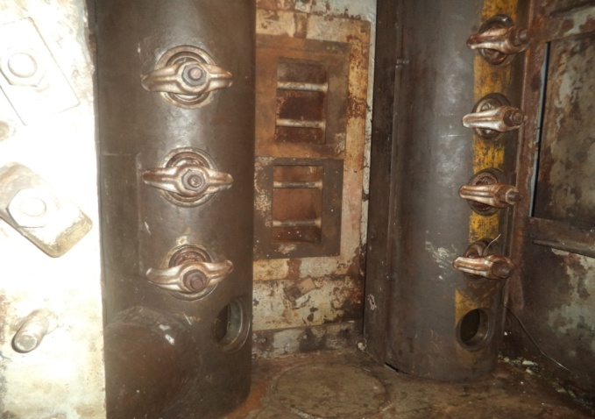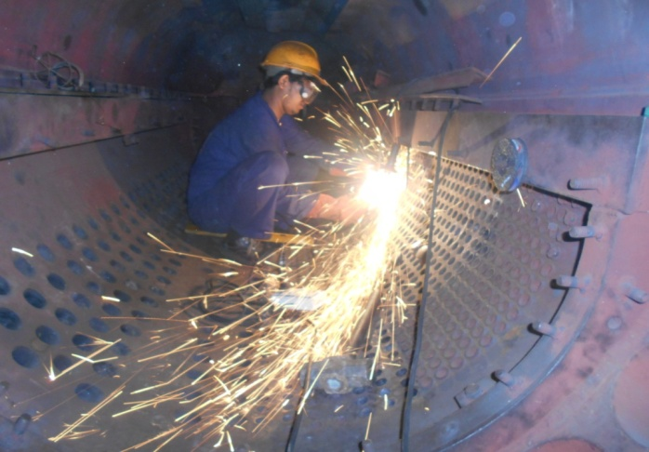

Fig.3 Fitment of new superheater header and grinding of tube nipples

6. The on-site metallography of both steam and water drum was carried out to assess their satisfactory health. In addition, the status of economisers, down comers and superheater support tubes was also as satisfactory as assessed by CBIU (MBI).

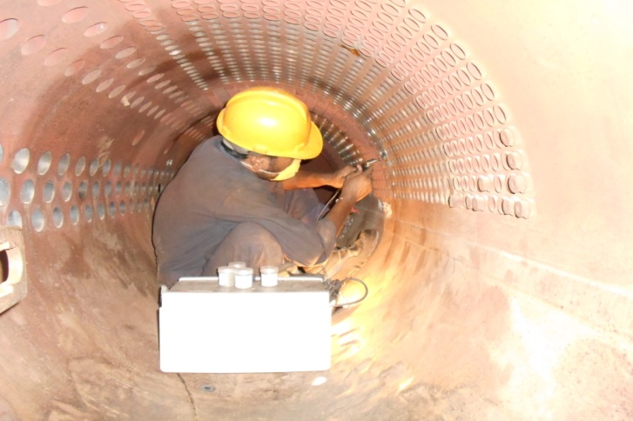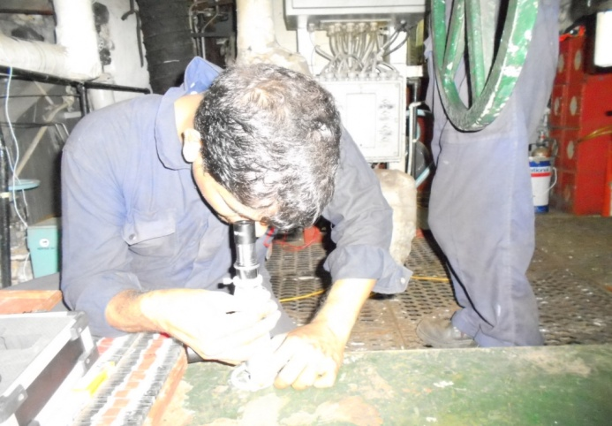

Fig.4 Onsite Metallography in progress

7. During the process of execution of maiden re-tubing of both boilers of Jalashwa a number of challenges in terms of welding/ RT/ pressure testing of individual intermediate tubes, non- availability of a right handed inlet header, rolling of superheater tubes, renewal of soot blower bearing etc. were encountered which were successfully overcome jointly by ND (V), SS and M/S YMS by finding technically sound, innovative solutions.

8. The timely execution of project of this magnitude required the effective coordination between the various stakeholders and the same was accomplished by having a close day to day monitoring at ND (V) and SS level.
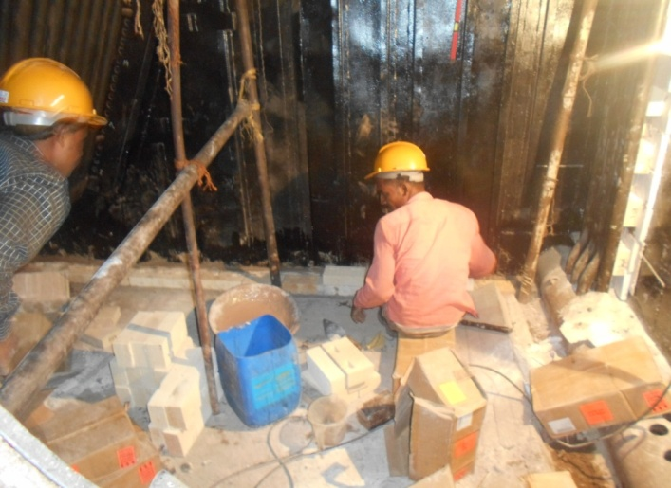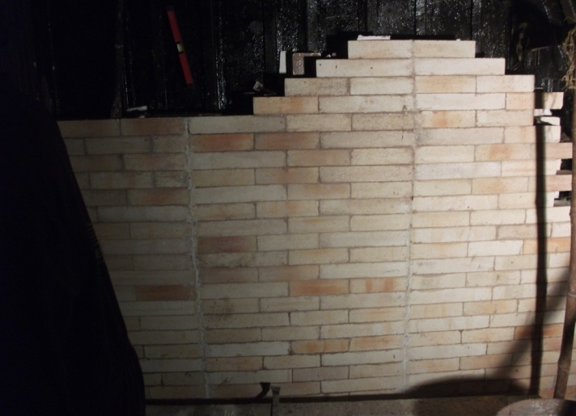

Fig.5 Refractory/Brick work in progress

9. The post re-tubing acceptance of boilers as per the OEM/ US Navy laid down procedure for these boilers was accomplished in a record time of 6 weeks with all ‘hold point’ inspections by OEM, CBIU (MBI) including hydrostatic pressure testing at defined test pressures(975psi, 825psi and 650psi), boiling out with chemicals/steam and baking out as per refractory manufacture recommendations. The availability of required documentation Ex-US and pre-planning with the check off lists resulted in completion of pre-flash up checks by CBIU (MBI) in two days (which usually requires four weeks) and clearance for firing of the boilers. In view of the limited expertise on these boilers with the Yard, the SS has to undertake the required operation and maintenance lead during the re-tubing and setting to work of these boilers.
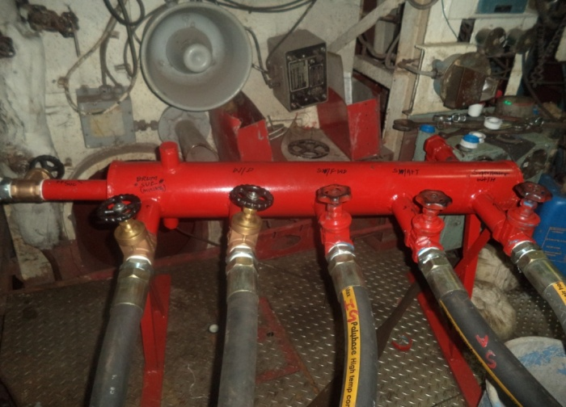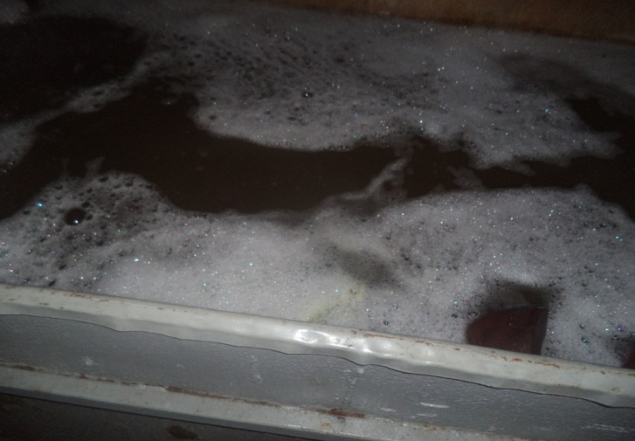

Fig.6 Boiling of boiler and internal fittings in progress

10. The work of boiler mountings, combustion system, boiler control system and associated turbo driven auxiliaries and steam system was planned and accomplished in such a way that on readiness of the boilers, these equipment and systems were available for firing and exploitation of the re-tubed boilers. The FPT of the both boilers was accomplished in the first trial sea sortie itself. And thereafter ship was deployed for continuously at sea for 20 days.

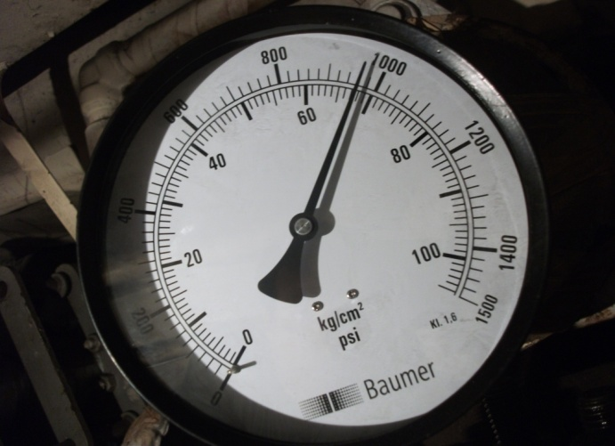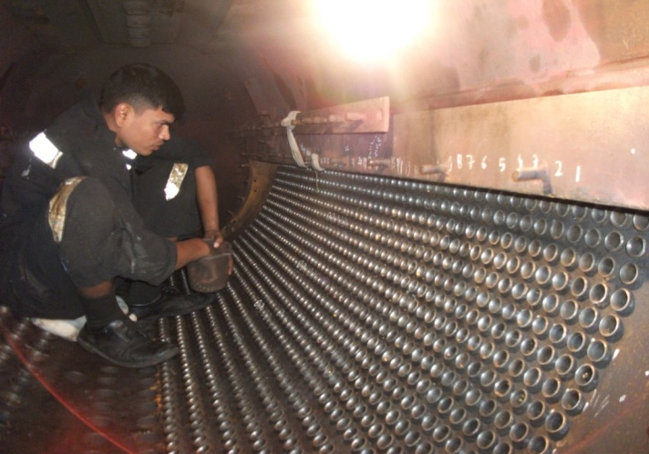

Fig.7 WPT and sighting of Boiler in progress

11. On completion of FPT the spirit of this accomplishment was poetically mused by the author of this article:-
PROUD TO PROCLAIM, IN ACHIEVING STATED AIM,
WITH STACKS CLEAR AND FLAMES AMBER !
THE FEARLESS PIONEERS, WITH HEAD HELD HIGH,
REV 213 ON BOTH PROPELLERS, ACKNOWLEDGED WITH AYE !
THE HAND IN HAND OF MIGHTY YARD AND SUPPORT ASSURED,
WE FULL FILLED THE WISH OF FLEET WITH SAFETY ENSURED !
BUT FOR 100% SIGNAL OF 2A, 2B FD BLOWER,
THE SCREWS WOULD HAVE BEEN 10 MORE TURNS OVER !
THE MAGIC OF RE-TUBED BOILERS AND RE-FURBISHED AUXILIARIES,
WAS MET WITH A MATCHING SPIRIT OF ‘BLACK GANG’ EXTRA-ORDINARIES !
NEVER IN THE PAST, IN SUCH A SHORT HOUR,
COMPLETED SEA TRIAL AND TRIUMPH AT 'JAL PRAHAR' !
Authors are presently serving as CTS, MO(Vzg) and Asst Engineer Officer, INS Jalashwa
ASSISTANCE RENDERED TO MCGS BARRACUDA
DI/ DR OF ON RO PLANT AND DG AT MAURITIUS
INS KOLKATA

Lt Cdr Ayush Pharasi

Background

- The Flag Officer Commanding Western Fleet (FOCWF) embarked onboard INS Kolkata during OSD 16/2 at Port Louis, Mauritius was formally requested by the National Coast Guard of Mauritius to render assistance to MCGS Barracuda for operationalising both RO plants and one out of the two fitted 200 KW Diesel Generators. It was informed that the RO Plants and DG were not available for exploitation since last two months due to outstanding defects. The same was severly hampering the sea going capability of MCGS Barracuda and was a point of concern for the National Coast Guard of Mauritius. The Flag Officer Commanding Western Fleet directed INS Kolkata to provide all possible assistance to MCGS Barracuda.

Equipment Fit- RO Plants

- MCGS Barracuda is fitted with two 10 TPD RO plants (Make- ROCHEM). Each plant consists of similar arrangement of components as on 30 TPD RO plants (Make – TECHNO PROCESS) fitted onboard INS Kolkata. The reverse osmosis de-salination plants are built in a standard modular construction with minor variations across different make of plant. The ROCHEM make plant consist of a feed pump supplying S/W through the sand filter and cartridge filter to the HP pump. Sea Water at high pressure (60 bar) is supplied to DT modules. The output permeate from the DT module is passed through a neutralite unit before diverting to F/w tank. The general arrangement of the plant is shown below:

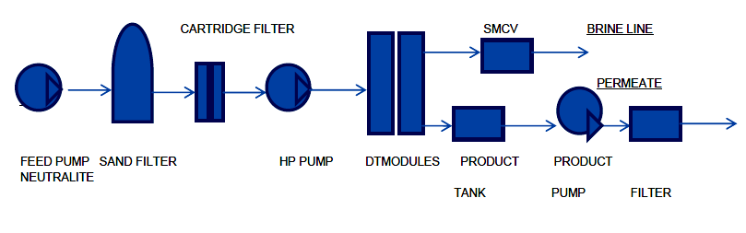

Fig. 1 General arrangement of RO Plant
Equipment Fit- Diesel Generators

- MCGS Barracuda is fitted with two Diesel Generators (DGs) of 200 KW capacity (Make – Cummins). One out of two fitted diesel generator being non-operational greatly affects the sea worthiness of the ship. The diesel generator fitted onboard MCGS Barracuda is similar to the one fitted onboard INS Kolkata with a variation of lower power output. The performance of the DG w.r.t the varying load requirements is controlled by controller circuit fitted in the Control panel . The electronic Fuel governor regulates the fuel feed to the engine based on intial settings and inputs from the control panel.

DI/DR undertaken on RO Plants

- A technical team from INS Kolkata was deputed onboard MCGS Barracuda from 01- 04 Sep16 for DI/ DR. Upon initial inspection, it was observed that salinity of both plants was above permissible limits causing frequent tripping of plants. RO Plant No.1 was started after disconnecting the permeate outlet line of both the DT module drained to the bilges. It was observed that the permeate discharge pressure from one of the DT module was high. The salinity of the individual module was found to be above the permissible limit, which could have been because of the slippage of O-ring or damaged membrane. While the other module was found to be in a good state, its permeate line was connected back to the permeate header. The same activity was undertaken on RO Plant No. 2 and one of the modules was found unsatisfactory. It was decided to shift the working module of RO Plant No. 2 to Ro Plant No. 1 so as to ensure 100% availability of one of the plants. Trials taken on RO Plant No. 1 post replacement of one module were found to be satisfactory.

- Overhaul of DT Module. Overhaul of the defective modules was attempted. Upon dismantling the membrane, it was observed that several O-rings had slipped from their position causing ingress of high pressure brine into the permeate line. It was also observed that a number of membranes were perished. Overhauling of the modules necessitated replacement of faulty O-rings and membranes. The module could not be overhauled during the duration of deployment due to want of spares (spares available onboard INS Kolkata were incompatible). The complete procedure of overhauling the DT module was explained to the SS of MCGS Barracuda.

- A training session on operation and maintenance of RO Plants was conducted for the SS of MCGS Barracuda which included troubleshooting methods.

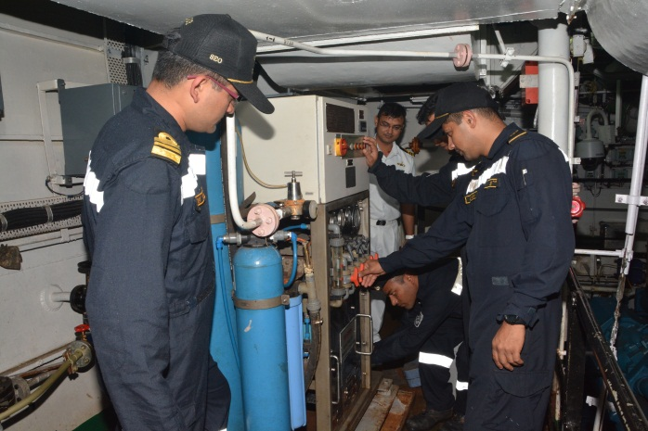 | 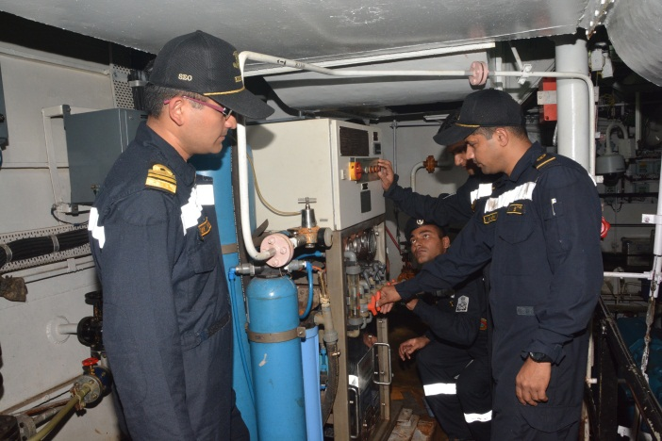
Fig.2 DI on RO Plant No. 01
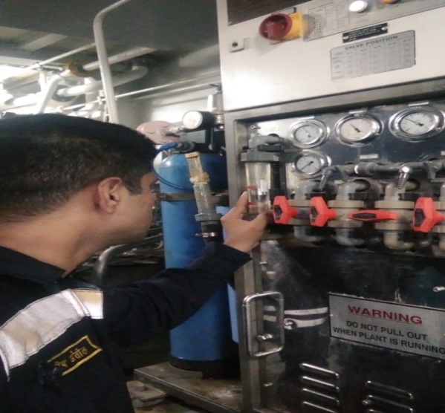 | 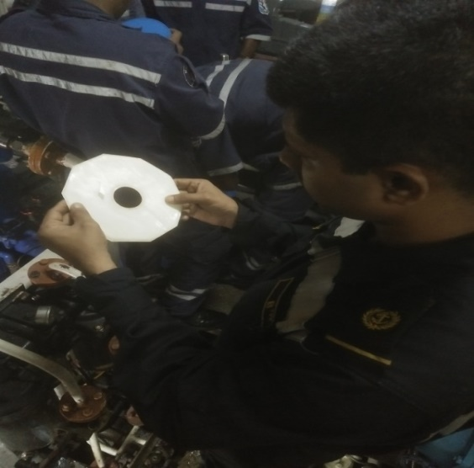
Fig.3 Setting of Parameters and Inspection of Membranes on RO Plant No 01
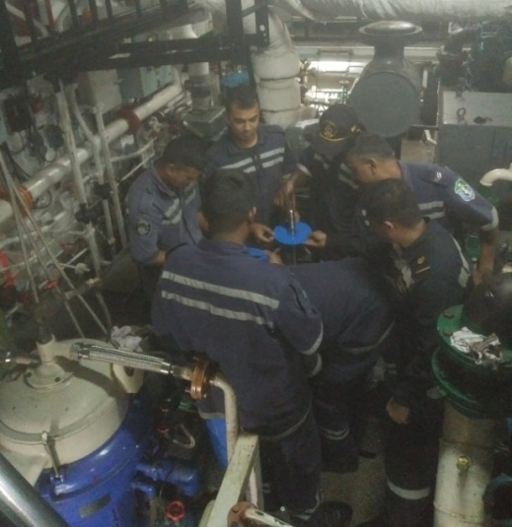
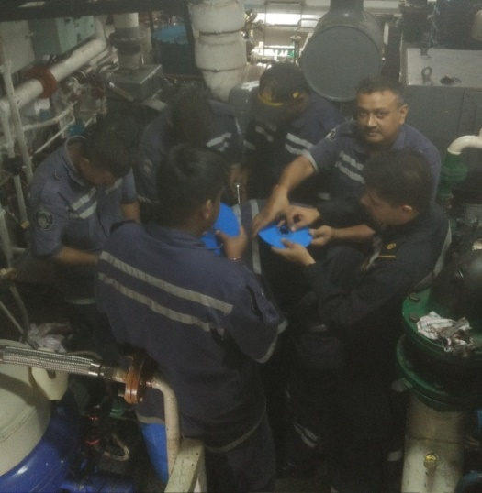
Fig.4 Dismantling of Defective Module of RO Plant No. 02
DI/DR undertaken on RO Plants

- During initial inspection it was found that the DG was tripping while starting due to over-speeding. The RPM of the DG is controlled by an electronic speed governor. The Governer Controller of the electronic speed governor has a number of settings to ensure RPM and Droop control of the engine. On further investigation by the team, it was revealed that settings of the Governor Controller were not correct for that model of engine. In the absence of documentation/ instructions regarding setting and tuning of Governer Controller, the team successfully tuned the controller by taking reference from the settings of the operational DG. The DG was thereafter started, proved and taken on load on 04 Sep 16. The correct setting values of the controller were handed over to SS of MCGS Barracuda for future reference.

- A training session on operation and maintenance of DG was conducted for the SS of MCGS Barracuda which included effective troubleshooting methods.

Conclusion

- The prompt and effective technical assistance rendered to MCGS Barracuda could resolve long pending critical defects on RO Plants and DG and was able to ensure sea worthiness of the ship. The training sessions organised for the crew were well attended and appreciated. The support rendered by INS Kolkata is in keeping with the best traditions of Indian Navy and also with its vision towards strengthening friendly ties with countries in the IOR.

Author is presently serving as Senior Engineer Officer onboard INS Kolkata
FREE ROTATION OF POWER TURBINE OF INOPERATIVE GAS TURBINE DUE TO WIND-MILLING EFFECT- KOLKATA CLASS SHIPS

Lt Cdr Ayush Pharasi, Lt Rajan Sharma

Introduction

- INS Kolkata is the first of the P-15A class of ship. It has been designed on the Delhi Class destroyers, in service in the IN. Both class of ships have similar propulsion package (M-36 Э.1) with the only difference being the advanced VME-based Burya-15A MPP Control system which is installed on Kolkata class of ships. Being a digital control system, digital read-outs of all parameters of MPP are available on a single screen with a least count of as low as 10 RPM. This is not possible to observe on a Delhi Class ship as analog instrumentation cannot read such low values.

Background

2. During EHM trials of INS Kolkata by GTTT(Mbi) on 28 Jul 16, rotation of power turbine (PT) of inoperative GTs, whilst operation of other GT on same shaft/reduction gear, was observed by SS and trial agency reps. As an immediate measure, the engine oil pump was run intermittently in order to provide lubrication to the bearings of the PT of inoperative GT.

Problem Definition/ Concern

3. Rotation of PT of inoperative GT, whilst operation of other GT on same shaft/reduction gear, was a matter of concern, view following:-

(a) Indication of rotation of PT is dependent on the accuracy of the digital control system (Burya) as the RPM observed was very low to be detected by analog gauges.

(b) Practice of starting engine oil pump to lubricate the PT bearings is dependent on the watch-keeper’s alertness to detect the low RPM PT rotation. Not starting the engine lub oil pump could lead to catastrophic failure of the PT bearing.

Investigation

4. After detailed study, the reason for free rotation of PT was attributed to either of the following:-

- Malfunction of the friction clutch mechanism of the RG which was suspected to be in the ‘engaged’ position and responsible for rotation of the PT of the inoperative GT. However, it was confirmed that friction coupling clearances for all GTs were within limit and there was no friction clutch malfunction.

- Malfunctioning of RG air system was ruled out after thorough audit of the system was undertaken and all valves were proved for leak tightness.

- Wind Milling effect, which is a rare occurrence, develops in case of twin marine gas turbine installations, wherein free PT of inoperative engine may rotate while other GT is operating due to wind flow/ direction. This could not be ruled out.

- Stack/ Chimney effect occurs when free PT of inoperative GT, post shutdown, may rotate due to reverse flow of gas through the exhaust funnel. However this phenomenon was more prominent on industrial engines.

Trials

5. The following trials were planned to ascertain the exact cause of the phenomenon:-

- Operating GT 1 & 4 upto 0.66 N after closing intake and exhaust of GT 2 & 3.

- Operating GT 2 & 3 upto 0.66 N after closing intake and exhaust of GT 1 & 4.

- Exploitation of port shaft with both GTs upto 210 SRPM while trailing the starboard shaft with closed intake and exhaust of inoperative GTs.

- Exploitation of starboard shaft with both GTs upto 210 SRPM while trailing the port shaft with closed intake and exhaust of inoperative GTs.
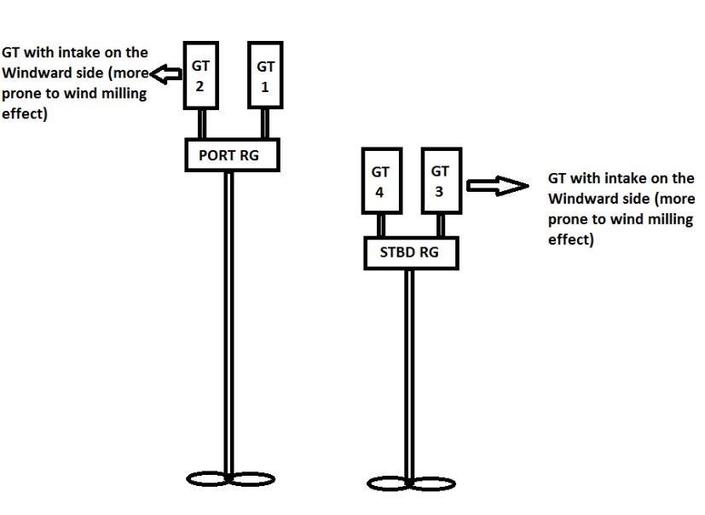

Fig. 1 Propulsion aggregate layout for P-15A class of ships

Conduct of Trials by SS

6. In order to rule out rotation of PT due to any effect of the reduction gear and to ascertain if the phenomenon was due to wind milling or stack/ chimney effect, GT 1 & GT 4 were operated upto 0.66 N with intake and exhaust of GT 2 & GT 3 closed. As GT 2 & GT 3 are the outboard engines, they were more likely to be prone to wind milling effect and therefore these were chosen as the inoperative GTs. The relative wind during the trials was Green 90, 27 Knots. Following was observed during the trials:-

- No rotation of PT of GT 2 and GT 3 was observed upto 0.66 N during exploitation of GT 1 & GT 4. The regime was maintained for 45 minutes.

- The trials were repeated in the same heading and in the same regime, after removing the intake and exhaust covers of GT 2 and GT 3. No free rotation of PT of inoperative GTs was observed.

- With GT 1 and GT 4 at 0.66 N, cold cranking of GT 2 & 3 was undertaken. Post cold cranking, PT of GT 3 (GT with intake on windward side) was observed to be rotating even after completion of the cold cycle. No rotation of PT was observed on GT 2. The PT of GT 3 was eventually stopped by coming down to 80 SRPM.

7. The above trials ruled out rotation of PT due to any effect from reduction gear and ascertained the free rotation was indeed due to wind milling or stack/ chimney effect.

Conduct of Trails by GTTT (Mbi)

8. The following trials were undertaken by GTTT(Mbi) on 30 Jul 16:-

Ser | Trials Undertaken | Observations
(a) | Exploitation of GT 1 & 4 upto 0.66 N with closed intake an exhaust of GT 2 & 3. | (i) With exploitation of GT 1 & 4 at 0.66 N, PT of GT 2 was observed to be rotating with Burya indicating 20 PT RPM. On reduction of port SRPM to 80, the rotation of PT of GT 2 was stopped. Subsequently, the power of GT was built upto 0.66 N, the rotation of PT was not observed.  (ii) Further on closing cooling intake, HPC started cranking at 10 RPM. Subsequently, on removal of cover of cooling intake HPC rotation stopped.
(b) | Exploitation of GT 2 & 3 upto 0.66 N with closed intake and exhaust of GT 1 & 4. | Rotation of PT of GT 1 & 4 not observed.
(c) | Exploitation of port shaft with both GTs upto 210 SRPM while trailing the stbd shaft with closed intake and exhaust of inoperative GTs. | Rotation of PT of GT 3 & 4 not observed.
(d) | Exploitation of stbd shaft with both GTs upto 210 SRPM while trailing the port shaft with closed intake and exhaust of inoperative GTs. | Rotation of PT of GT 1 & 2 not observed.

9. The abovementioned trials reaffirmed that free rotation of PT was due to wind-milling effect.

Remedial Actions

10. The phenomenon of wind-milling effect, its limit and remedial actions are enumerated in P-17 class LM-2500 GT operating instructions. The LM-2500 engine installed onboard P-17 class of ships have been provided with PT braking facility for, which is utilised to obviate wind milling effect while engine is not running. However, the remedial actions for the wind-milling effect are not indicated in OI of M-36 GTs of P-15 and P-15A class of ships. Further, the lubrication system of the Russian GT’s is not designed to cater for wind-milling effect.

Conclusion / Recommendations

11. Based on the findings of trials undertaken to ascertain the cause of rotation of PT of inoperative GT, following has been recommended:-

- Case taken up with IHQ MoD(N)/DME to seek OEM recommendations for promulgation of amendment in operating instructions to cater for wind-milling effect.

- In the interim, following measures have been instituted:-

(i) Alert watch-keeping to closely monitor PT rpm of inoperative GT.

(ii) Local monitoring of cordon shaft, by the GT watchkeeper, to observe PT rotation.

(iii) If rotation of PT of inoperative GT, while operating in 01 GT/shaft mode is observed, bring down the SRPM to 80 to stop the rotation of PT.

(iv) While PT of inoperative GT is rotating, ensure lubrication of PT by switching on lub oil pump intermittently, till the rotation of PT is stopped.

The authors are presently working as Senior Engineer and Assistant Engineer Officer onboard INS Kolkata

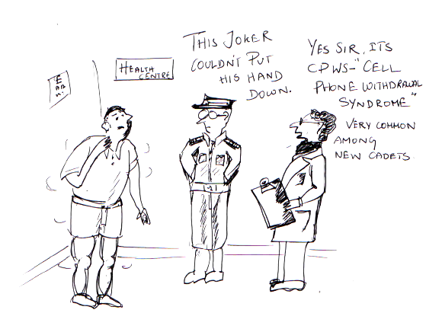
MESC STAFF STUDENT PROJECTS UNDERTAKEN
BY MESC 60.081 (MAR 16– JUL 16)

- Staff-Student Projects are a vital aspect of the Course curriculum for the Officers undergoing Marine Engineering Specialisation Course (MESC) at the Centre of Marine Engineering Technology (CMET), INS Shivaji. Emphasising on the engineering aspects and research areas currently in vogue that could be useful for the Indian Navy is the main aim behind this exercise. Selected projects are generally sent for field trials at Naval Dockyards and operational checks on Fleet Ships as well.

- A brief on Staff – Student Projects been under taken by the Officers of MESC Phase II (60.081), over the last MESC Phase II is enumerated in the succeeding paragraphs.

Design, Fabrication and Installation of IRSS Device on Cummins KTA 50DM (1MW) Diesel Engine

- A team of staff and trainee officers have ‘Design, Fabricated and Installed an IRSS device for Cummins KTA 50DM diesel engine as staff-student project. Infrared Signature Suppression System (IRSS) lowers the infrared signature of ships and is a state of art technology that is becoming fast popular in the defence domain due to its ability to significantly enhance stealth capability of a ship by lowering the temperature upto T_{ambient} + 35 ̊C.

- The project has been carried out in three distinct and planned phases. Phase I included gathering of data, literature study, detailed study of the system, mathematical calculations and dimension analysis for the device. In Phase II, design of the device, its support and instrumentation purchase was carried out. Phase III included fabrication, transportation and installation on site. Post installation of IRSS device on the KTA 50DM DA at DAG wing trials were undertaken at different load conditions. The results were evaluated and compared with the predicted CFD results. Satisfactory parameters were obtained with considerable drop in exhaust temperature. The exhaust temperature at various load conditions were measured at different positions of the device, i.e. at mixing tube, rings 1,2,3 and were compared with the respect to the exhaust temperature prior installation of IRSS device

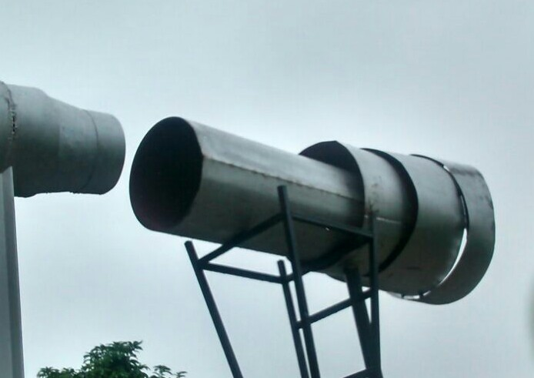 |  |  | 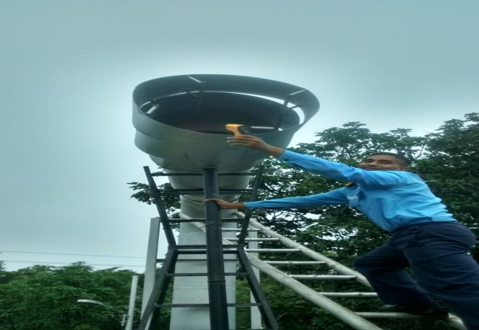
Fig.1 Installation of IRSS device post fabrication

Design and Development of PID & Microcontroller Based Temperature and Pressure Fault Simulators

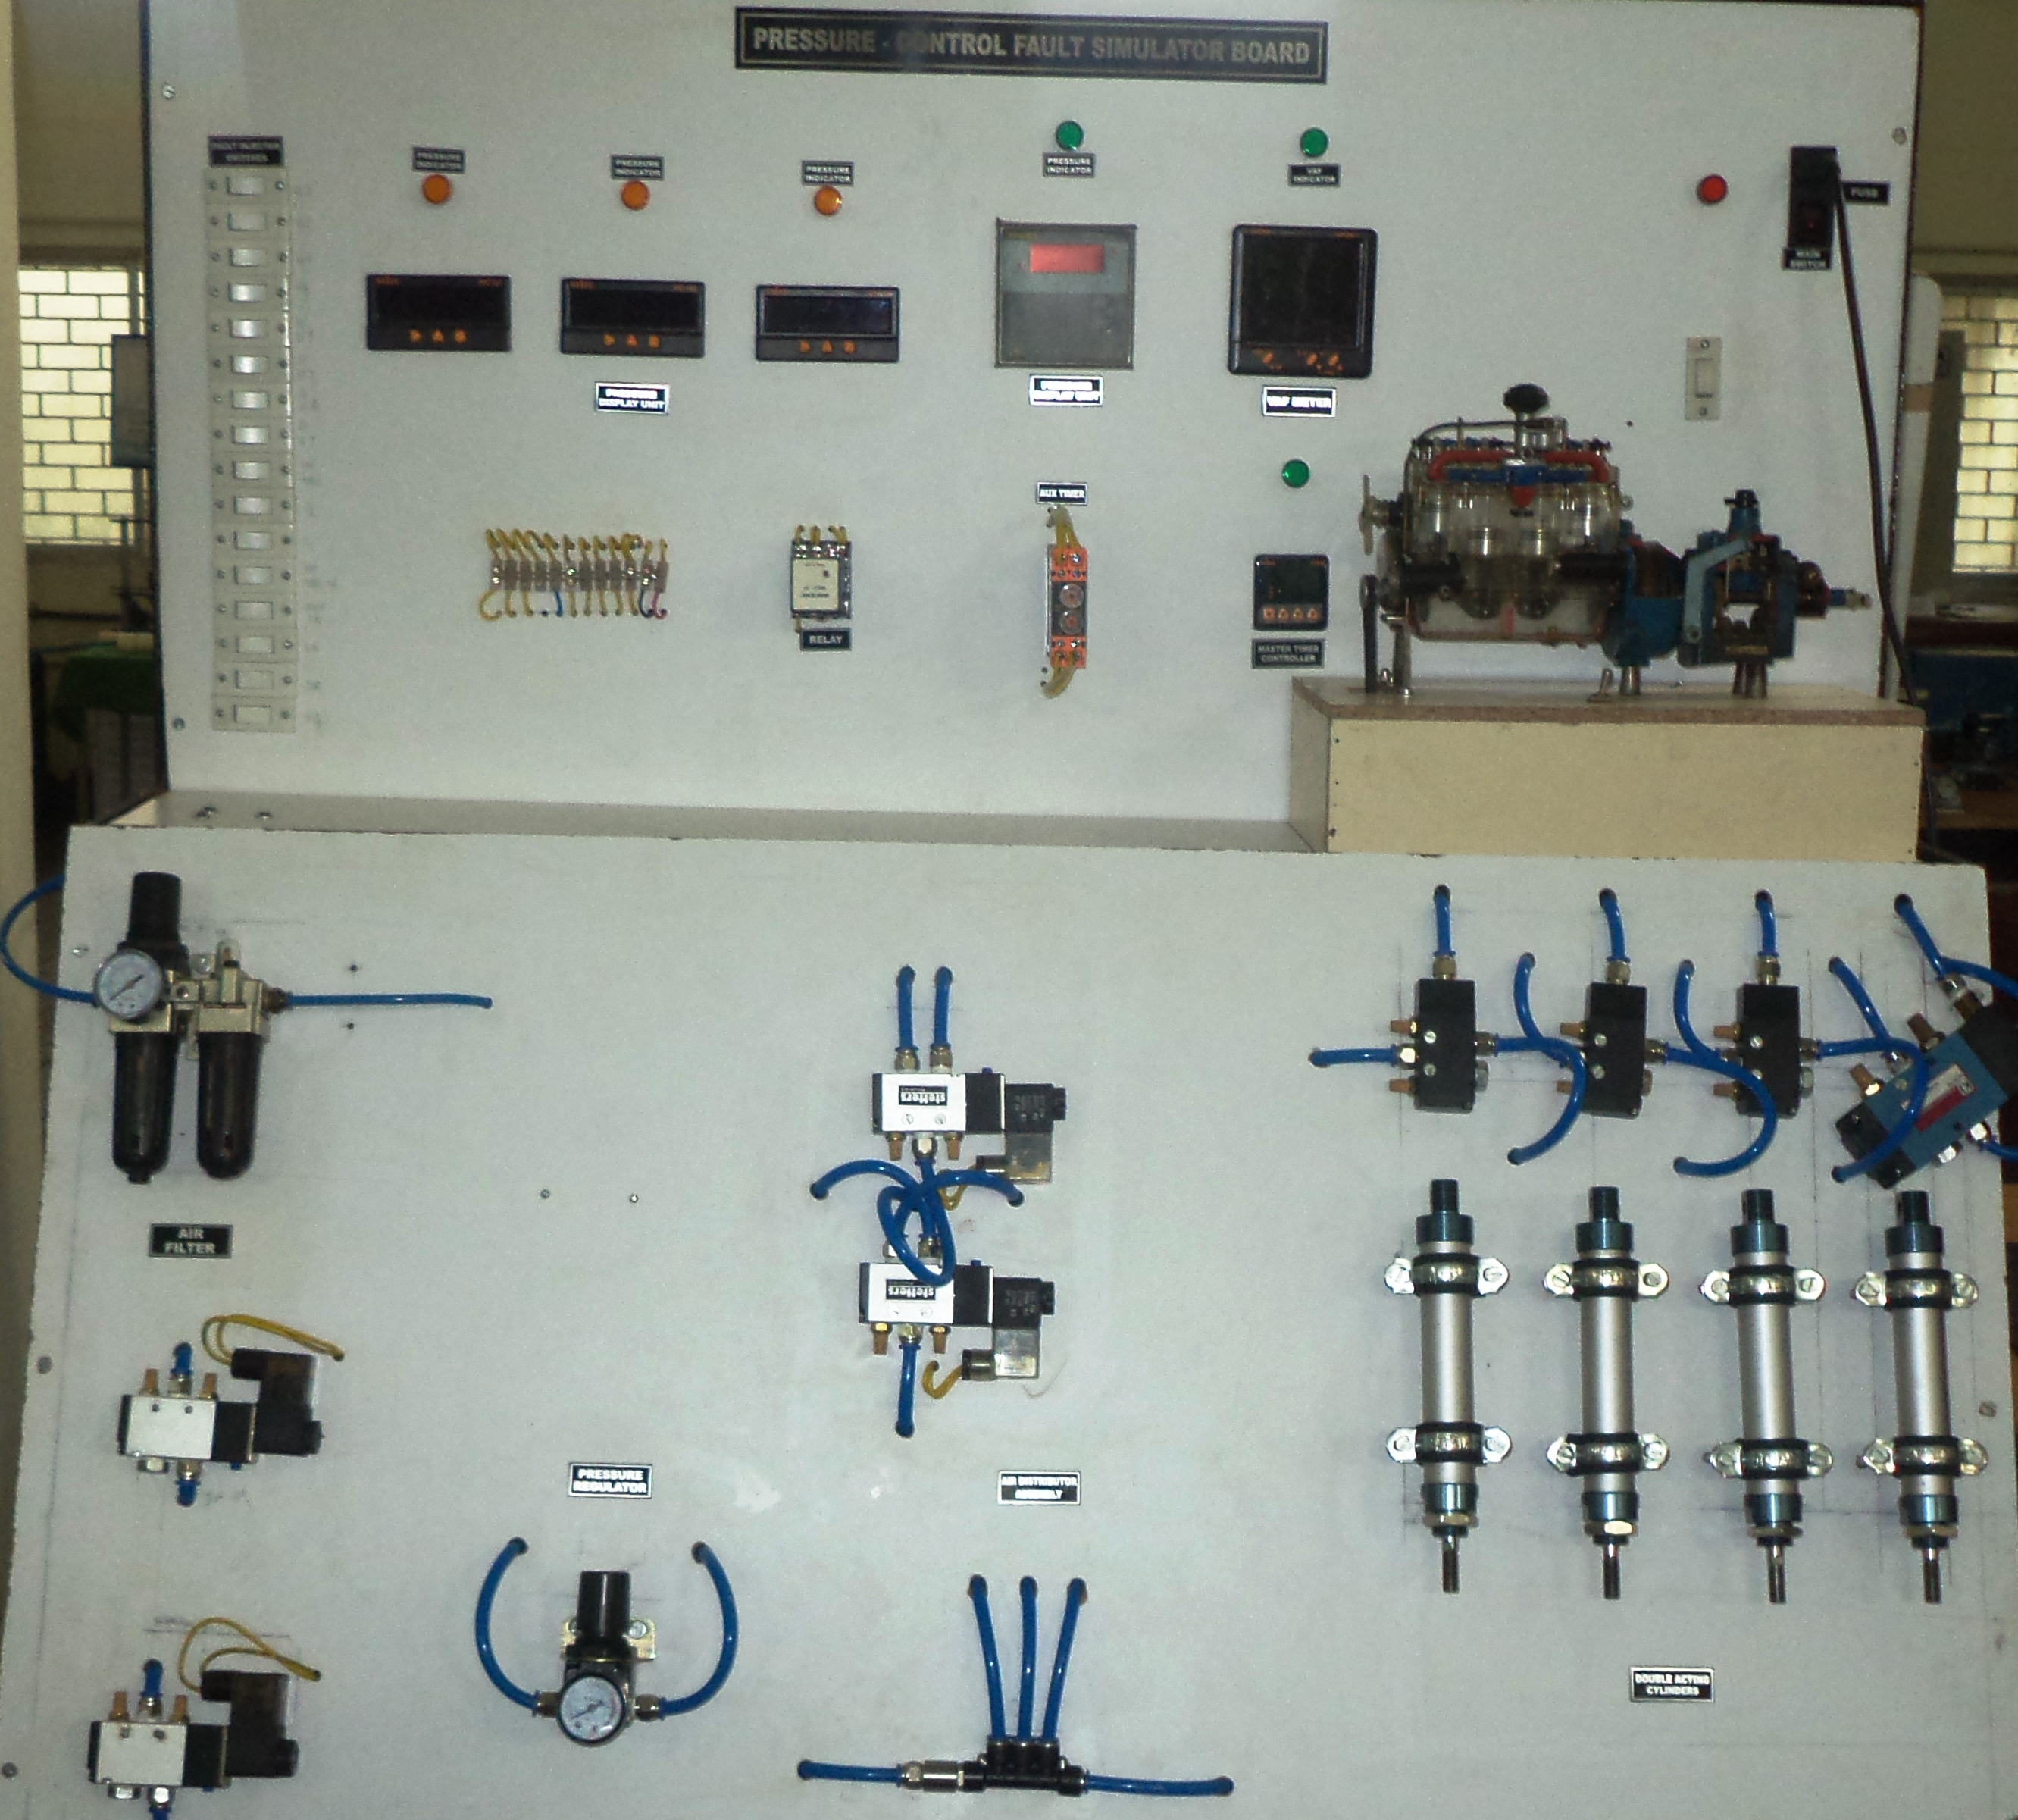
- INS Shivaji has developed ‘Temperature and Pressure Control Fault Simulators’ through in-house efforts. The aim of these simulators is to develop training aids that incorporate temperature & pressure fault simulation for a marine system and is in line with the present job specifications of the Marine Engineers / ERAs onboard.
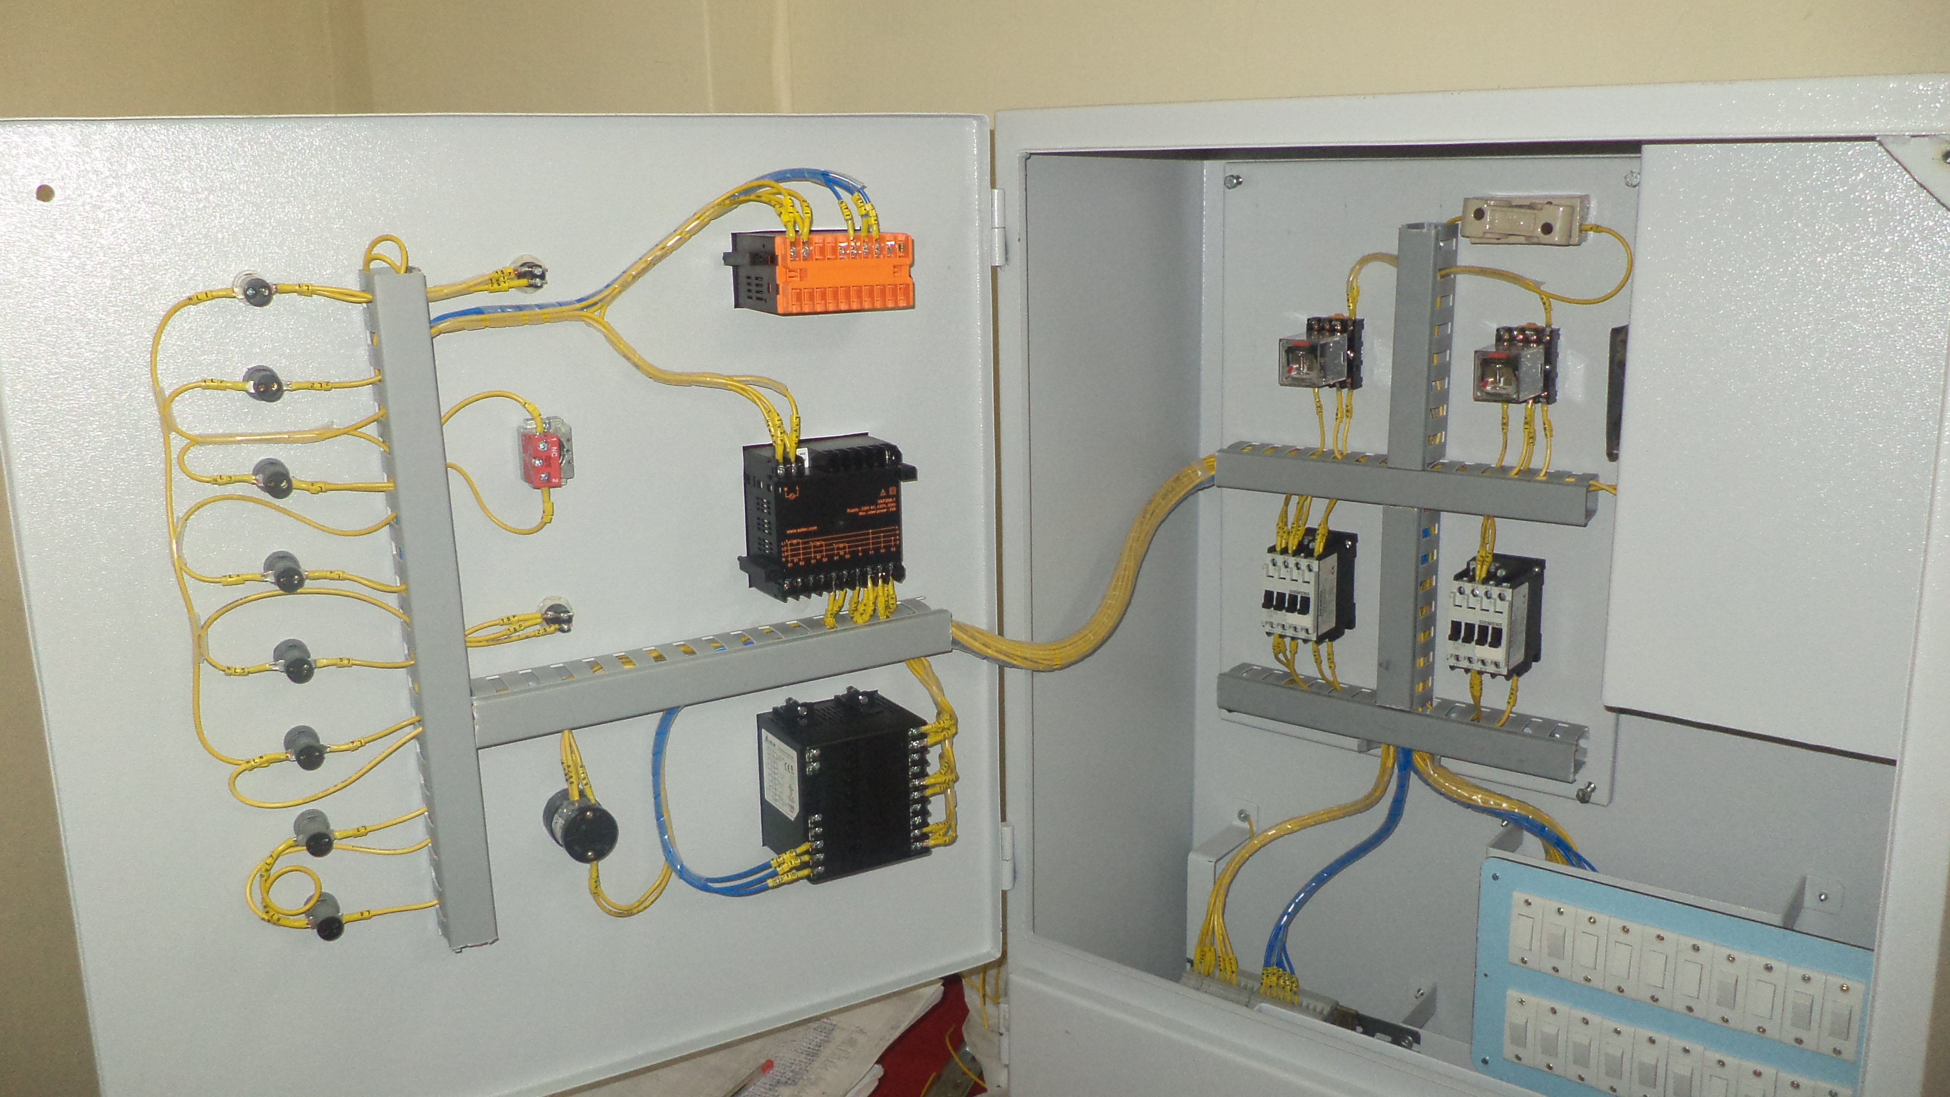
Fig. 2 PID Based Electrical Fault Simulators
- The simulators are based on Microcontrollers and PID controller. The temperature fault simulator reproduces steady temperature requirement in the system with the help of fan & heater. Direct air starting system for marine diesel engines is chosen as the simulation for pneumatic system, which is integrated with controller. The project uses timer controllers to efficiently control the air injection apart from various other electronic components, which indicate pressures and aid in injecting faults. The electro-pneumatic fault injection system enhances the confidence and effectiveness of trainees in controls and gives them an insight about control elements, their functions and electrical circuitry. A total of 20 different faults can be induced in the simulator which the trainees have to identify. Six simulators have been developed by the wing to provide ‘Hands on Skill’ training to respective class of all ab-initio and qualifying courses.

Installation of Ex-Godavari Exhaust Gas Flu Analyzer in Steam Wing

- Presently, IN Steam Ships are fitted with Flue Gas Analyzers to check the quality of flue gases produced by the combustion of fuel in boilers. Y-160 Boiler at INS Shivaji is used to impart practical training to the trainees on boiler operation. However, there was no provision to check the quality of the flue gases in Y-160 boiler. Therefore, the exhaust gas flue analyzer installed onboard erstwhile INS Godavari was installed as a staff student project post approval from HQWNC. The scope of the project involved removal of Flue gas analyzer fitted onboard Ex- Godavari, serviceability checks of the components, installation on Y-160 boiler of the Flue Gas analyzer, calibration and trials.

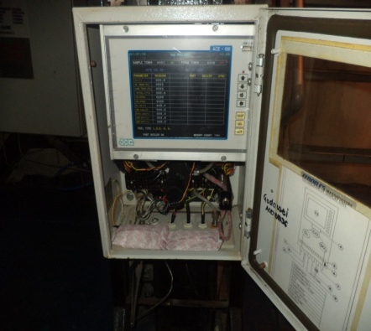 | 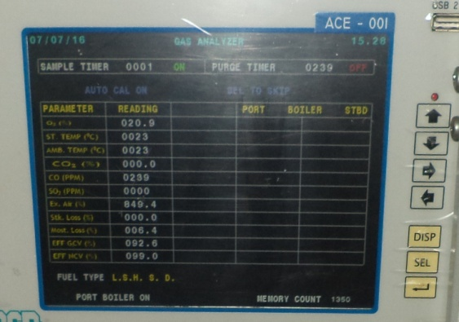
Fig. 3 Flue gas analyzer | Fig. 4 Readings of emissions observed as display

8. The exhaust gas flue analyzer is technically named as ACE 10000 FGA. It is a wall mounted periodic sampling type online analyzer which can be used for fast, accurate and convenient measurement of gases. It samples the process gas by using a powerful sampling system consisting of pumps, filters and flow control valves. The analyzer provides data of gases viz. CO, CO₂, SO₂ in terms of ppm. It is pertinent to mention that the readings obtained would help in understanding the emissions wrt to the combustion dynamics. It would help in optimizing the fuel air ratio which finally is adjudged on the basis of emissions recorded. It also gives an idea of harmful emissions in the atmosphere in order to access and optimize the combustion in respect of MARPOL compliance.

Pneumatic Heaving Line Thrower

9. A heaving line is a light weight rope with a weight at the end, made to be thrown between a ship and the shore, or from one ship to another and used to pull a heavier line across. A monkey fist or a monkey paw is a type of knot used as an end weight. Throwing a heaving line is a cumbersome task onboard ship and a seamanship evolution. Presently, heaving line onboard ships are thrown manually which often requires many attempts to throw the rope to the jetty. Taking this as a background, a syndicate of trainee officers has undertaken a Staff-Student project to develop a gadget / system which will assist the men onboard for throwing heaving line accurately with less effort and more efficiency.

10. The project has been designed and developed at Shivaji with in house resources and efforts. The innovative design used for the project is unique and original. Two designs are developed for the operation of Heaving line, one with piston and other without piston. The models have been made by using UPVC material and are designed for operation at LP air only keeping the safety aspects in consideration. The model uses accumulator, barrel, control valves and a wooden thrower hooked with thin heaving line. Various iterations were done at different pressures and angle of throw at Shivaji and onboard ships. The developed model is capable of throwing heaving line to 80-100 mtrs at the pressure of 80-90 psi. The models are being forwarded to Ships at WNC & SNC for further trials.

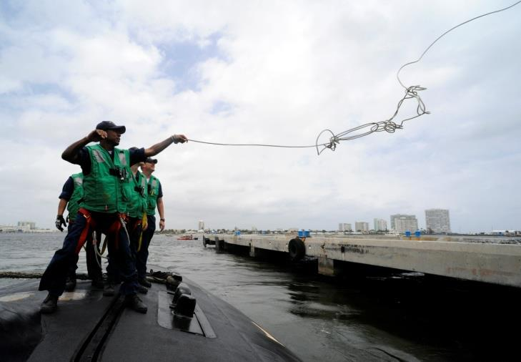 | 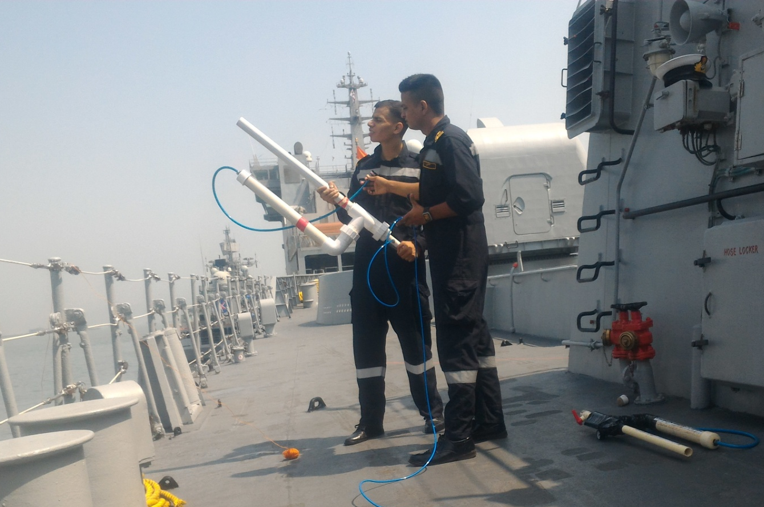
Fig. 5 Throwing Heaving Line Manually | Fig. 6 Throwing line with Thrower

Design and Fabrication of Pneumatically Operated Chipping and Spraying Gun using Single Compressor

11. Ships operate at highly corrosive marine environment and require effective hull/equipment preservation frequently by application of proper paints post removal of rust and chips. The traditional process is time consuming and laborious. With the advances in technology various power tools are available to reduce human effort. To simplify the process of chipping and painting of the affected surface(s), a syndicate of trainee officers under Staff-Student project have designed & developed an integrated machine customised to operate onboard Indian Naval Ships to ease manpower constraints and improve the quality of work.

12. The design (machine/ unit) comprises of pneumatically operated needle scaler (for chipping) and paint spraying gun integrated to a single air compressor unit. The needle scaler removes the rust from the surface or even removes excess weld lengths. The machine is mounted on a chassis with wheels attached to it, for portability even on ships. A needle scaler has a set of very fine chisels known as needles. The compressed air forces these needles against the working surface at variable speeds up to a maximum of about 5,000 beats per minute. This makes the laborious task of chipping manually easier and faster. The spray painting gun has brass air cap. The paint can be controlled using trigger control. It has excellent spraying efficiency upto 65%. Spray painting enables even application of paint onto the surface thereby increasing the life of the paint scheme. The model is being forwarded to the ships at WNC & SNC for trials onboard.

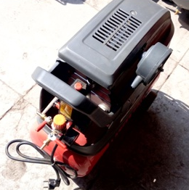 | 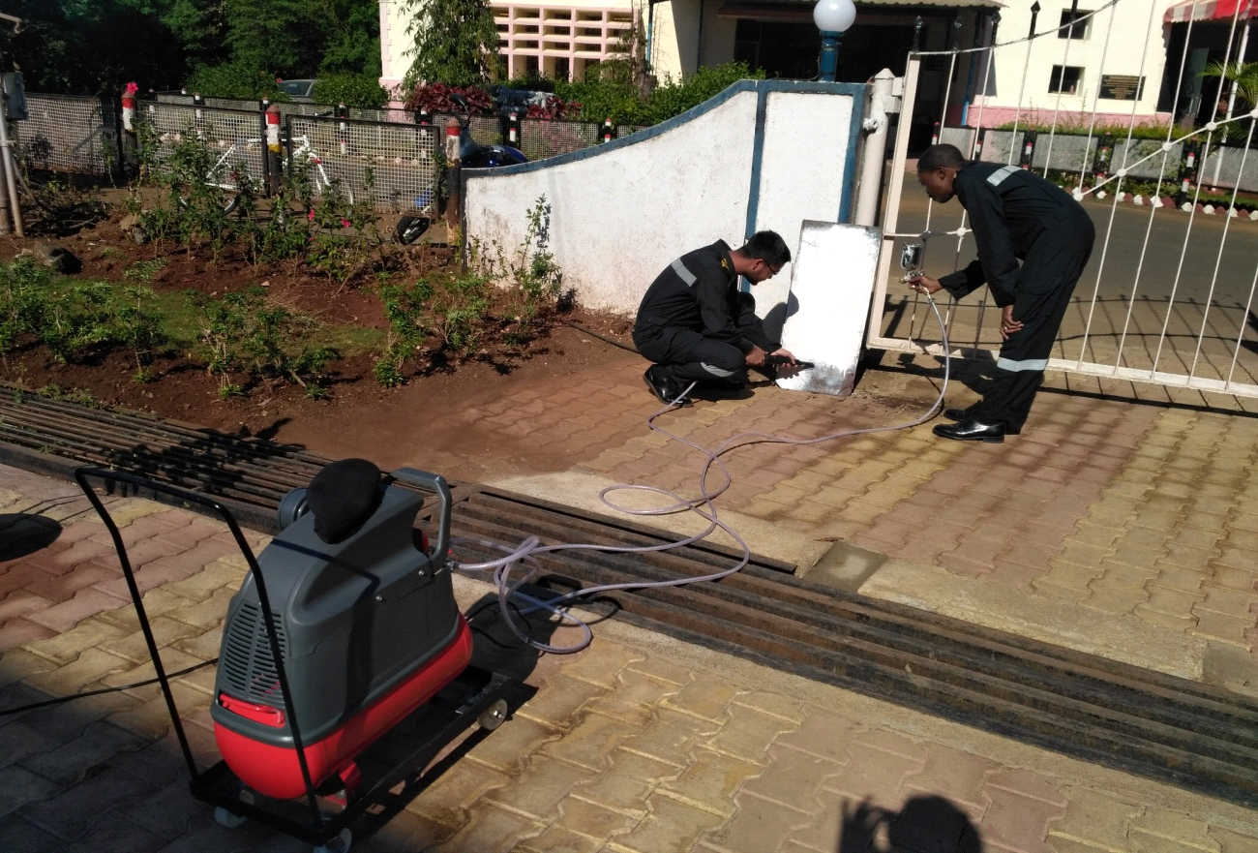
Fig. 7 Pneumatic Chipping/Painting machine | Fig. 8 Application of Paint in progress
Installation of SCADA based Automatic Fire Sensing and Detection System onboard INS Kalpeni

13. A team of staff and trainee officers have developed ‘Automatic Fire Sensing, Detection and fighting system’ as staff-student project integrating the PLC’s, Sensors & Camera with Supervisory Control & Data Acquisition system. As the warships operate at very highly combustible and closed conditions, probability of fire is comparatively high in magazines and machinery compartments where detection of actual seat of fire is a real challenge for all fire fighters. Fire is generally detected through excessive smoke or after spread of fire, thus, making identification of seat of fire difficult. The designed system will locate the seat of fire immediately and focus the camera onto it for continuous monitoring and effective fire-fighting efforts. Machinery compartment is monitored using UV/IR sensors to avoid false signatures and photo-electric sensors integrated with PLC controlled camera. SCADA provides supervisory control for central monitoring. This project has been demonstrated to Hon’ble Prime Minister at IFR-16 and at Navy House, New Delhi on the occasion of Navy Day. It was also demonstrated to Hon’ble Defence Minister during Combined Commanders Conference at Kochi. The project has already been installed successfully on Water Jet Fast Attack craft INS Kalpeni for field trials.

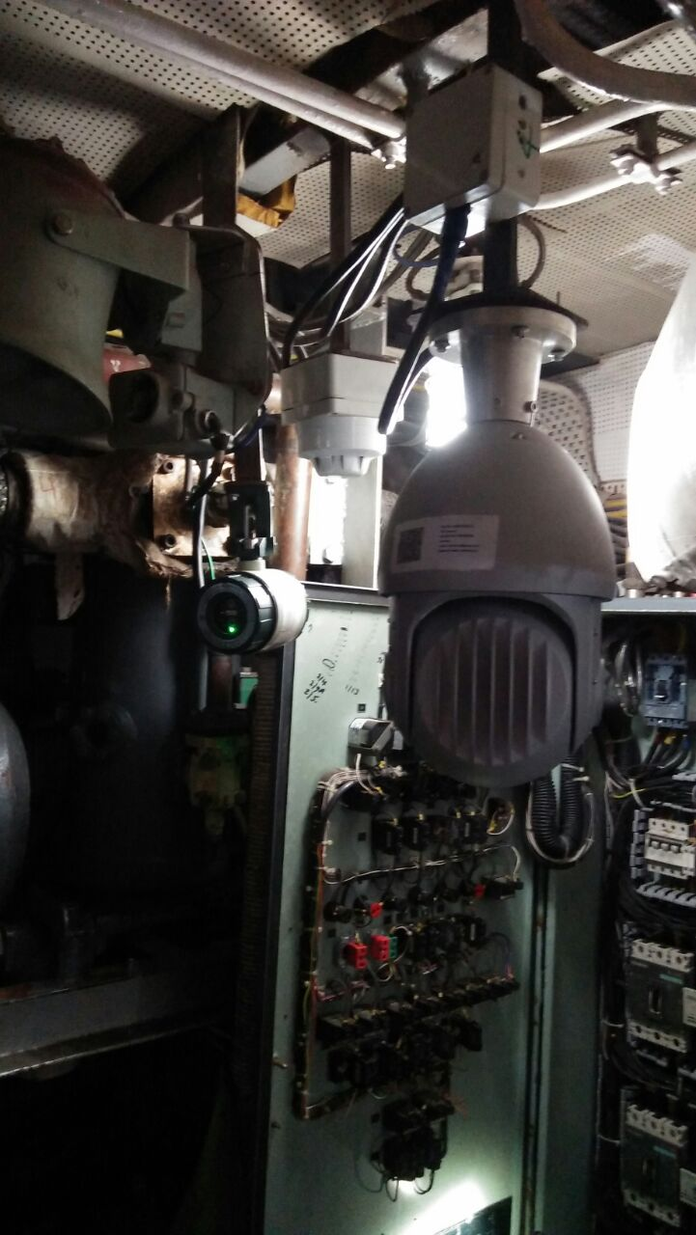 | 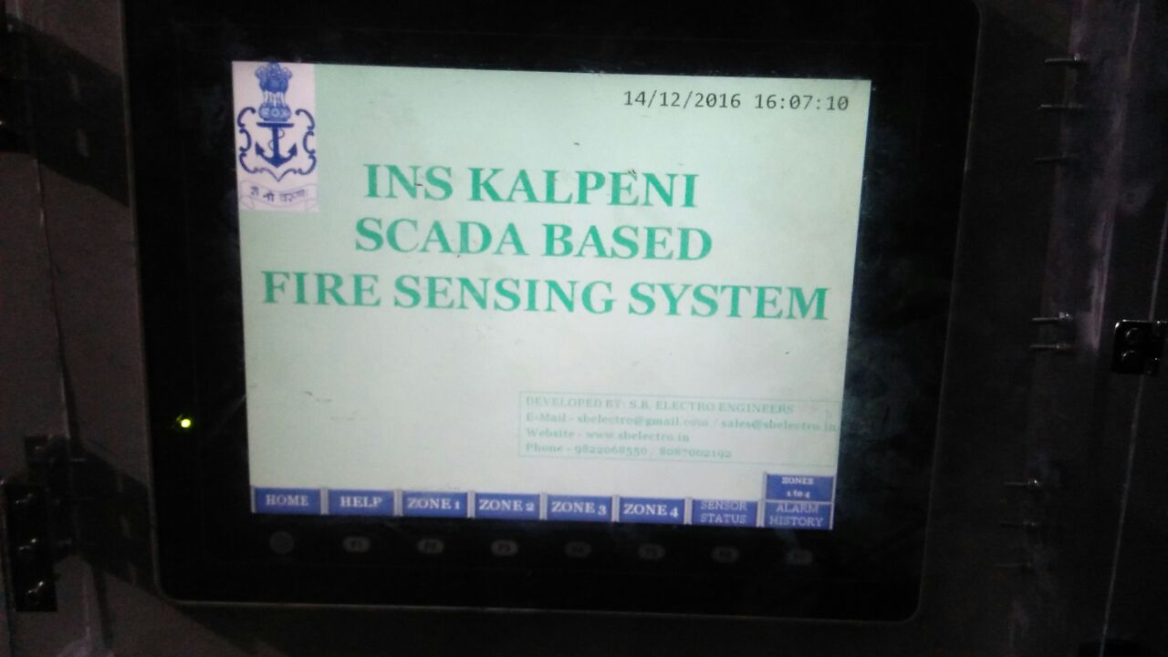
Fig. 9 Installation of Fire Fighting System onboard INS Kalpeni

Installation of PLC Based Control Panel onboard INS Sarvekshak for VTA1710MG
14. The types of Diesel Alternator being exploited onboard IN ship[s are varied in nature in terms of the OEMs and countries of origin. Each of these come with their own Control and Monitoring Panels posing a challenge for onboard operators, maintainers, repair yards and entail customized training. To tide over this problem, design of a standardised control panel was envisaged which could be customized to function for all kinds of DAs. A compact control panel was thus developed as a Staff Student project at Shivaji and was successfully proven on two live DAs. The system consists of PLC based control panel with a colored LCD display for the monitoring of parameters in local and remote. Subsequently, the prototype has been installed onboard INS Sarvekshak and has replaced the existing relay based control system for its DA VTA1710MG. Field trials of the same is in progress presently.

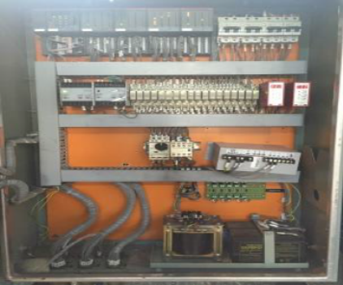 | 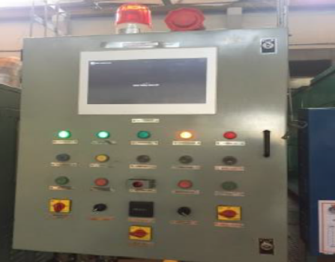
Fig. 10 PLC based DA Control Panel
KALEIDOSCOPE OF DEVELOPMENT AND TRAINING ACTIVITIES UNDERTAKEN AT INS SHIVAJI

Green Initiatives and Power Conservation

- Shivaji has been awarded the ‘Best Green Practices’ award for the year 2016 on Navy Day by the Chief of Naval Staff and also the ‘Best Green Practices’ Trophy for Southern Command by the FOC-in-C, South for the year 2016.

- Smart Micro Grid Technology. Renewable Energy is the order of the day and future of the world. There was a need to ensure that the establishment is fed with Renewable Power to offset the heavy electric and diesel bills each year. Further, there was a need felt to electronically regulate the essential and non-essential loads in station on an automatic basis which would lead to tremendous saving of power. Such cheap power would also be available on a round the clock basis to the essential loads and also to non-essential loads for reasonable durations, even during grid outages. A “Smart Micro Grid” /Smart hybrid Renewable energy system serves this purpose. The objective of the smart micro grid is to optimize energy cost and also ensure continuity of power supply to critical installation at the time of grid failures. INS Shivaji is a picturesque and quiet Naval Training Establishment in the Western Ghats and is one of the locations earmarked by HQ IDS for the incorporation of a Smart Micro Grid. A pilot study was undertaken at Shivaji by M/s Premier Solar, Hyderabad towards ascertaining feasibility of installation of Micro Grids.

- The peak load of the unit is about 1.4 MW and the project envisages integrating all the energy resources such as IMW solar plant, 0.8MW Wind Turbine, the MSEDCL grid and 1 MW DG set available with unit through smart control technology. The objective of the smart micro grid is to optimize energy cost and also ensure continuity of power supply at the time of grid failures. The entire network will be monitored from a central PLC based platform, which will be capable of taking decisions to use green energy over conventional energy. Post installation of Micro grid, about 30 lakhs units can be generated in-house every year which will lead to a saving of about 2.67 crores every year.

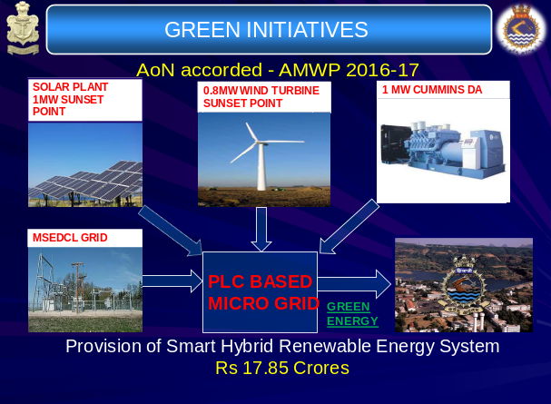
Fig.1 Micro Grid Technology Layout

- Installation of 15kW Intelligent Solar Panel. A 15 kW intelligent solar power system has recently been commissioned by FOC-in-C (South), during the Unit’s Annual Inspection as a pilot project in the area behind the EPCT School. The electric power generated by the system is fed to the EPCT School through a controller which will balance the load requirement by drawing only the required excess power from the incoming main supply. This Initiative will result in a net savings of 70 units (kWh) per day, which would result in a matching savings over a period of seven years.

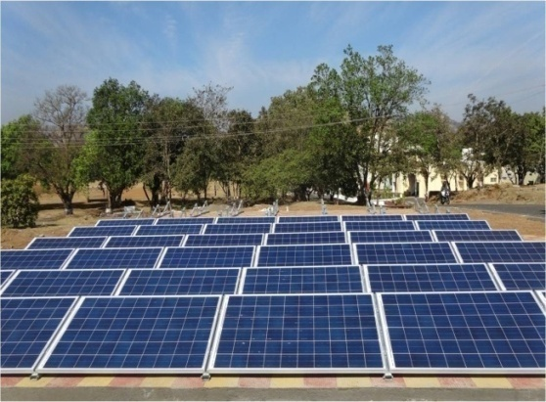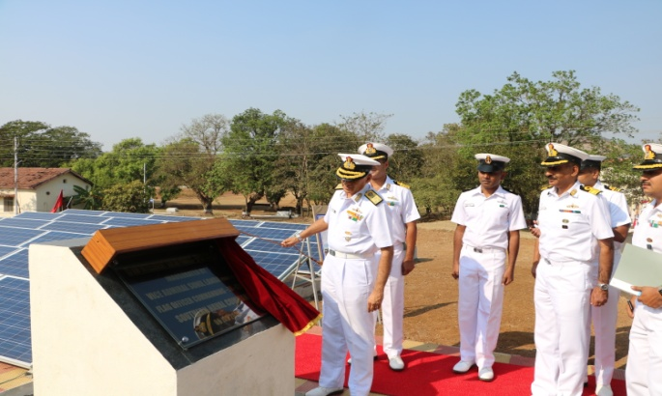
Fig. 2 Solar Panel layout near Fig.3 Inauguration by FOC-in-C, EPCT School South

- Installation of Bio Gas Plant. As part of Green initiative, the unit has installed waste processing cum Bio Gas generation plant at Brahmaputra Galley. The plant can process 100 Kg of bio degradable waste on a daily basis which in turn will generate 6-8 Cum of bio gas (equivalent to 2 kg of LPG per day). The plant was inaugurated by Flag Officer Commanding-in Chief, Southern Naval Command on 17 Oct 16.

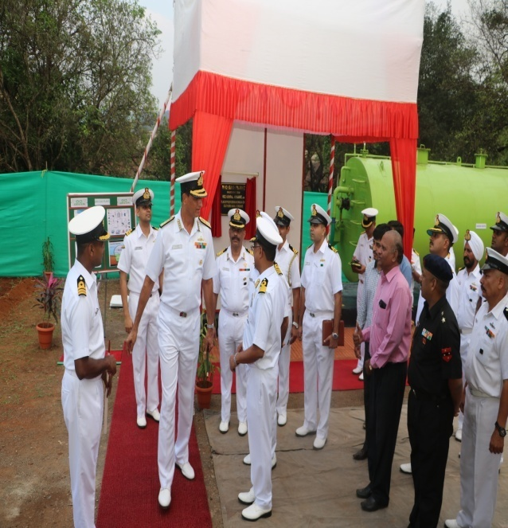
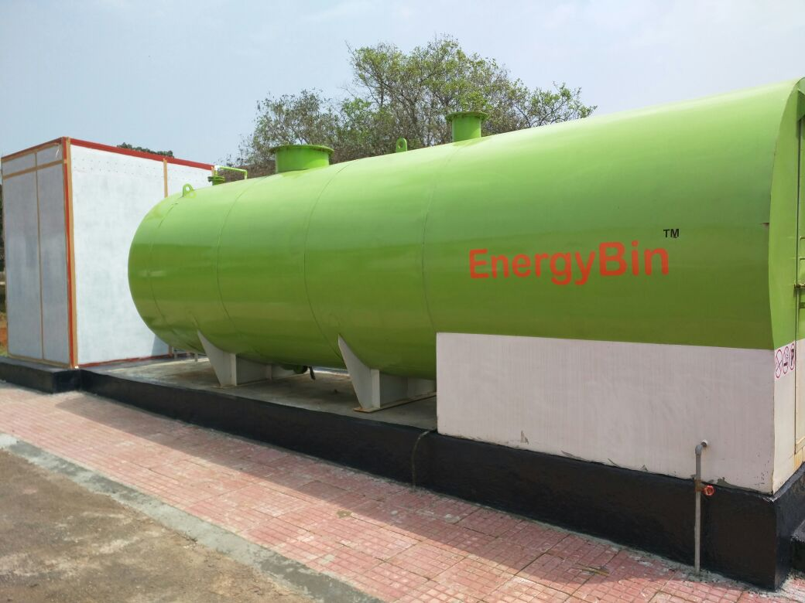

Fig. 4 Inauguration of Bio Gas Plant by FOC-in-C, South

- Laying of Foundation Stone of Band Accomodation. The significance of Navy Band in a training establishment is of paramount importance. The band provides an inspiring and motivating factor to the trainees on parade. Apart from above they also perform for various service engagements that include POP of Officers courses, Mess nights, Band concerts during Navy Week and concerts in foreign ports. The unit has a 20 men band and a case has been taken up with IHQ for augmentation of band to 33 men. The band was initially allotted a space in family welfare center for practicing, which was later declared unsafe and was subsequently demolished. The performance of a band to a large extent depends upon the infrastructure available with the band. Presently, the band is functioning/practicing in a make shift arrangement available in gunnery office complex. Towards the smooth conduct of band practice and to keep the morale of the band members high a permanent accommodation for band has been approved under AMWP 15-16. The foundation stone for the same was laid down in presence of COM on 26 Sep 16. The same is likely to be completed by end Jan 17.
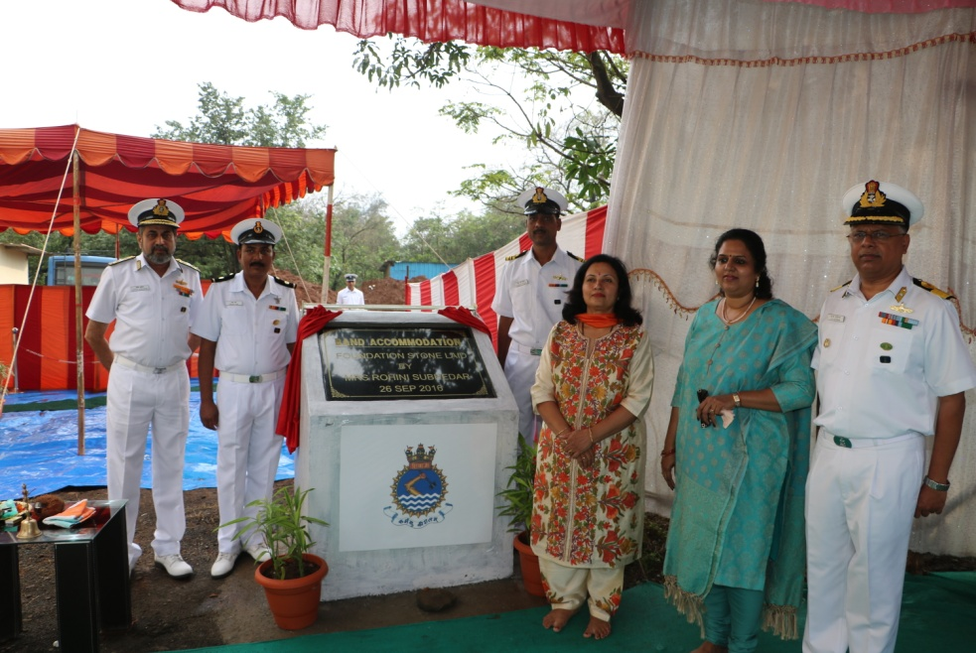

Fig.5 Laying of Foundation Stone of Band Accommodation by COM

- Laying of Foundation Stone for NBC Training Facility. On the lines of DCTF and FFTF, an NBC Training Facility (NBCTF) is proposed to be set up at the NBCD School. The contract for setting up of NBCTF at NBCD School has been signed on 31 Mar 16 and the simulator is likely to be commissioned by Sep 18. The Foundation Stone for NBCTF was laid by Vice Admiral AV Subhedar, Chief of Materiel on 26 Sep 16.

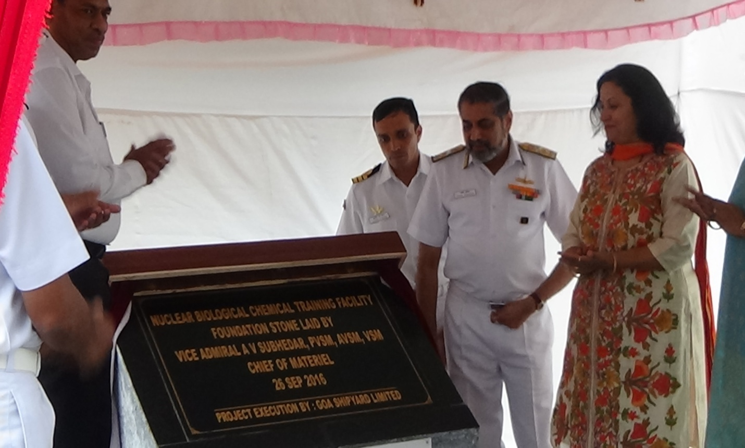

Fig. 6 Laying of Foundation Stone of NBC TF by COM

- Laying of Foundation Stone of Vikramaditya Boiler Complex. A prototype boiler was received at Shivaji in Aug 15 which was subsequently housed in Temporary Shed. Staging was erected around the boiler to impart training on construction and maintenance of boilers to various ab-initio and PCT courses. The boiler is proposed to be housed in a Boiler Complex along with auxiliaries and Classrooms. Towards this , foundation stone was laid by Flag Officer Commanding-in Chief, Southern Naval Command on 17 Oct 16.

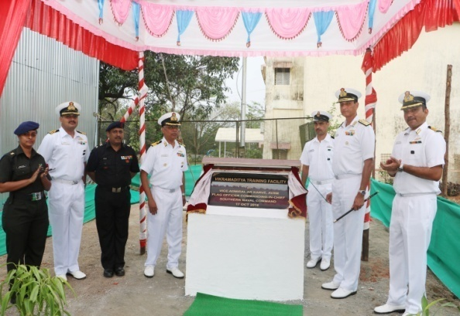

Fig. 7 Laying of Foundation Stone by FOC-in-C, South

Centre of Excellence (Marine Engineering) - Recent Activities

- Major activities progressed at CoE(ME), during the past six months, are enumerated in succeeding paragraphs.

10. Professional Domain.

(a) Preparation of Specifications/ SOTRs/ SQRs. Following draft documents were prepared by CoE(ME) since Jun 16, for subsequent promulgation by IHQ MoD(N):-

- DME Specification on Bilge Plates.
- SOTRs on Oily Water Separator.
- SQRs on Marine Diesel Engine for Combatant Ship.
- SQRs on Marine Diesel Engine for Non-Combatant Ship.
- SQRs on Marine Diesel Engine for Boats.
- SOTRs on HP Water Mist FF System.
- SOTRs on Gas Detection System.
- SOTRs on Refractory Material for KBГ 3Д Boiler, installed onboard Vikramaditya, based on reverse engineering of the ship-fit item.

- SQRs on Propulsion System Integration (PSI).

(b) Operationalisation of Static Boiler of Vikramaditya. A prototype static boiler of Vikramaditya, was received at INS Shivaji in Aug 15, for training purpose. Feasibility of operationalisation of the static boiler, through indigenous sources, was examined by CoE(ME), with an aim to facilitate live training at Shivaji and also provide a platform for future support of the ship-fit. Subsequent to the Feasibility Study, contract for preparation of Detailed Project Report (DPR) for conversion of the static boiler into a land based operational unit, was concluded by CoE(ME) with an Industry Consultant, in May 16. The Contract entails among other deliverables, establishing of sources for indigenisation of various auxiliaries and indigenous COTS equipment, both at system and component levels, and associated timelines for execution of the project along with Budgetary Estimate. The DPR is scheduled to be submitted to IHQ MoD(N), in Feb 17, for further consideration.

- Standardisation of Ship’s System Valves.

- A comprehensive study on Ship’s System Valves was undertaken by CoE(ME), with an aim to alleviate the problem areas, as also to achieve higher material reliability and standardisation. The study was undertaken in a phased manner, taking into consideration the induction process by shipyards, vendor capability, acceptance criteria, recurrent defects, repair methodology at dockyards, maintenance routines and advancement in technology. Anomalies observed during the course of the study, are illustrated below.

Illustration of Field Level Issues

Problem - Induction Stage

Lack of Comprehensive / Uniform Standard
Lack of detailed QAP
Problem – In Service
Dimensional Variance
Use of Non Standard Dia
Variance in Type of Valve
Use Non Standardised Material
Implications
Lack of Interchangeability
Non Standardisation
Lack of Rationalisation
Increase in Inventory

Use of Non Standardised Material

- Fuel & AVCAT system valves required to be Fire Safe iaw
NES 319,320 & 360

- Use of Gunmetal not prescribed in these systems. However same has been used.

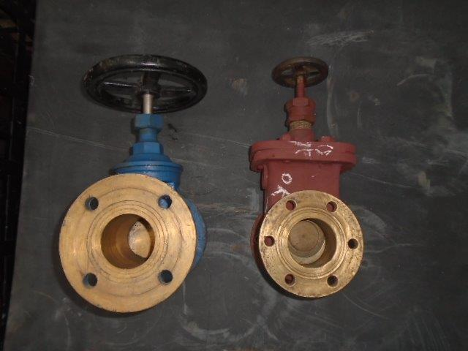
Illustrative Example –
Swing Check Valve

Dia  of Valve  (in mm) | Project 1  Conventional | Project 2  Wafer Type
50 | 203 | 55
65 | 216 | 58
80 | 241 | 82
100 | 292 | 92
125 | 330 | 105
150 | 356 | 109

Variance in
End Flanges PCD

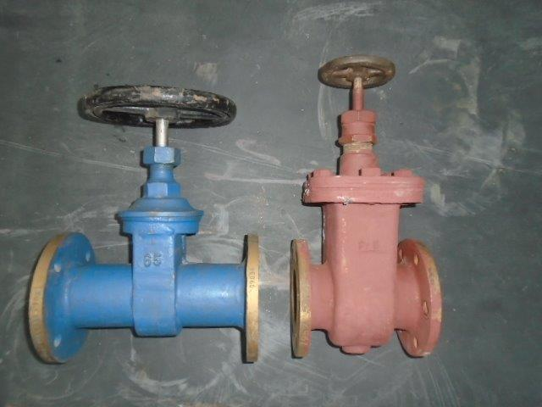

Illustrative Example – Ball Valve
Face to Face Dimension (mm)
Dia (mm) | NES 375 | ASME  B 16.10 | BS 2080 | Project 1 | Project 2
15 | 108 | 108 | 108 | 85 | 115
20 | 117 | 117 | 117 | 110 | 120
25 | 127 | 127 | 127 | 120 | 125
32 | 140 | 140 | 140 | 130 | 130
50 | 178 | 178 | 203 | 178 | 150
65 | 190 | 190 | 222 | 190 | 170

Variance in
Face to Face Dimensions

(ii) To address these issues in a holistic manner, a need was felt to formulate a comprehensive specification for ‘system valves’, so as to standardize the selection and use of valves, for a given application. Accordingly, standardization of attributes such as type, dimensions (ie, diameter and face-to-face dimension), end connections, material, design consideration and inspection & testing criteria, were comprehensively addressed in the document. The said process is aided by the following ‘Valve Selection Template’, included in the Specification:-
Valve Selection Template

Input Data (to be filled by Designer)
Ser | Description | Input Particulars
1 | Ship’s System
2 | Determination of System Application
3 | Location of Valve
4 | Pipe Diameter (NB)
Output Data (based on this Specification)
Ser | Description | Output Obtained
5 | Valve Dia (NB) (based on Pipe Dia)
6 | Applicable Manufacturing Process
7 | Applicable Class
 | (a) Casting (Class I/II)
 | (b) Forging (Class 2)
8 | Type of Valve, as applicable
9 | Face-to-Face/ Centre-to-Face Dimension
10 | Minimum Bore Diameter (for Ball Valve only)
11 | Valve Material
12 | Internal Component Material
13 | End Connection (Screwed/ Flanged)
 | (a) Screw end Connection Particulars
 | (i) Thread Size
 | (ii) No. of Threads/ inch
 | (iii) Pitch (P)
 | (b) Flange Particulars, if applicable
 | (i) Outside Dia (D)
 | (ii) PCD for Bolts (K)
 | (iii) Diameter of Bolt Hole (L)
 | (iv) No. of Bolts
 | (v) Bolt Size
 | (vi) Flange Thickness (C1)
14 | Valve Actuation Mechanism
15 | Rod Gearing, if applicable
16 | Fire Safe, if applicable
17 | Standard Design Considerations, as defined in Chapter 8 of Specification to be complied with.
18 | Acceptance Test Criteria, as defined in Chapter 9 of Specification, to be complied with.

(iv) The draft specification since forwarded to IHQ MoD(N), in Jun 16, has been approved and promulgated as DME Specification.

(iii) In addition to enabling standardization, it is considered that, the document, would also enhance reliability, interchangeability and reduce onboard inventory.
- Academic Domain.

(a) CEPs. CoE(ME) is mandated to conduct CEPs, for a duration of one week, for 20 IN Officers nominated from IHQ MoD(N) and various Commands. Faculty for the courses comprise of specialists in the related field, from Academia, Industry, R&D and senior IN Officers from Professional and Design Directorates at IHQ MoD(N). CEPs conducted over the last six months, are as follows:-

(i) Marine Fuels; Jun 16.

(iii) Management of New Construction Projects; Aug 16.
(iv) QC & Quality Management for Acceptance of Equipment/ Machinery; Nov 16.

(d) Collaborative M.Tech at IIT(B). An MoU with Indian Institute of Technology, Bombay was concluded for Collaborative M.Tech programme in ‘Thermal & Fluid Engineering’. Selection of Officers is on the basis of Entrance Examination, conducted at IIT(B). As a prelude, a two-week refresher course is conducted at CoE(ME) for the shortlisted candidates. Out of the nine shortlisted candidates, eight Officers qualified the Entrance Examination, for M.Tech Admission Year - Jul 16. Also, M.Tech projects with a potential for application in the IN, have been shortlisted by CoE(ME) in consultation with IIT(B), and their progress is monitored closely.

- Key Thrust Areas.

(a) Firm Deliverables. While the promulgated mandate envisages CoE(ME) as a single advisory body on all matters concerning Marine Engineering, a need was felt to define ‘Key Thrust Areas’ of the organisation and establish firm deliverables for the next two years. Accordingly, an in-house study was undertaken to identify the Key Thrust Areas, taking into account various factors including available manpower and resources. Based on the study, proposed Structure of Activity and Plan of Action, as part of the Key Thrust Areas planned for implementation at CoE(ME), categorised under Academic & Professional Domains, have been approved by IHQ MoD(N), in Oct 16.

(b) MoU with IIT(B) for PhD and Consultancy Services. CoE(ME) is in the process of concluding two separate Memorandum of Understanding (MoU) with IIT(B), for conduct of PhD and hiring of Consultancy Services for professional activities, related to the mandate of CoE(ME). Draft MoUs have been prepared in consultation with IIT(B), and the same would be concluded shortly.

Advancements/Upgradation of Training Aids

12. The training facilities at CMET, INS Shivaji are constantly upgraded to meet the requirements of operating and maintaining fleet and flotilla shipboard equipment. The recent value additions to the training facilities have been enumerated in succeeding paragraphs:-

(a) Virtual Reality Bay. With the increase in training load it is not possible to ensure adequate time for each trainee to work on real systems. Whilst at least one Prototype of any Equipment/Machinery/System is necessary, increasing these systems to match the trainee load is cost prohibitive. Technology can be utilized effectively to counter these emerging problems and accordingly, a VR lab has been set up in the Computer Application Centre of CMET. The VR lab consists of 20 high end work stations and 15 head mounted displays (model-Oculus rift). The lab will simulate real life experience by facilitating walk through of onboard compartments and depict equipment assembly/ disassembly which will enable a trainee to be trained using virtual equipment and ships. The VR projects are immersive by nature and allow a trainee to start/stop, open/close any system valve, assemble and disassemble equipment in VR Environment, and thus provide realistic training.

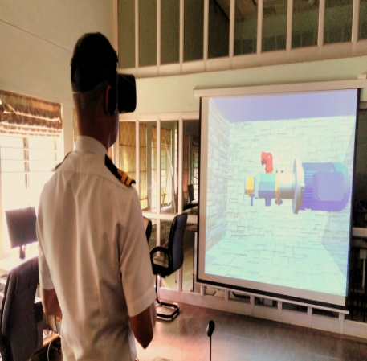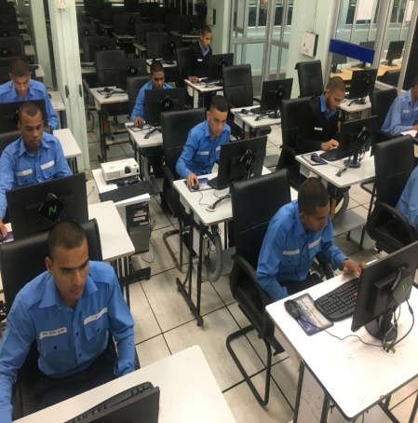

Fig.8 Virtual Reality Based Appreciation of
Engineering Equipments Onboard

(b) 57 Node N-Computing Lab. With a vision to continuously upgrade the facilities, a 57 terminal N-Computing lab (with one high end server) has been commissioned at CAC in CMET. This is the largest congregation of N-computing devices presently in the Navy. The model class room is being extensively used for conduct of practical training on MS Office applications, Navy specific software’s viz E-DART, E-SRAR, SDRS and SLMS. Further the lab is utilized for conduct of online and ELKT exams for Officers and sailor classes. Advantages accrued from installation of N-computing devices are as appended below:-

(i) Low power consumption.
(ii) Cost effectiveness (one N computing device with a monitor, keyboard and mouse costs Rs 11000/- against cost of Rs 24000/- for a thin client and Rs 35000/- for a core i3 desktop PC).
(iii) Optimal use of resources.
(iv) Better energy efficiency.
(v) Simplified administration.
(vi) Easy software patches management.

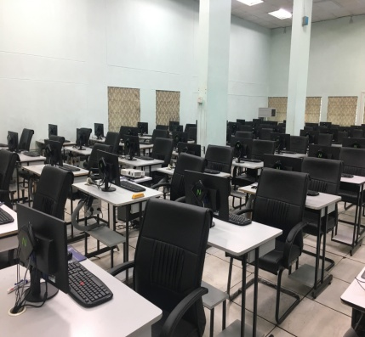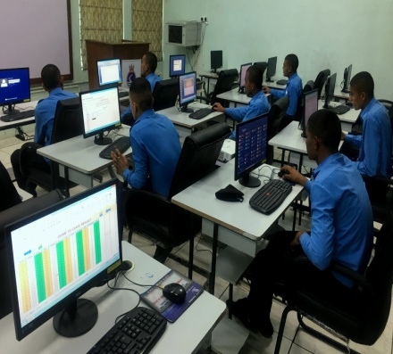
Fig.9 Classroom with N Computing Facility

(c) Training Facility for CO₂ Fixed Fire System. In line with recent FOST guidelines a facility to impart training on maintenance aspects of major fire fighting system has been created. While basic training on firefighting is covered for all personnel during ab-initio NBCD course and type specific during PCT, a need was felt to augment the methodology through a facility specifically centered upon imparting training on operation and maintenance. Accordingly, a Fixed CO₂ Fire-fighting system similar to the one onboard Kamorta class ships has been created. The facility includes actual working components and utilizes compressed air to simulate CO₂. Additionally, the facility is also being used for HoS sessions for all ab-initio courses and PCT courses.

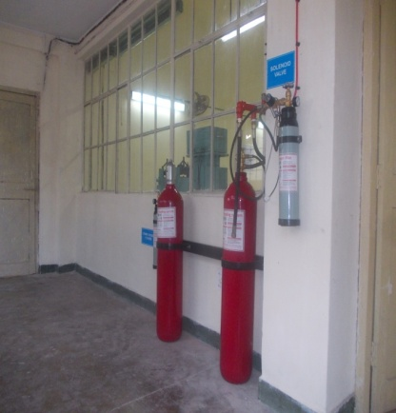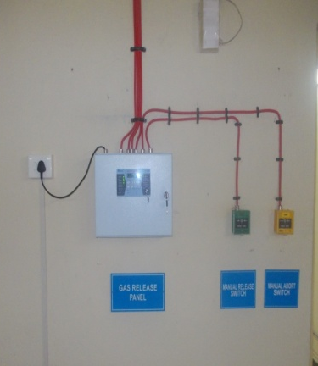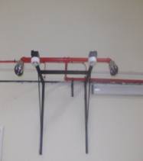
Fig.10 Newly Commissioned Fire Fighting System
akin to ‘Kamorta’ Class of Ships

(d) Provisioning of Pneumatic Tools. The Valve Overhauling Bay in the Systems and Auxiliary Wing (SAX) has been provisioned with Pneumatic Tools. Use of Pneumatic tools has considerably reduced the time required for overhauling of valves. Additionally, exposure of trainees to such labor saving devices will make them competent to utilise similar devices and promote the use of labor saving devices onboard ships. Training on usage and application of these tools is conducted during HoS and practical sessions every week. A total of 32 work stations have been created for maximum reposure to trainees.
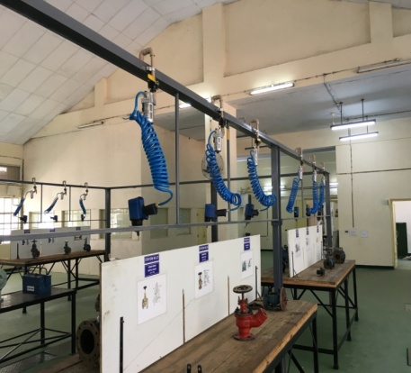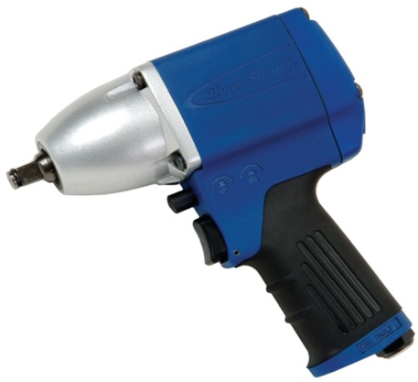
Fig.11 Pneumatic Tool Stations | Fig.12 Pneumatic Gun
Training and Administrative Activities

13. Online Seva. The establishment has taken a number of e-Governance initiatives in the past one year thus ensuring faster online transactions like requisitions/ requests and subsequent processing in electronic form which has resulted in an annual saving of more than 10000 sheets of paper. This has ensured optimal utilisation of printer resources view paperless transactions and aided in reducing the carbon footprint of the establishment. The various applications are as follows:-

(a) E-Seva (E Leave and E-Ty-duty for Officers). This application automates the leave and Ty-duty process in respect of officers thus making the entire process online. This has aided in significant reduction in time and aided concept of paperless transaction. The application is being forwarded to IHQ MoD (N)/ DIT for Navy wide implementation.

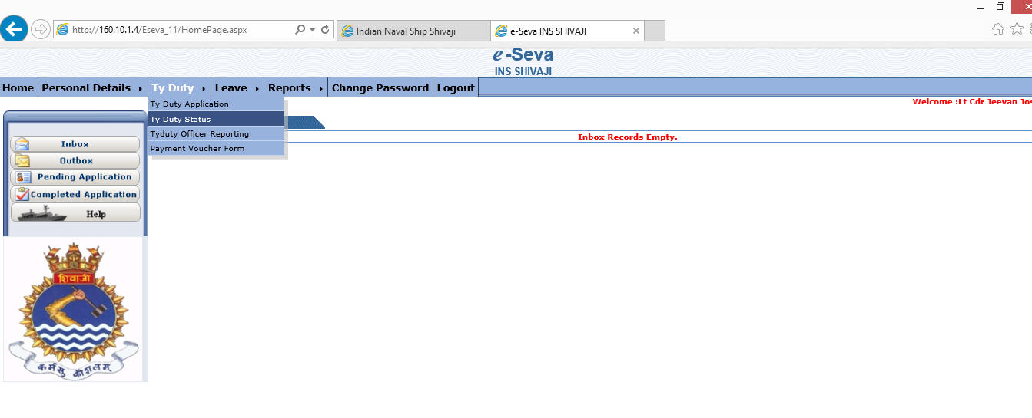

Fig.13 E-SEVA (Ty Duty and Leave) for Officers

(b) E-leave for Sailors. This application automates the leave process in respect of sailors, thus making the process online and the same has aided in saving of time and material resources. Previously, a sailor used to get his leave approved through a process which was manual by initiating a file. The process used to take at least 3-4 days to complete before final leave approval. With this application, the entire process takes only a day for final leave approval and further administrative action. The application has been forwarded to HQWNC, INS Agrani, INS Tanaji, ND School, INS Hamla & INS Chilka for implementation.

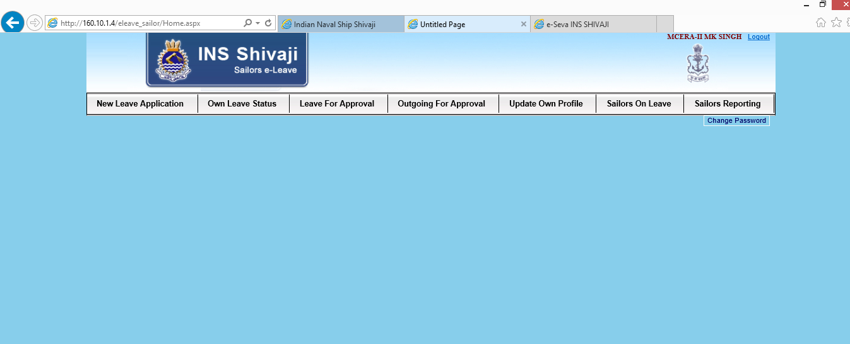

Fig. 14 E-Leave for Sailors

(c) Application forms of Sailors. There are a large number of forms which are required to be filled up by sailors to avail various entitlements. These forms are filled up manually and then approved manually on file which is resource intensive. In order to streamline the same, this application automating 10 forms has been developed and put into use at this unit. The same has significantly reduced carbon footprint of the establishment. The various forms that have been automated are:-

(i) Performa for Submitting Request for Ty Duty.

(ii) Application for Family Warrant on LTC.

(iii) Application for Family Warrant on Transfer.

(iv) Application for LTC Advance.

(v) Application for Concession Voucher for family.

(vi) Temporary Advance from AFPP Fund.

(vii) Order Authorisation for claiming In Living CILQ.

(viii) Claim for Grant of Children Education Allowance.

(ix) Permanent Duty Advance – Sailors.

(x) Application for Final Withdrawal from AFPP Fund.

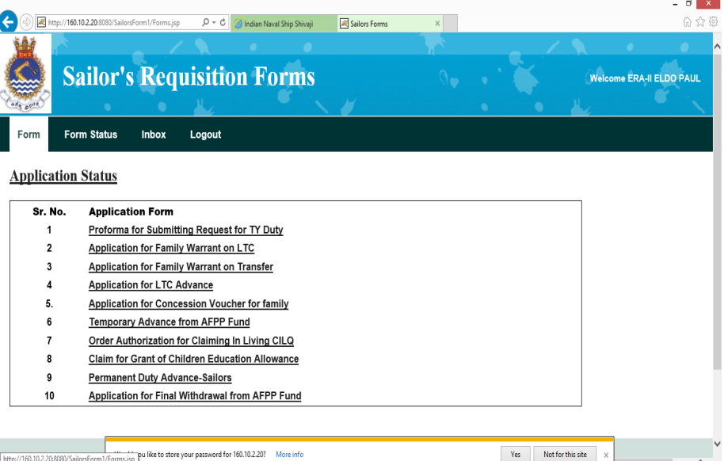
Fig.15 Sailors Requisition Forms
14. Visitor’s Management System. To have an automatic system of issuing casual visitor passes to the individuals visiting this establishment, a self service visitor management system has been installed at the main gate. Upon arrival at the pass section the visitor presents himself in front of the kiosk and enters his personal details. In addition biometric thumb impression and photograph of the visitor is captured on the e-kiosk. The system also has the feature of scanning Identity card produced by the visitor for saving in the system. The pass is generated via a printer which has a bar code on it, upon leaving the premises the bar code is scanned. The details of whether the visitor has left the premises or not is available online to the Officer of the day. The system has the facility to recall any record. The second time visitor just has to scan his thumb print to get the pass, rest all details are automatically fetched from existing database. The system has resulted in following advantages:-

(i) The accounting of security passes has become easy.

(ii) The black listing of the visitors based on the biometric impression has become effective.

(iii) The database is available for analysis in case required in future.

15. Training Activities –Marine Engineering Specialisation Course (60.081). Center of Marine Engineering Technology (CMET) is one of the largest training schools of Indian Navy involved in rigorous training of the officers and sailors of marine engineering cadre of the IN, Coast Guard and friendly foreign Navies. Marine Engineering Specialisation Course (MESC) is the most important training phase in moulding of Marine Engineers out of raw Engineering Graduates. The Officers of MESC as part of their 79 Weeks of training are put through a rigorous curriculum which transforms them into thorough Gentleman Officer, Capable leaders and Professional Marine Engineers. Apart from attending classroom theoretical instructions the officers also are trained with hands on skills which is imperative for putting knowledge to practical application. For moulding them into leaders they are assigned duties of Assistant Divisional Officers for trainee sailors. For grooming them professionally they undertake technical projects, deliver presentations on military history and technical / contemporary issues, attend dinner nights and social evenings. The Officers of MESC have been in the forefront of all Shivaji sports and extra-curricular activities viz. Hockey, Football, Aquatics ,Cross Country, Social evenings and DO (T) Camps to name a few. Visits to M/s Mercedes Benz, Mazagaon Docks Limited, Tata Power and Bhabha Atomic Research Centre (BARC) were 103rganized for the Officers of MESC 60.080 and MESC 60.081. The 81st batch of MESC passed out from the portals of this institution and were honored by the presence of Rear Admiral DS Chouhan, Commandant, College of Defence Management, Secunderabad for their passing out parade which was held in Jun 16. It was a moment of great pride for this hallowed institution, having delivered well groomed and battle ready marine engineers in the form of the 81st batch of MESC.

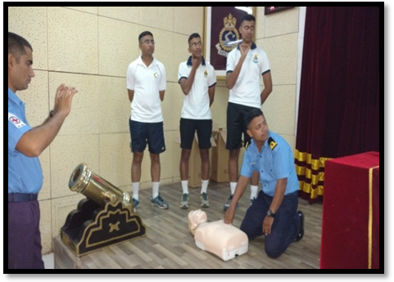 | 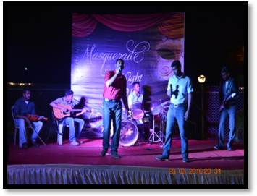
Fig. 16 Conduct of First Aid Lecture | Fig. 17 MESC Night – Social Grooming
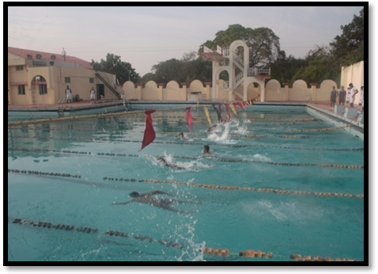 | 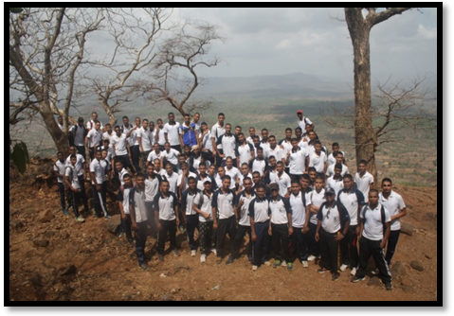
Fig. 18 Inter divisional Aquatics Championship | Fig. 19 Trek to Sudhagarh Fort
16. Training Activities - Trainee Sailors. The Divisional Organisation for Trainees, DO(T) at CMET has been involved in constant grooming and mentoring of young budding minds of trainee sailors. A host of initiatives as well as activities have been undertaken at DO (T) to achieve the aim of ensuring overall personality development of close to 4000 trainee sailors annually including 60 international trainees. A cycling expedition to Tungi fort for trainees with an aim to develop stamina and to bring change in their routine schedule. Intra DO(T) Cross country, Hockey, Handball , Aquatics
and Athletics Championship was conducted with an emphasis of building division spirit, sportsmanship and physical fitness. The quality of work displayed by various clubs such as Woodcraft club, Music club and Painting club of DO (T) to various dignitary visits and Monsoon concert-16 is praise worthy. Also towards augmenting the facilities, setting up of model dormitory with modular furniture and multi nodes NKN lab proved to be milestones in training.

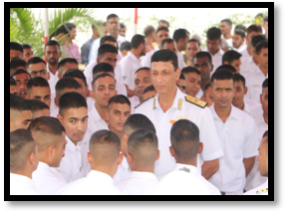 | 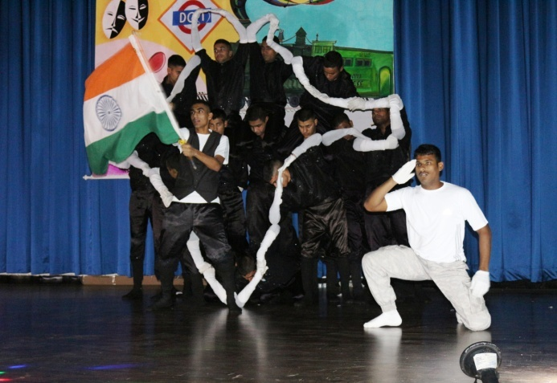
Fig. 20 Visit of FO C-in-C, Southern Naval Command | Fig. 21 Monsoon Concert 2016
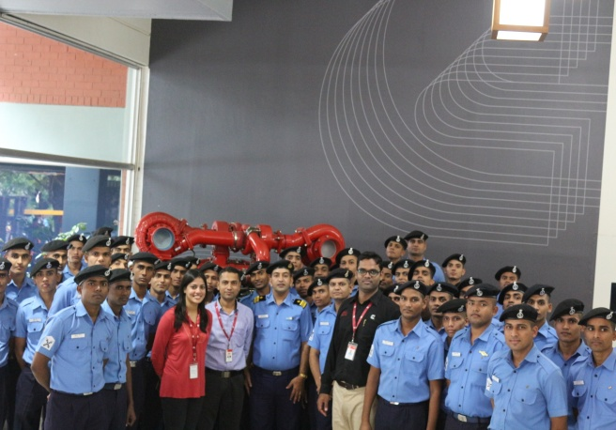 | 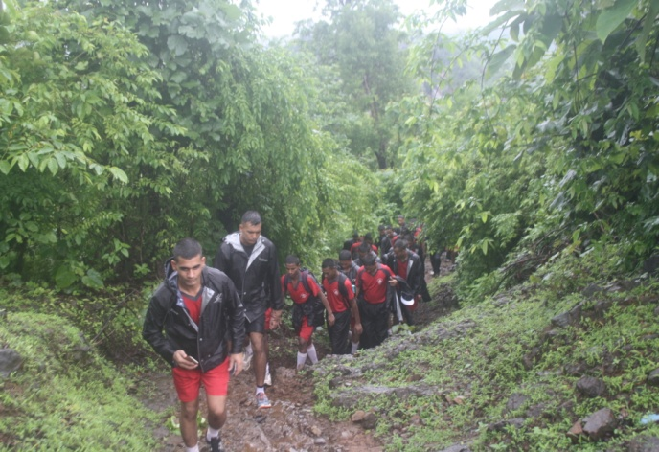
Fig. 22 Industrial visit to M/s Cummins India Pvt Ltd | Fig. 23 Trek to Tungi Fort

17. Infrastructure Development.

(a) Renovation of the Museum. The Naval Engineering Museum at Shivaji, the only known Marine Engineering Museum, houses several rare artifacts, documents and interesting information on the evolution of marine propulsion from rafts to modern day Nuclear Propulsion. The Museum has been in existence since 1990 and has evolved ever since. The Museum has been upgraded recently. Whilst the building and associated structures have been repaired and upgraded through the MES works route, the interiors, displays and exhibits have been completely renovated. The work has given the Museum a major facelift and a new lease of life.

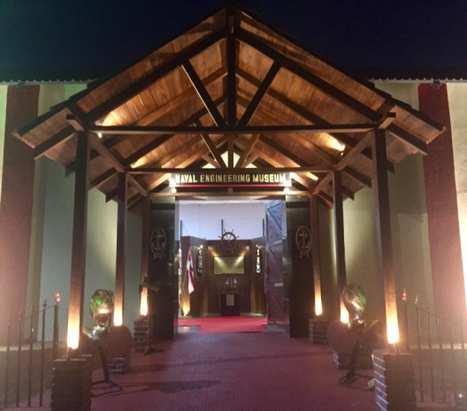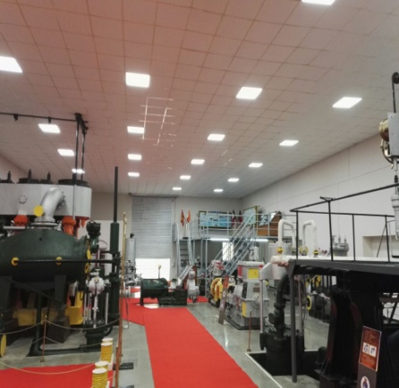
Fig.24 Refurbished Entrance | Fig.25 Museum from Inside

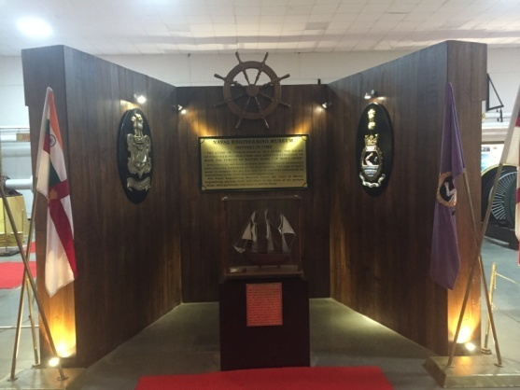
Fig.26 Front Partition

(b) Renovation of Main Entrance Gate. Renovation of the main gate has been undertaken to provide an enhanced aesthetic appearance at the entrance of the establishment. The upgrade includes increase in the height and width of the entrance facade with a fortress concept. The construction has been accomplished using black Ashlars Stone with golden lettering mounted on it. The ‘before and after’ images of the main gate are as under:-
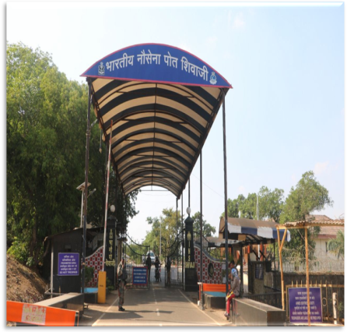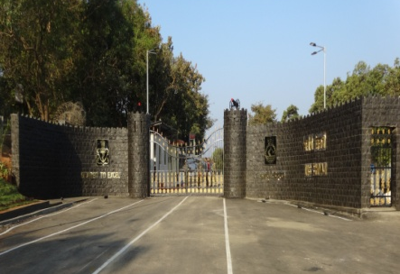
Fig.27 Old Main Gate | Fig.28 New Improved Main Gate

ON THE HORIZON

1. To remain abreast with constantly evolving technology, the training methodology at Shivaji for Naval Engineers is also updated to sustain high confidence levels whilst operating new induction ships and state-of-art technologies. Shivaji has always strived hard to impart quality training in Marine Engineering to officers and sailors. Training methodologies have evolved from theoretical instructions to use of Live Equipment for Maintenance Oriented Training (MOT), Computer Based Training Technologies, Simulators, Modern Tools / Test Equipment and Reference Systems.

2. “On the Horizon”, attempts to appraise the technical fraternity and the Naval Community on ongoing activities and future plans of team Shivaji.

Setting up of Predictive Technology Lab

- With the IN growing into a blue water force, the continuous and sustained operations at sea are the future challenges. To overcome these limitations and meet the sustained operational requirements of Naval Platforms the onboard maintenance philosophy would have to be more predictive and proactive. It is pertinent to mention that correct and proper utilization of CBPM techniques for maintenance of machinery hygiene and prediction of imminent defects has been highlighted by all trial/repair agencies and the same is also a major observation during workups & inspections. Apart from planned lectures and instructions at training establishments a lot of emphasis is required to be laid on practical usage of CBPM techniques such as oil & coolant analysis, use of portable test kits, SPM and T-30 meter and all others related predictive equipments / kits.

4. While all these aspects are already included in various syllabi, greater first hand and interactive practical usage will go a long way in ensuring that the trainees can use these methods as soon as they are deployed onboard. Therefore, as a part of augmentation of training aid, a training bay is proposed to be setup under the XIII ^{th} Defence Plan and would consist of the following ‘’ Hands On’’ training facilities under one roof:-

(a) Vibration analysis
(b) Lub oil and coolant testing
(c) Non-Destructive Testing
(d) Equipment Health Monitoring
(e) Acoustic Signature Analysis

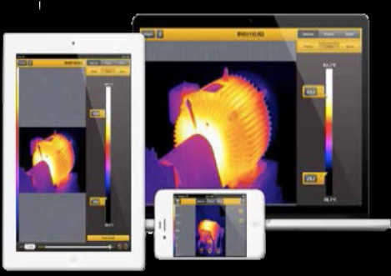 | 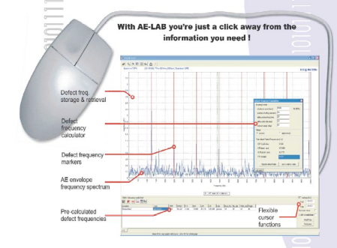
Fig.1 Thermal Imaging Camera for condition monitoring | Fig.2 Machinery Health Monitoring

Simulator for Steam Propulsion Plant
- Modelling and Simulation are proven and effective training tools which provide an insight of real time operations without the need to run actual machinery. Further, it can also be used to study, understand and implement the change which occurs due to the dynamics of operation. It is planned to undertake Modeling and Simulation of a Naval Steam Plant with the help of available database of IN ships. Simulation of the steam plant would be utilized for studying the effect of various regimes of operation w.r.t. boiler load, based on the demand. It would also help in explaining the dynamics of various processes inside a boiler in respect of combustion and heat transfer. The simulated mathematical model thus created will be used for integration of an actual control system along with hardware with the simulator. Further, it will act as a tremendous exposure to trainees in terms of usage and implementation of software based mathematical modeling and designing of an automatic combustion control algorithm and simulation.
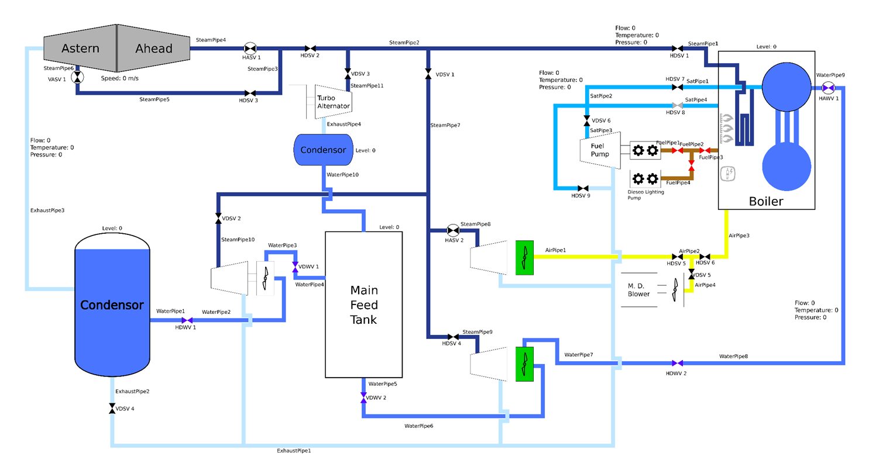
Fig.3 Envisaged GUI for the simulator

- The project would be undertaken in a phased manner, with first phase consisting of design of a simulator for a typical Naval Plant with a Graphic User Iinterface incorporating all the basic modes of operation ranging from 0 to 100% load on the boiler based upon the typical regimes of operation. The first phase has been completed as a part of MESC Project. The subsequent phases would involve integration of the software based simulator with automated hardware. The project has been approved under INTB and it is planned to design a functional control system using the above mentioned framework for Vikramaditya prototype operational boiler housed in a separate live steaming bay.

Virtual Reality Classrooms at Computer Application Center

- With the increase in training load it is not feasible to ensure adequate time for each trainee to work on real systems. Whilst at least one prototype of any equipment/machinery/system is necessary, increasing the number of the same to match the trainee load is cost prohibitive. Accordingly, a Virtual Reality Classroom has been set up which will enable a trainee to be trained using virtual reality. A pilot project for development of a VR model of Pump has been taken up and order has been placed to the firm. Few more VR models are envisaged out of which Air Conditioning Plant is in final sanction stage and Fire Fighting system is in AIP stage. Further, AIP for virtual walk through of engine room and boiler room of Vikramaditya has been accorded and case is at tendering stage.

Development of IMTP for Kolkata Class of Ships

- EPCT School conducts more than 226 courses for 47 classes of ships annually. The School conducts training on various aspects of Engineering, Machinery Control and Power Generation & Distribution System so that the personnel are poised to meet any challenge onboard. The advent of virtual reality based training has enabled better understanding of onboard system and equipment. Using these technologies, Integrated Multimedia Training Packages (IMTP) have been developed for Talwar, Brahmaputra, P-25/25A, 1241RE and Jalashwa class of ships and Integrated Electronic Training Manuals (IETM) have been positioned for Shivalik, Kolkata and Deepak class of ships. Further, a case for development of IMTP for Kolkata class of ships with virtual walk around has been taken up and work order is likely to be placed by Mar 17. This IMTP would also feature a Delhi Class Module and shall greatly rationalise the Training Time and requirements of Trainees.

Development of ONEGA Simulator for Talwar Class of Ships and Upgradation of LBTF Simulators

- The present state of the art simulators viz-a-viz, Burya, LBTF, 1241 RE and MCS-5, have proved to be one of the most effective training aids as they are the exact replica of the control machineries fitted onboard. The trainees are given hands on training for preparation, Start/stop operation, watchkeeping, maintenance, troubleshooting and emergency drills. The trainees are then assessed for their performance on these simulators and suitable course correction is given to fine tune their operational skills. In order to augment the existing simulator based training, Onega control system of Talwar class, MCR panels for NOPV class and upgradation of LBTF to include P-28, follow-on NOPV and ECU of IAC are being progressed through IHQ MoD/DME. Work order for Onega simulator is likely to be placed by Feb 17

Development of LM 2500 Training Facility

- Development of a LM2500 Maintenance Training Facility is envisaged as part of the Policy on Life Cycle Management of LM 2500 Gas Turbine. Consequently, Board of Officers had examined the feasibility and assessed the work involved in creation of a training complex behind EPCT School with facilities like a Static bay for LM2500 Gas Turbine, Training Simulators and Multimedia Classrooms. Presently the case for infrastructure development is in tendering stage and work order is likely to be placed by end Jan 17. The soil sampling of the site has been completed and construction work will commence from Feb 17. The case for procurement of training GT and relevant tooling for maintenance is pursued by IHQ MoD(N)/DME through FMS route. Price and Availability data has been received from US ODC and the case is presently being processed for approval of Hon. RM.

New Induction Training Committee

11. Shivaji has undertaken a detailed study of the equipment/ machineries presently available for training vis-a-vis their future training value factoring obsolescence. Accordingly, the establishment had forwarded an agenda point for 17th NITC meeting towards provisioning of new induction equipment/ machineries to augment the training at Shivaji. IHQ MoD(N)/DME has recommended Shivaji to initiate cases for MTU 4000 series engine, KPCL make AC and Ref plant, Burckhardt HPAC plant. Cases for provisioning the above equipment through OEM are in progress. In addition, a SEMT Pielstick engine from a decommissioned ship and live expired LM2500 gas turbine will be provisioned by IHQ MoD(N)/DME for training.

Acquisition through Capital Cases

12. Various areas of training that require being enhanced / augmented were taken up through the capital cases route under the 13th Defence Plan. The Unit’s requirements were taken up with IHQ MoD(N)/DFM/DME for inclusion in 13th Defence Plan under Major head 4706-02 and Minor head 103(A). The following labs/bays have been identified and are proposed as a Capital Training Augmentation Case:-

Ser | Description | Training Augmentation
(a) | Predictive Technology Lab | Predictive and Proactive maintenance philosophy onboard by using the following:-  (i) Vibration Analysis Lab  (ii) Luboil Testing Lab  (iii) Non-Destructive testing Lab  (iv) Equipment Health Monitoring Lab  (v) Acoustic Lab
(b) | Virtual Reality Bay | 3D visual training by exploded view of equipment for understanding internal construction, assembly procedures & operation The setup can also be used for virtual walk around of machinery spaces.
(c) | Industrial Training Bay | Overhauling of auxiliaries, pumps, valves using pneumatic/ hydraulic tools. Hot/ cold repairs of pipes, use of precision tools and Common Range Electrical Test Equipment (CRETE).
(d) | Simulator Bay | Upgradation of LBTF to cater for the requirements of P-28, P-21 and IAC-1/2 class of ships, in addition to the existing P-17 and LST(L) setup. A civil infrastructure is also included in the proposal.

Table.1 New Training Bays/Labs Proposed in Capital Cases
AWARD WINNERS - OFFICERS
MESC (60.081)

Award/ Prize | For | Awardee
The Hammer & Book Prize | Best ‘All Round Officer’ | SLt Abhilash Cherian (43584-B)
CNS Rolling Trophy & Book Prize | First in Order of  Academic Merit | A/C Divesh P (4283-J)
Book Prize | Second in Order of  Academic Merit | SLt Deepak Bamola (43593-Z)
Rolling Trophy & Book Prize | Best Project Syndicate  Design, Fabrication and installation of IRSS device for 1 MW DA | Lt WVM Watareka (NRE-2743)
Rolling Trophy & Book Prize |  | SLt Prabin Mankathra Prasannan (43590-T)
Rolling Trophy & Book Prize |  | A/C Pankaj Ghugtyal (4280-C)
Rolling Trophy & Book Prize |  | SLt Deepak Bambola (43593-Z)
Commodore’s Trophy & Book Prize | Positive Living | SLt Shohail Quadir Hazarika (43527-Z)
VAdm Daya Shankar Trophy | Best in Sports | SLt Lakshay Kandiyal (43581-Y)
DGCG Rolling Trophy | Best CG Officer | A/C Navaneetha S Muthusamy (4279-X)
FOCINC (South) Rolling Trophy | Best International Trainee Officer

AWARD WINNERS – SAILORS
FIRST IN ACADEMICS

Course | Stream | Awardees
MAAC XXII | ICE  GT  STEAM | Mulayam Singh, LME, 230118-Y  P Chandra Sahoo, LME , 230146-K G.Laxman Kumar, LME , 228527-F
Commodore’s Rolling Trophy |  | S Satwik, ERA/APP, 503547-A
International Trainee | ICE | MHDR Kumara, LME, EE 46075  KWCM Kalatuwawa, ERA/APP, AE109107  NLM Nafas, ERA IV, AE 105842
International Trainee | Best Sportsman | YN Fernando, LME, EE 39736
DEME  (60.937) | ICE  GT  STEAM | Shanker Rao Gorle, NVK (ME), 13611-P  Prabin Surya JK, DEME, 240863-T  Deepak Khulbe, DEME, 242402-R
DEME (60.937) | Best Sportsman | S Mondal, DEME, 403829-W
International Trainee | ICE | SDW DE Silva, ME-I, EE 46459

BEST ALL ROUND
Course | Stream | Awardees
MAAC XXII | DEDH  Mech/Nea/ERA/App | Yogesh Yadav, YTK(ER), 08972-S Mulayam Singh, LME, 230118-Y
DEME (60.937) | ICE ,GT ,  STEAM | Shanker Rao Gorle, NVK (ME), 13611-P

KIND ATTENTION TO AUTHORS
PLAGIARISM

Plagiarism is defined by the Oxford Dictionary as the “Wrongful Approach”, “Close Imitation” or “Purloining and Publication of another Author’s Thoughts, Language, Ideas or Expressions and the representation of them as one’s own original work”.

The increased availability of Intellectual Property due to a rise in Information Technology (IT) has furthered the debate as to whether copyright offences are criminal. Plagiarism is not a crime per se but is disapproved more on the grounds of moral offence; and cases of Plagiarism can involve liability for copyright infringement. While both terms may apply to a particular act, they are difference concepts. Copyright Infringement is a violation of the Rights of a Copyright Holder, when material restricted by copyright is used without consent. On the other hand, the moral concept of Plagiarism is concerned with the “Unearned Increment” to the Plagiarising Author’s reputation that is achieved through false claims of authorship.

Technical Manuals routinely copy facts from other manual without attribution, because they assume a common spirit of scientific endeavor. Within an organisation, in its own working levels, standards are not as stringent but definitely not non-existent. If someone helped with a report, or if a paragraph is taken from an existing source, a citation is expected to be written down.

The thin line between permissible literary and impermissible source code Plagiarism is finally left to the maturity level, morality, integrity and honesty of the author. In short, authors are requested to adhere to the guideline. If you did not write it yourself, atleast you must give due credits.

